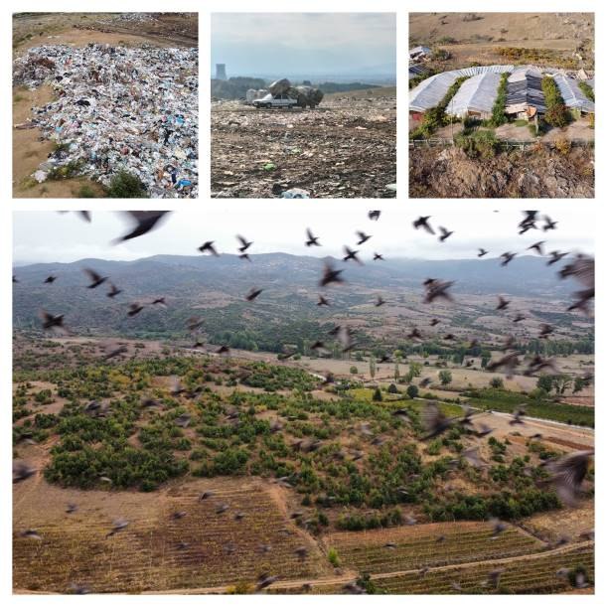
NON-TECHNICAL SUMMARY – NTS
North Macedonia – Regional Solid Waste Project

April 2022

Table of Contents
1 INTRODUCTION 4
2 PROJECT PREPARATION BACKGROUND 6
3 LEGAL ASPECTS AND COMPLIANCE WITH RELEVANT LAWS AND POLICIES 7
4 PELAGONIA AND SOUTHWEST REGION 8
4.1 Project Location 8
4.2 History of Project Development and Planning 9
4.3 Summary of Environmental and Social Baseline 10
4.4 Summary of Environmental and Social Impacts and Measures 12
5 POLOG REGION 18
5.1 Project Location 18
5.2 History of Project Development and Planning 19
5.3 Summary of Environmental and Social Baseline 20
5.4 Summary of Environmental and Social Impacts and Measures 22
6 VARDAR AND SOUTHEAST REGION 28
6.1 Project Location 28
6.2 History of Project Development and Planning 29
6.3 Summary of Environmental and Social Baseline 29
6.4 Summary of Identified Environmental and Social Impacts and Measures 31
7 ADDITIONAL ACTIVITIES TO BE UNDERTAKEN FOR THE PROJECT 32
8 DISCLOSURE AND COMMUNICATIONS 34

List of Abbreviations
E&S | Environmental and Social
EBRD | European Bank for Reconstruction and Development
EIA | Environmental Impact Assessment
ESIA | Environmental and Social Impact Assessment
EU | European Union
FS | Feasibility Study
GHG | Greenhouse gas
H&S | Health and Safety
MoEPP | Ministry of Environment and Physical Planning of North Macedonia
OHS | Occupational Health and Safety
PIU | Project Implementation Unit
PR | Performance Requirement
PSW | Pelagonia and Southwest
PUE | Public Utility Enterprise
RWMP | Regional Waste Management Plan
SE | Southeast
SEA | Strategic Environmental Assessment
SEP | Stakeholder Engagement Plan
SW | Southwest
TS | Transfer Station
VSE | Vardar and Southeast
WM | Waste Management

INTRODUCTION

Project scope and rationale. North Macedonia is committed to following the key principles of European Union (EU) waste policies as the basis for development of its waste management sector. Recognising the importance of protecting the environment and human health from uncontrolled waste dumping, the country has developed a set of strategic and planning documents foreseeing the development and implementation of sound waste management. Most notably, the National Waste Management Strategy and Waste Management Plan aim to develop integrated waste management in line with the EU waste hierarchy and directives, and ensure environmentally safe recovery and disposal of solid waste. Current waste management practices in the country pose a risk to human health and the environment. Waste is mainly disposed of at non-sanitary landfills without implementation of appropriate control measures such as base lining system, landfill gas and leachate collection and treatment/utilisation. In addition, there are practically no source-separation and recycling activities organised by municipalities or public utilities in the country.

In order to improve the waste management system and achieve its strategic objectives, the Government of North Macedonia has asked the European Bank for Reconstruction and Development (EBRD) to consider providing finance for establishing and developing regional waste management systems compliant with EU standards in five administrative regions in the country: Polog region (the “Polog region”), Vardar and the Southeast regions (“VSE region”) and Pelagonia and the Southwest regions (“PSW region”) (the Project).

EBRD is considering the financing of the following components:
- PSW region – construction of a sanitary landfill in Novaci and five transfer stations (TS), and procurement of waste collection trucks and bins/containers for both mixed waste and recyclables,
- Polog region – upgrading of the disposal site Rusino including associated equipment, construction of two new composting plants and two TS including the required equipment, and procurement of waste collection trucks and bins/containers for both mixed waste and recyclables, and
- VSE region – construction of a sanitary landfill in Dobrosinci and four TS, and procurement of waste collection trucks and bins/containers for both mixed waste and recyclables.

The borrower will be the Ministry of Finance, whereas the Project implementor will be the Ministry of Environment and Physical Planning (MoEPP). The loan will be provided in two tranches. Tranche 1 will cover investments in: (i) all above listed activities in the Polog region (to be co-financed together with the Swiss State Secretariat for Economic Affairs – SECO); (ii) waste collection and transport equipment for the VSE and PSW regions; and (iii) landfill and TS for PSW region. Tranche 2 will finance: (i) the landfill and TS in the VSE region and (ii) the waste collection and transport equipment for PSW and VSE regions.

The locations of the TS and composting plants have not been formally approved by MoEPP yet. To date, only three TS locations for the SW region (i.e., in the municipalities of Debar, Kichevo and Ohrid) have been decided whereas all other locations are yet to be chosen.
Figure 1 shows the locations of all three regional landfills and the chosen TS locations in the SW region.
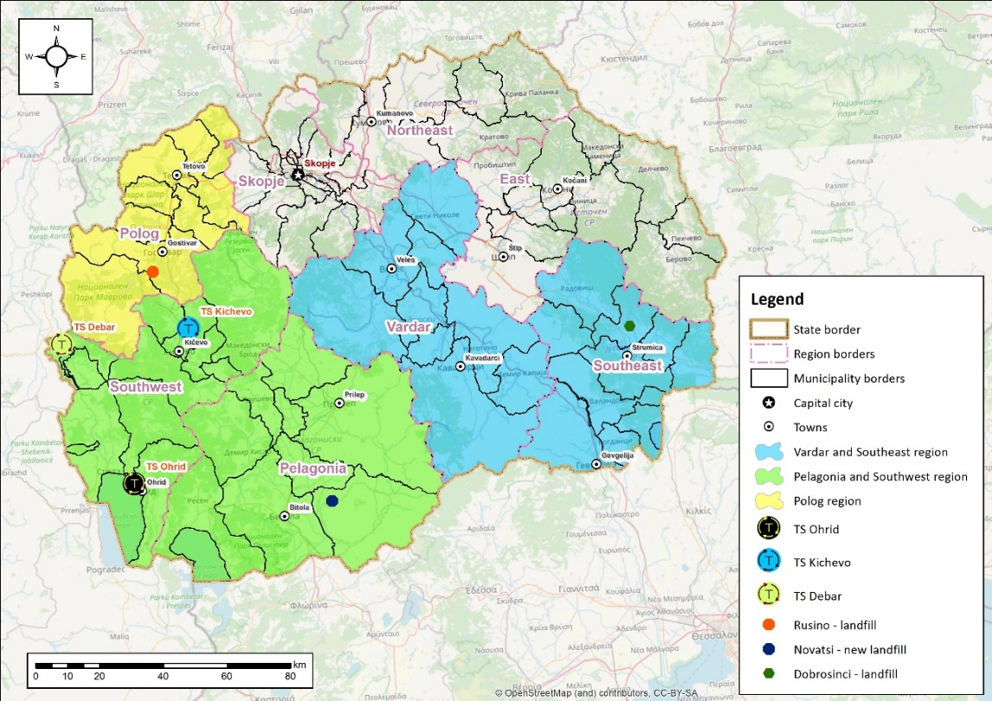
Figure 1: Overview map of the regions of Polog, VSE and PSW
Project benefits. The Project will improve the environmental and health situation in the Project regions by reducing environmental pollution. Some of the numerous benefits of the Project include: (i) fulfilment of strategic and operational objectives defined in national strategies; (ii) conversion of existing unused and heavily degraded areas into modern regional centres for waste disposal and recycling; (iii) reducing pollution caused by unsanitary disposal of waste; (iv) reducing emissions of greenhouse gases (GHG); and (v) improving the visual characteristics of existing heavily modified areas by planned recultivation of landfill sites.

Implementation responsibilities. The MoEPP will be responsible for Project implementation. It plans to establish a formal Project Implementation Unit to manage all Project activities. It will also be responsible for issuing permits and licensing, monitoring, data collection and inspection. Landfill operations (and operations of accompanying facilities) will be managed by regional public operators, while at local level the municipalities and their Public Utility Enterprises (PUE) will continue to be responsible for organising the collection, transportation and disposal of municipal waste. Currently, only one regional operator has been established to date (in Polog region) but is still not fully functional.

Future activities. Following the construction of regional sanitary landfills and accompanying infrastructure, the Government of North Macedonia also plans to close and rehabilitate the non-compliant landfills and dumpsites in all the Project regions in cooperation with municipalities. In the PSW region, there are 17 non‐compliant landfills and 197 dumpsites. (Dumpsite is an informal dumping area created by non-regulated dumping of waste by citizens, whereas a non-compliant landfill is an official non-sanitary municipal landfill which was or is used by the municipal public enterprise to dispose of waste.) In the Polog region, there are three non-compliant landfills and 73 dumpsites. In the VSE region, there are 18 non-compliant active landfills and 29 dumpsites. The MoEPP is currently in the stage of planning and seeking financial resources for this investment.

This document is a Non-technical Summary which provides a summary of the Project in non-technical language covering the Project background and description, the national environmental assessment process, the environmental and social (E&S) benefits/impacts, mitigation measures needed to structure the Project to meet the EBRD Environmental and Social Policy (2019), and the disclosure and communication requirements.

PROJECT PREPARATION BACKGROUND

The Project has been in preparation for a long time under the jurisdiction of the MoEPP as the responsible agency to conduct the environmental assessment and permitting procedures.

For the landfill in PSW region, a draft Environmental and Social Impact Assessment (ESIA) has been developed in line with national procedures, and will soon be publicised by the MoEPP. For the Polog region, an Environmental Impact Assessment (EIA) has been developed in line with national procedures and the procedure is in the final stage. MoEPP will issue a Decision for its approval by the end of June 2022. There is no assessment for the VSE region yet but the Ministry is in the process of preparing an application for a Western Balkans Investment Framework (WBIF) grant and technical assistance for the preparation of all necessary documentation for this region. It should be noted that once all locations for TS and composting plants are decided, these will be subject to separate elaborates in line with national legislation and separate approval decisions by the MoEPP.

An overview of the status of Project preparation for each region is provided below:
 | PSW region |  | Polog region | VSE region
 | Pelagonia | SW |  | Vardar | SE
Regional Waste Management Plan (RWMP) | RWMP 2016 | RWMP 2016 | RWMP 2020 | RWMP 2016 | RWMP 2017
Strategic Environmental Assessment (SEA) | SEA 2016 | SEA 2016 | SEA 2020 | SEA 2016 | SEA 2017
Feasibility Study (FS) | FS 2017 | FS 2017 | FS 2020 | FS 2017 | Pre-FS 2008
Environmental (and Social) Impact Assessment (EIA/ESIA) | EIA 2017 | EIA 2017 | EIA 2021 (first draft) | EIA 2017* | None
 | Consolidated draft ESIA for PSW region, 2021
Design documentation for landfill | Detailed Design 2017 |  | Detailed Design 2019 | None
Design documentation for TS/ composting plants | Detailed Design (for TS Ohrid and Kichevo) |  | None | Detailed Design (for TS Veles and Kavadarci)
* The EIA from 2017 refers to the Rosoman landfill which was previously planned, not to the now considered Dobrosinci landfill.

An independent gap analysis review of the national ESIA/EIA and other relevant documentation was completed in 2022 against EBRD/EU standards and best practice. While the national ESIA/EIA identify E&S impacts and mitigation measures as required by national standards, additional measures were identified through the gap analysis review and included in the Environmental and Social Action Plan (ESAP) as specific-time bound actions with clear responsibilities for implementation allocated between the MoEPP, the future contractors and landfill operators. It contains key actions aimed at achieving compliance with EBRD’s Performance Requirements and national legislation. The ESAP will constitute an integral part of the financing agreement with the EBRD.

LEGAL ASPECTS AND COMPLIANCE WITH RELEVANT LAWS AND POLICIES

National standards. The implementation of this Project requires compliance with a set of national laws and bylaws in the areas of environmental protection, water protection, air pollution, nature protection, solid waste management, etc. One of the key laws applicable to the Project is the new Law on Waste Management (2021) which was just recently adopted, repealing the 2004 Law. It sets a regional approach for waste management, i.e., establishment of a regional structure with municipalities jointly introducing regional systems for integrated municipal waste management. Accordingly, eight waste management regions have been created in the country. Another significant law is the Law on Environment (2005 with the latest amendments in 2018) which represents the framework for environmental protection in the country covering the waste sector as well. It establishes the principles for environmental protection and defines the roles and responsibilities of state administration bodies at central and local level, as well as legal entities and individuals.
As mentioned in the previous chapter, national environmental assessments have been conducted for the PSW and Polog regions in accordance with the regulations and standards of North Macedonia, whereas the assessment for VSE region is pending. Letters of intent have been submitted for initiating the procedure in the PSW and Polog regions, and scoping decisions have been issued by MoEPP.
EBRD/EU standards. In parallel to the national procedure, a due diligence assessment of the Project has been undertaken by EBRD to identify further mitigation and management actions to bring the Project into compliance with EBRD and EU requirements. Bank-financed projects are expected to meet good international practice related to sustainable development. In its EBRD’s Environmental and Social Policy 2019, EBRD has defined 10 specific Performance Requirements (PRs) for key areas of E&S issues and impacts as listed below:
PR 1: Assessment and Management of E&S Risks and Impacts
PR 2: Labour and Working Conditions
PR 3: Resource Efficiency and Pollution Prevention and Control
PR 4: Health, Safety and Security
PR 5: Land Acquisition, Restrictions on Land Use and Involuntary Resettlement
PR 6: Biodiversity Conservation and Sustainable Management of Living Natural Resources
PR 7: Indigenous Peoples (not applicable to this Project)
PR 8: Cultural Heritage
PR 9: Financial Intermediaries (not applicable to this Project)
PR 10: Information Disclosure and Stakeholder Engagement
The implementation of this Project will therefore enable North Macedonia to meet the national requirements and strategic objectives, as well as EBRD and EU requirements. The Environmental and Social Action Plan (ESAP) which has been approved by MoEPP and the EBRD includes a set of comprehensive mitigation measures to bring the Project into compliance with EBRD, EU and national legislation requirements.
A summary of the key impacts and mitigation measures are provided in the following chapters for each region separately.

PELAGONIA AND SOUTHWEST REGION

Project Location
Regional landfill. The proposed location for the regional sanitary landfill for the PSW region is in Novaci municipality, which is situated in the southern part of the country and extends to the south-eastern part of the Pelagonia plain. The micro-location of the regional landfill is 6 km northeast of Novaci (Figure 2).
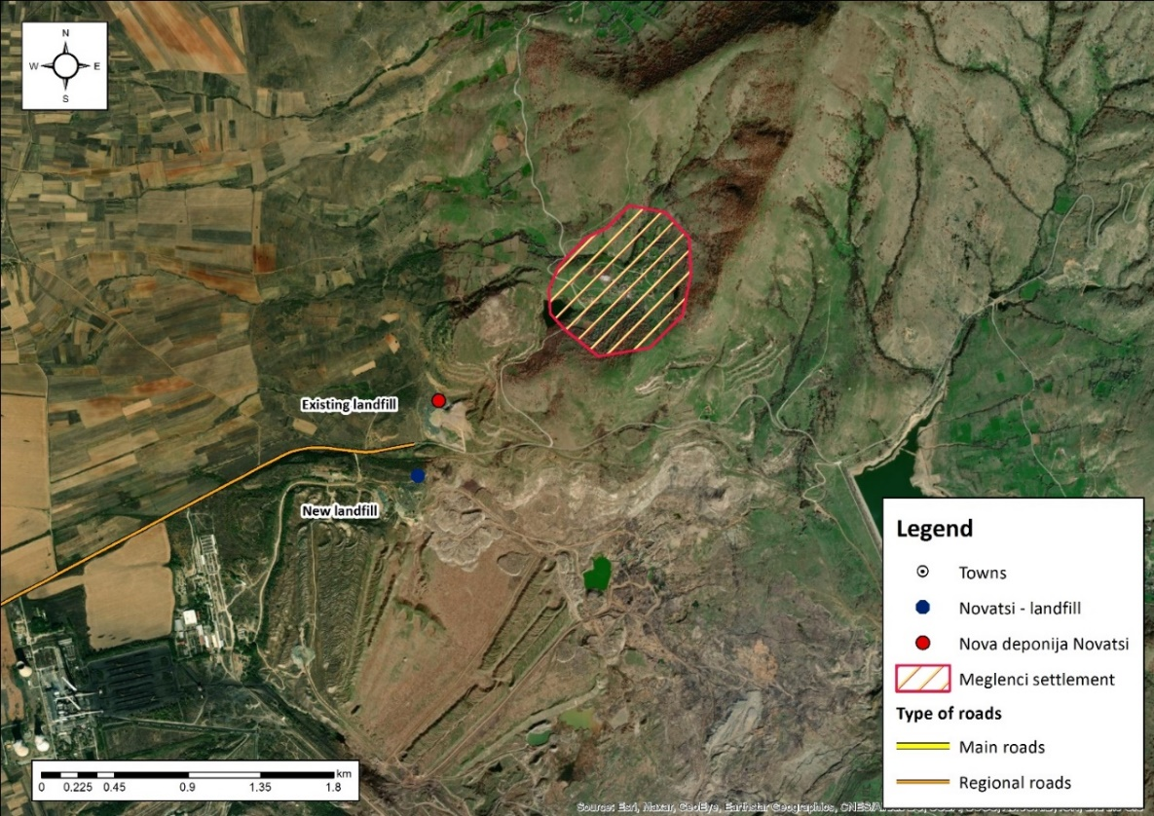
Figure 2: Micro location of the future regional landfill and the existing landfill "Meglenci"
The site is located on a gentle slope with an altitude of about 680 m. The location of the landfill is 1.3 km from the nearest house in the Meglenci village. The village is located uphill from the landfill. The planned landfill site is inside the industrial zone belonging to the depleted Suvodol lignite mine, still active and operated by Mine and Energy Combine REK Bitola. The area is easily accessible by roads and railway. The existing Meglenci landfill is shown in Figure 3.
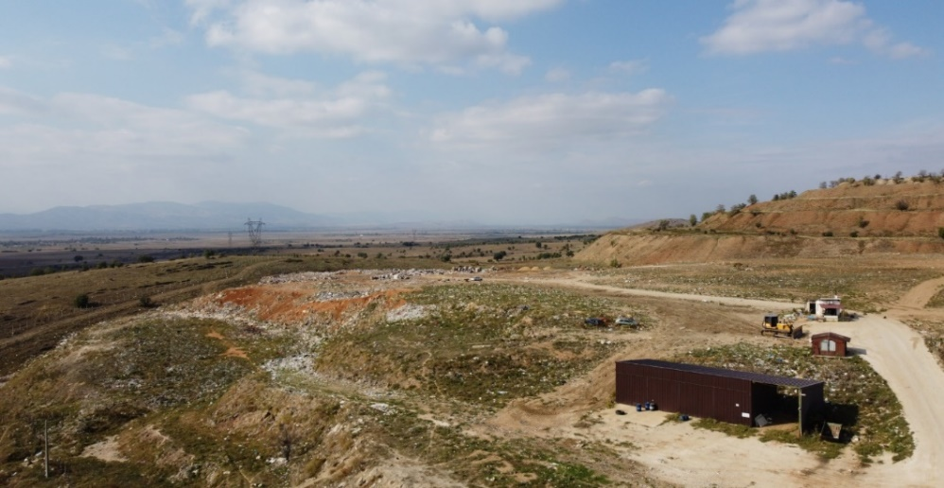
Figure 3: Existing non-compliant municipal landfill Meglenci
Transfer stations. The regional system will include five TS in total – three in SW region (in the municipalities of Debar, Kichevo and Ohrid), and two in the Pelagonia region (in the municipalities of Bitola and Prilep). Only the micro-locations of the TS in the SW region have been decided to date and will be formally approved by MoEPP.
TS Debar is located next to the municipal non-compliant landfill, just across the access road on the east side. South of the location is the municipality of Debar at a distance of 1 km. There are only two isolated houses in the vicinity of the TS (east and west), both at an air distance of around 300 m. The urban centre of Debar is around 1.2 km from the TS to the south. The nearest river is the Crn Drim, which flows west of the TS at a distance of 3.6 km. The location of TS is characterised by flat and stable terrains.
TS Kichevo is located south of the thermal power plant Oslomej at a distance of 700 m. To the north are the first residential houses of the Oslomej settlement and a church at a distance of 300m. The TS is at 7 km away from the centre of Kichevo municipality. There are no rivers near the site. South of the TS is the artificial lake Oslomej.
TS Ohrid is located next to the municipal non-compliant landfill Ohrid to the east, at a distance of 250 m. The nearest residential house in Orman is located at 200 m to the south. The centre of Ohrid municipality is on the east side at about 3 km. South of the TS is the Ohrid Lake at a distance of 1 km. On the east side, at about 1 km, flows the river Daljan, which flows into Ohrid Lake.

History of Project Development and Planning
Information on key milestones, preceding the Bank’s involvement in the Project, is given in Table 1.
Table 1: Project milestones – PSW region
Year | Activity | Description
2004 | Adoption of the Spatial Plan of Macedonia (2002-2020) | In the Spatial Plan, recultivation of the existing dumpsite in Novaci is planned, including designation of an area for a potential new sanitary landfill.
2005 | Development of the Operational Programme for Regional Development | The Operational Programme 2007-2013 adopted by the European Commission in November 2007 (amended in November 2010) foresaw the financing of implementation of the Project.
2015 | Start of the EuropeAID project | The Project titled “Preparation of necessary documents for establishing of an Integrated and Financially Self‐sustainable WM System in Pelagonia, SW, Vardar and Skopje Regions” was launched. The purpose was preparing a set of documents for Pelagonia, SW, Vardar and Skopje Regions including: Regional Waste Management Plans (RWMPs) and SEAs, Feasibility Studies, Cost‐Benefit Analyses, EIAs, Detailed Designs and assistance with preparation of tender documents for works and supply contracts for construction of waste treatment and disposal facilities, closure of non-compliant landfills/dumpsites and supply of equipment for waste collection and transferring of waste according to EU standards.
2016 | Development of Draft RWMPs | In 2016, Draft RWMP for the Pelagonia Region and Draft RWMP for the Southwest Region were developed.
2016-2017 | Development of Final SEAs | Public meetings for the RWMP and the SEA for both regions were held in 2016. The final SEA Reports for the RWMP for both regions were submitted to MoEPP in the same year. In 2017, MoEPP issued positive opinions on both SEA Reports.
2017 | Development of Draft EIAs | In November 2017, the draft EIA Studies separately for both regions were developed and submitted to the MoEPP following the national environmental impact assessment procedure.
2017 | Development of Final FS | In November 2017, final feasibility studies were developed separately for both regions.
2017 | Development of Detailed Design for Central Waste Management Facilities in SW | In November 2017, the final detailed design for central WM facilities in SW region was developed.
2018 | Consent for Project Implementation | In the framework of the national procedure, MoEPP issued the “Decisions on approval of EIA for implementation of the Project” for both regions.
2020 | Report on Solid Waste Management in 4 Regions - Baseline and Finance Options Study | A report was prepared to evaluate the most appropriate financing structure for WM systems in four regions. The conclusion was to implement two solid WM systems in four regions; one for Vardar and SE region and one for Pelagonia and SW region.
2020 | Official merging of Pelagonia and SW regions | The Government of North Macedonia decided to merge the two regions to reduce the number of regional landfills.
2021 | Submission of letter of intent for initiating the national EIA procedure in the PSW region | In July 2021, the “notification of intention to carry out an EIA procedure” was submitted to MoEPP and published on its website. MoEPP issued the scoping decision in October 2021.
2021 | Preparation of the ESIA Study for PSW | The process of consolidating two separately developed EIA studies into one integrated ESIA study for the PSW region began in 2021. The study has not been submitted to the MoEPP yet. Two online public disclosure and hearings events were held for the draft consolidated ESIA in August 2021, one for the SW region and the other for the Pelagonia region. The meetings were attended only by several government stakeholders.

Summary of Environmental and Social Baseline
This section provides a summary of the national ESIA study (2021) for the planned landfill location as well as information collected during the independent E&S due diligence process conducted on behalf of EBRD throughout September 2021 to February 2022. The summary also identifies the need to conduct additional collection of information/data and required mitigation measures and actions that need to be implemented as part of the ESAP. This will be done through conducting a Supplementary E&S Analysis to address the identified gaps in the national ESIA regarding the planned landfill location. Furthermore, once the locations of transfer stations in this region are formally approved, the MoEPP will prepare separate “elaborates” (Small-scale E&S Assessment Studies) which will be subject to separate approval decisions. These additional analyses may result in the identification of additional impacts and associated measures to mitigate such impacts.
Biodiversity. 13 general habitat types can be distinguished in the area including the planned landfill in PSW region and the 500m buffer zone, including two habitat types listed in Annex I of the Habitats Directive: 6220 Pseudo-steppe with grasses and annuals of the Thero-Brachypodietea and 6510 Lowland hay meadows (Alopecurus pratensis, Sanguisorba officinalis). Annex I habitats meet the criteria for priority biodiversity features and therefore highlight the need for Critical Habitat Assessment and ensuring “no net loss” as given in the EBRD E&S Policy. Out of approx. 16.15 ha, the landfill will mainly directly impact already degraded habitats, namely E5.1 Anthropogenic herb stands – 12.43 ha. There are no endangered or endemic flora or fauna species in the area. The planned landfill site and its buffer zone marginally overlap with the boundary of the IBA site (MK024) Pelagonia. Supplementary rapid biodiversity surveys, related to habitats and birds, need to be collected during spring/early summer which will further facilitate the Critical Habitat Assessment. Relevant actions have been included in the ESAP.
Water. The site is located in the mid part of Crna River catchment area, in the Pelagonia Valley. Crna River flows at 6.5 km from the landfill location and it represents the main drainage artery for whole area. Regarding the project site, there are two small rivers, Sinjevska and Oreovska, at about 3 km to the northeast from the site. There is an artificial lake in the vicinity of the landfill site belonging to REK Bitola, as well as mineral springs in Germijan and Medzitlija. At around 2.5 km from the location, there is a set of wells that drain the water from existing lignite mine excavation area. Groundwater of the Pelagonia Valley is more extensively exploited for water supply, irrigation, and drinking water bottling. Additional information needs to be collected on possible sources of drinking water near the landfill site, water quality and water demand as well as options for water supply at the future landfill. Relevant actions are included in the ESAP.
Air quality. Air quality in the area is poor due to uncontrolled waste disposal and burning which have resulted in emissions of pollutants (mainly СО₂, methane and organic compounds), odours and dust in the air. Specific odour emission rate values from different emitting surfaces are evaluated in the ESIA. Odour emissions might occur during the process of biodegradation of the organic fraction of waste. There are no sensitive odour recipients in the vicinity of the landfill site.
Land. The landfill site is located inside the depleted Suvodol lignite mine area, whose one part is still active and operated by the Mine and Energy Combine REK Bitola. The area around the landfill site is composed of Precambrian micaschists, Pliocene sediments and proluvial sediments. The terrain is very complex with very steep slopes and several small flat levels at different altitudes. However, the location of the future sanitary landfill can be classified as a stable terrain. The wider area of the landfill is characterised as an artificial surface. Additional information should be collected on baseline soil quality to monitor any future impacts. Relevant action is included in the ESAP.
Climate. The area has a temperate continental climate with wet and cold winters and warm, dry summer. The average annual temperature is 11.9 °C. The lowest temperature of -6.8 °C was recorded in January 2000, and the highest temperature of 25,9 °C was recorded in July 2012. The coldest month is January. Average annual rainfall is 600 mm/m². The prevailing winds are northeast. Climate change projections indicate an increase in temperature and decrease in precipitation throughout the period 2025-2100. Additional site-specific data and information will be collected required for the climate assessment, including calculation of GHG emissions.
Landscape. The altitude of the area ranges from 616 to 650 m (mean average 637 m). The landfill site is not visually isolated from the local road network and the road R-1311, whereas visual isolation from the closest settlement (Meglenci) as well as nearby settlements is at a medium level. The site is located next to an existing landfill and lignite mine, so important anthropogenic components of the landscape have been changed significantly because of continuous lignite extraction during the last 30 years.
Noise and vibration. Noise levels are elevated in the area due to the existence of a coal mine, power installations and unsound waste collection and disposal. Additional baseline noise survey will be conducted as part of the ESAP actions.
Waste and materials management. Based on the current population data and waste generation rates, the estimated amounts of generated waste for the municipalities of the PSW region in 2021 is 137,358 t/year. Regarding waste composition, the highest share is garden and other biodegradable waste. The waste management system in the PSW region is largely based on the “collect and dump” concept. Several municipalities cooperate with system operators that have been formed as a result of the national extended producer responsibility legislation and policies. There are numerous small and large dumpsites with various types of waste (municipal, construction/demolition and agricultural waste). Additional information on projected waste generation and management will be collected in order to develop and implement an appropriate Operational Waste Management Plan to monitor the amount of collected waste quantities and separately collected waste suitable for further recycling or treatment, as well as to develop robust, effective and pragmatic system for segregated collection of waste at the source and identify timeframe for its deployment in time for the commissioning of the EU-compliant landfills.
Land requirements. Both the existing and the planned Novaci landfill sites are within the boundaries of the coal mine Suvodol. The mine is owned and operated by the governmentally owned company (“ESM”) for production of electricity. Land ownership has not been formalised entirely, even though the land has been actively used by ESM for around 40 years – cadastral data show that some land plots are still registered in the name of individuals which means that procedural land ownership issues will need to be formally resolved prior to start of landfill construction. There is no land use adjacent to the landfill.
Population and nearest settlements. The closest settlement is Meglenci (northeast of the proposed site) at a distance of 1.2 km, located uphill from the landfill. This settlement officially has 18 inhabitants (2015 estimate) but is mostly empty during the winter periods. Some domestic pigs and cattle travel from the village of Meglenci toward the landfill daily and eat organic food at the landfill site. Other surrounding settlements include Novaci (5.3 km), Dobromiri (5 km) and Golno Aglartsi (4.4 km).
Cultural heritage. There are no cultural and historical heritage sites at or around the planned landfill, or archaeological sites within 3 km.
Waste pickers. There are approximately 10 Roma families who live on the outskirts of the City of Bitola and collect waste on the existing landfill daily.
Access road to the landfill. The landfill site can be accessed from Novaci which is connected to the road network with regional road R-1311. The road passes through the settlements Logovardi and Novaci. The road has sufficient capacity to accommodate waste truck traffic and there is currently no alternative route for waste transport.

Summary of Environmental and Social Impacts and Measures
This section provides a summarised description of impacts and mitigation measures for construction and operation of the planned landfill based on the assessment provided in the national ESIA (2021) as well as the results of the due diligence process conducted by EBRD. Where applicable, it highlights the need to conduct additional assessments or undertake additional mitigation measures, included within the ESAP as implementable actions.
Biodiversity. Construction activities will lead to emissions of dust and other air pollutants noise and vibrations; and vegetation removal and degradation of habitats. There is also a potential for pollution releases to soil, surface water or groundwater. Therefore, measures to mitigate these impacts and risks include:
- control of construction methods and equipment
- careful planning of construction works
- covering of excess material and storage for further re-use
- avoiding equipment emitting more than 70dB
- clearance of vegetation only in the operational area
- avoidance of pastures and grassland in the surroundings
- education of workers
- strict control of waste and careful selection of the location for the disposal of construction waste.
Operation impacts and risks are expected to be minor and related to: formation of landfill gas (mainly impacting birds); leachate and runoff from the landfill; dust emissions; carried small materials and odour; concentrated presence of rodents and birds; noise due to landfill operation and increased traffic; and loss of conservation value. Mitigation measures planned for this phase are:
- equipping landfill with gas and leachate collection and treatment systems
- waste residues to be compacted and covered regularly
- landfill to be fenced and landscaped (e.g., planting of a green buffer zone)
- impacts from dust to be monitored
- inspection of vehicles to be done regularly
- installing physical barriers for rodents and preventing their access to edible waste, and
- periodical monitoring of noise levels.
Additional rapid biodiversity surveys with a focus on habitats and birds at the planned landfill site in spring/early summer are included in the ESAP. Potential impacts to be analysed upon completion of the surveys relate to spread of invasive species, and possible negative impacts on IBA site Pelagonia and critical habitats and/or priority biodiversity features potentially established by critical habitat assessment. If any additional impacts are identified upon completion of rapid biodiversity and critical habitat assessments, additional mitigation measures targeted at species and habitats of concern, and at IBA site Pelagonia will need to be proposed.
Water. Construction impacts and risks are mainly related to: generation of municipal wastewater and generation of surface runoff that contains suspended soil particles and/or pollutants; and use of machinery and vehicles and hazardous liquid waste. Mitigation measures in this phase include:
- establishing sanitary facilities at the worksite
- proper management of borrow pits
- preventing accidents and leakages
- avoiding maintenance and refuelling of machinery and vehicles on the construction site, avoiding infiltration
- maintenance and refuelling to be done in appropriate facilities
- materials such as lubricants, grease, fuels, and chemicals to be stored properly.
During operation, there is a risk of groundwater pollution through leachate infiltration caused by damage or failure of the liner system or the collection system or from damage occurring in the structures. This risk will be mitigated by:
- installing a mineral layer which provides protection to soil, groundwater and surface water
- installing a bottom system
- proper drainage pipes and leachate collection system
- regular monitoring of groundwater
- emergency plan for pollution in case of liner failure,
- providing the top cover of the landfill and soil cover
- construction of a flood protection system
- proper maintenance and clearing of circumferential ditches
- frequent visual inspections and surface water monitoring 3 times a year; and monitoring of wells once a month in the first year of operation and every 3 months after that and after closure of the sanitary landfill.
Additional mitigation measures included in the ESAP are related to (i) performing additional baseline surveys, (ii) collecting information on the water supply of the nearby local communities and water demand and options for water supply at the future landfill, (iii) conducting hydrogeological investigation and risk assessment, (iv) developing a monitoring plan for water quality in the pre-construction phase, with clearly defined sampling points and parameters to monitor, (v) revising the water quality monitoring plan given in the ESIA for the operation phase, (vi) construction of a leachate collection pipe system, (vii) preparation and implementation of Landfill and Dumpsite Remediation and Closure Plan, (viii) including water specific mitigation measures in construction and operation plans, and (ix) preventing flooding and ingress of pollutants into and their spreading by water by prioritising cleaning of dumpsites that are near the surface flows.
Air quality and odour. Two main sources of impacts during construction will be exhaust gases from vehicles and construction machinery and dust emissions from earthworks and excavation activities. The following mitigation measures are foreseen:
- careful manoeuvring of vehicles at the construction site
- water sprinkling during dry and windy weather
- daily cleaning of the access points of the area
- covering of the transported inert materials
- temporary storage of excavated soil
- construction works will be limited during daytime.
During landfill operation, landfill gases, CO₂ and CH₄, and dust will be the main sources of negative impacts. The measures include:
- proper establishment, operation and maintenance of a de-dusting and deodorisation system
- proper and regular soil cover applications on the landfill
- every 3 months, monitoring of the concentration of VOCs, ammonia, hydrogen sulphide and dust particles, using a biofilter, nitrogen compounds (NOx) and solid particles of dust at the biogas plant; monitoring of meteorological parameters; monitoring of general and specific indicators of air pollution at the project location.
Additional mitigation measures included in the ESAP are related to (i) development of a monitoring plan for air quality in the pre-construction phase, with clearly defined sampling points and parameters to monitor, (ii) revising the air quality monitoring plan given in the ESIA for both construction and operation phases, (iii) defining odour management measures for the operation phase, (iv) developing a Landfill and Dumpsite Remediation and Closure Plan, (v) including air and odour quality specific mitigation measures in construction and operation plans.
Soil. Impacts and risks during construction can be the result of excavation works; soil degradation after humus layer removal; soil contamination due to leakage of liquid substances from vehicles and machinery and accidental spillage and failure of infrastructure; inadequate management of sanitary and other wastewater; and inappropriate disposal of waste material. The proposed mitigation measures in this phase are:
- excavated soil quantities to be stored or otherwise disposed of accordingly
- quantities that will be obtained during earthworks for foundation of buildings and disposal cells excavation can be used for daily waste cover
- contamination of soil from grease and fuels to be avoided with the use of absorption materials, and
- traffic of heavy construction vehicles to be limited only to the construction site.
Impacts and risks during operation can be the result of inappropriate collection and treatment of generated wastewater; leakages due to malfunction or damage of the liner system, drainage/leachate collection system, basins and structure; accidental spillages during refuelling; and maintenance and scattering of light objects in the wider area. The following mitigation measures will therefore be implemented:
- landfill control systems to prevent unwanted release of landfill gas into the soil
- waste produced in the facilities to be directed into the waste treating process
- waste truck tires to be cleaned and waste and waste residue transportation to be done with proper care to prevent scattering of small particles.
Additional mitigation measures included in the ESAP are related to (i) performing additional baseline surveys (ii) revising the soil quality and erosion monitoring plan given in the ESIA for both construction and operational phases, (iii) defining specific soil quality and erosion mitigation measures for the construction and operation phases, (iv) defining physical and biological reinstatement measures, and (v) implementation of specific landfill stability measures for both construction and operation phases and development of Construction and Operation Landfill Erosion Control Plans.
Climate. Climate change impacts during the construction phase are characterised as positive, since GHG emissions will be reduced in comparison to the current situation. The operation of the landfill facilities will contribute to GHG emissions such as methane, carbon dioxide etc. No measures are foreseen in the existing ESIA.
The ESAP includes a requirement to carry out a climate risk assessment including calculation of GHG emissions. Appropriate mitigation measures will be included in the design and operation plans.
Landscape. Landscape impacts in the construction phase are characterised as minor and short-term. The ESIA considers a “curtain” of vegetation around the construction site and landfill of a low height, and adequate organisation and maintenance of the construction site through good housekeeping. Regarding operation, impacts from traffic increase are characterised as minor while the impact of aesthetic deterioration will be insignificant. It is to be noted that no visually sensitive receptors are found in the vicinity of the site.
As included in the ESAP, landscape impact evaluation will need to be revised and include potential landscape disturbances as a consequence of the presence of construction equipment and machinery, as well as the construction of landfill facilities. Mitigation measures for landscape alteration and visual impacts will be revised and will include implementation of progressive clean-up and physical reinstatement of surfaces, as well as conduction of appropriate biological reinstatement afterwards.
Noise and vibration. The main sources of increased noise levels during construction phase will be stationary sources (mechanisation) and mobile sources (vehicles) inside the construction area. Standard mitigation measures will be applied, such as:
- regular inspection and maintenance of equipment
- construction works to be limited only to daytime
- noise barriers at the facility’s borders and surrounding roads
- using a controlled environment for the sorting station or isolating machinery equipment, and
- establishing necessary environmental monitoring at the site.
Noise levels during operation may increase due to movement of transport vehicles and operation of machinery on the site, but the impact is considered to be negligible. The following mitigation measures will be implemented:
- design of the equipment in line with national and EU noise regulations
- the mechanical facilities and machines to be restricted and isolated in closed facilities
- regular service and replacement of machinery and trucks
- establishing a noise monitoring system, and
- measures for protection of workers against noise.
Additional impacts to be analysed are related to increased noise on the population living in the Novaci settlement (caused by passing of trucks transporting waste) and Meglenci village (operational noise). Additional mitigation measures included in the ESAP are (i) performing additional baseline survey on noise intensity, (ii) additional specific noise abatement and mitigation measures for pre-construction, construction and operation phases, (iii) including specific measures in construction and operation plans.
Waste and materials management. In the construction phase, spoil and construction waste will be generated, and will be used for landscaping and covering the landfill area. Construction waste will need to be adequately disposed on the landfill for construction waste or stored and used as landfill cover in the operation phase, while large amounts of spoil waste are not expected to be generated.
Mitigation measures included in the ESAP are related to (i) developing a Construction and Operation Waste Management Plan, (ii) developing a Construction and Operation Landfill Erosion Control Plan, (iii) developing of robust, effective and pragmatic system for segregated collection of waste at the source, (iv) developing a Landfill and Dumpsite Remediation and Closure Plan, and (v) construction of material recovery facilities.
Labour/working conditions and occupational health and safety (OHS). During construction and operation, there will be some OHS risks commonly associated with activities of constructing and operating a sanitary landfill. It can be expected that local and regional employment will be a positive impact of both phases. Mitigation measures in the national ESIA are focused on the operation phase and include detailed measures such as workers training, use of PPE, adequate ventilation in all processing units, etc.
The ESAP includes a requirement for MoEPP to require contractors and regional operator in PSW region to develop and implement OHS measures during the construction and operation phases respectively, as well as to ensure that the future regional operator develops HR policies and procedures fully in line with national law. The contractors and regional operator will also need to develop an internal grievance procedure for workplace concerns.
Community health and safety (H&S). In the construction phase, impacts on the population include construction-related nuisances (noise, vibrations, dust, etc.). Standard measures in the construction phase are defined, such as:
- limiting construction works to daytime
- proper disposal of construction waste, and
- avoiding contamination of surface and groundwater with any oils and fuels.
H&S impacts and risks related to landfill operation include groundwater contamination in case of failure of the liner system of the landfill; odour generated by landfill operation; air emissions from waste haulers/tractors; litter, vermin and pests’ proliferation; overpopulation of birds in the landfill area; and health risks from major hazards (explosions, fire, gas diffusion through soil) during landfill operation. Detailed measures are defined for this phase, such as:
- installation of a fire detection and fire protection system
- installation of an odour control system
- installation of a noise control system, and
- monitoring of air quality, groundwater quality, noise levels, etc.
The ESAP includes a requirement for MoEPP to require contractors and regional operator to develop and implement community H&S measures during the construction and operation phases respectively. A Project-specific grievance mechanism will be available to address community concerns.
Traffic and transport. During construction, increased traffic may lead to changes of traffic conditions but this impact is not expected to be significant. No measures for this phase are foreseen in the ESIA. During operation, the impact of increased traffic on the local road network due to the movement of waste trucks will be negligible because the surrounding area is already degraded and with low existing traffic levels. To avoid negative impacts in this phase:
- routes of waste trucks should be carefully planned to avoid sensitive receptors, and
- a traffic study should be conducted for movement of waste trucks in case of a 10% increase in traffic load.
The ESAP includes a requirement to carry out additional analysis of traffic impacts due to the movement of waste trucks in the operation phase and evaluation of the possibility to link the planned expressway in the region (to bypass the city and populated settlements) to the landfill in order to minimise traffic and transport related impacts. The MoEPP will also need to ensure that contractors and regional operator in PSW region develop and implement traffic and road safety measures during the construction and operation phases respectively.
Cultural heritage. No impacts on cultural heritage are expected as there are no cultural, historical or archaeological sites nearby.
However, the ESAP includes a requirement to develop a Chance Find Procedure to mitigate any impacts on previously undiscovered chance finds during construction.
Impacts on waste pickers. There are active waste pickers at the Novaci landfill (approximately 10 Roma families present on the landfill daily). Their livelihoods will be impacted as these people will no longer be able to continue collecting waste.
Therefore, a Livelihood Restoration Framework has been developed as part of this Project. The Framework is a preliminary document that outlines the approach to livelihood restoration and will require more information and data once the full Project description is finalised. The ESAP contains a requirement to develop a Livelihood Restoration Plan to address specific impacts.

POLOG REGION

Project Location
Regional landfill. The regional sanitary landfill for the Polog region is planned at the location of the existing non-compliant landfill Rusino in the municipality of Gostivar. The springs of the largest Macedonian river Vardar are located in this municipality. The site is about 8 km south of the Gostivar urban area, 2 km from the Sushica village and 1.8 km from Mitro Krsti village (Figure 4). The E-65 highway that connects Gostivar with Skopje/Kicevo/Ohrid passes 3 km east of the site. Mavrovo Lake is located about 8 km south-west from the site.
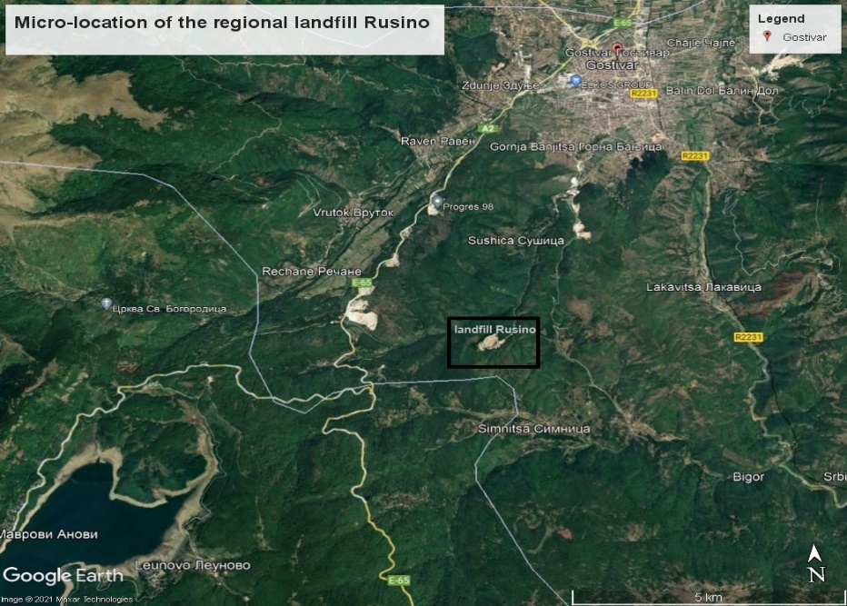
Figure 4: Micro location of the regional landfill and the existing landfill “Rusino”
The site is located on the extreme northern slopes of Mount Bistra at an altitude of about 780 m. However, there is no risk of landslides, as the terrain is stable. The site is positioned on the upper parts of a large and deep valley through which the Sushichka River flows. This valley descends to the south towards Gostivar, which is situated at an altitude of about 560 m. A few kilometres to the west, the steep slopes of Shar Mountain rise above the area, while to the south, the terrain rises slightly to 1,000 m above sea level reaching the border with the municipality of Mavrovo Rostuse. The existing Rusino landfill is shown in Figure 5.
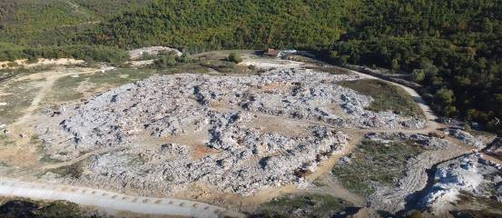
Figure 5: Existing non-compliant municipal landfill Rusino (central part)
Transfer station and composting plants. The definite location of the TS and composting plants are not known.

History of Project Development and Planning
Information on key milestones, preceding the Bank’s involvement in the Project, is given in Table 2.
Table 2: Project milestones – Polog region
Year | Activity | Description
1998 | Selection of landfill location | The Ministry of Urban Planning, Construction, Traffic and Environmental Protection issued a decision on granting land for a temporary landfill in the former Municipality of Dolna Banjica (now called the Municipality of Gostivar).
2000 | MoEPP delegates responsibility to the municipality of Dolna Banjica to manage the landfill | The MoEPP adopted a decision on limiting the site of the temporary landfill for disposal of municipal solid waste from the municipality of Dolna Banjica to the area of the clay exploitation site (Rusino), and delegating landfill management responsibility to the Municipality of Dolna Banjica.
2003 | Municipal Council Decision on the new municipal landfill Rusino | The Municipal Council of Dolna Banjica adopted a decision to use the Rusino clay exploitation site as the new municipal landfill Rusino. This is when the Rusino site became a municipal waste disposal site.
2004 | Adoption of Spatial Plan of Macedonia | The Spatial Plan (2002-2020) was adopted in 2004. According to the Spatial Plan, the existing dumpsite in Rusino was planned to be closed and recultivated, while the construction of a regional sanitary landfill was planned in the Municipality of Vrapciste. However, the Vrapciste site could not be approved by state authorities as it is very close to the protected area National Park Sara Mountain and in the catchment area of Rasce spring).
2005 | Inter-municipal agreement between Gostivar and Tetovo on establishing the joint landfill | Municipalities of Gostivar and Tetovo signed an agreement for establishing the inter-municipal solid waste landfill Rusino to accept waste from these two municipalities, and to be financed and managed by these municipalities.
2008 | Pre-feasibility assessment of 8 locations for the regional landfill for Polog Region | A Pre-feasibility Assessment was carried out to determine the feasibility of establishing a regional system for 9 municipalities in Polog including the selection of a location for the regional landfill. The Rusino location in Gostivar was chosen as the most favourable.
2015 | Inter-municipal agreement on establishing a WM system in the Polog region | 9 municipalities of the Polog region signed an inter-municipal agreement on joining together and establishing a waste management system. An Inter-Municipal Waste Management Board was established based on this agreement.
2017 | Signing of a bilateral agreement on financial and technical support to establishing WM in the Polog region | The Government of N. Macedonia signed a bilateral agreement with the Government of Switzerland for financial and technical support for improving solid WM in Polog.
2019 | Completion of the Detailed Design for Rusino regional sanitary landfill | The Detailed Design for upgrade of the existing landfill Rusino to EU or nearly EU standard landfill was completed. It foresees the construction of „landfill-on-landfill “, meaning that the existing landfill be covered with a liner and serve as a foundation for the new landfill with a leachate collection system added. Landfill gas collection and utilisation is included as an element of the design.
2019 | Development of RWMP | The Draft Regional Waste Management Plan (RWMP) for the Polog region was prepared in 2019.
2019-2020 | Development of SEA | The SEA for the Draft RWMP for Polog was prepared in 2019, and approved by the Ministry in 2020.
2019- 2020 | Decision on establishing a joint public enterprise in Polog | In the period December 2019-January 2020, municipalities in Polog signed a decision on establishing the Joint Public Enterprise (JPE) “Rusino-Polog”. The municipalities also signed an agreement to regulate their mutual rights and obligations.
2020 | Submission of Letter of intent for initiating the national EIA procedure | In April 2020, the Letter of Intent for implementation of the Project was submitted to the MoEPP, based on which the MoEPP issued a decision in August 2020 on the need to conduct an EIA procedure and on scope of the EIA study.
2020 | Development of Final FS | In June 2020, the final Feasibility Study for improvement of solid waste management services in Polog was prepared.
2019-2020 | Protests by the residents of Gostivar | In July 2020, the local communities of Gostivar (Cerovo, Gorna Banjica, Dolna Banjica, Simnica, Grudeica, Benjanica, Ciglana 1 and 2 and Fazanierija 1 and 2) complained about the high level of pollution caused by frequent fires at the Rusino landfill, the damaged access road, as well as general dumpsite conditions. A series of meetings were held with the representatives of the “Stop Rusino” initiative which resulted in the signing of an agreement in the form of an Action Plan between the MoEPP and the Stop Rusino.
2020 | Development of Final RWMP | The final RWMP was prepared in October 2020, with a planning horizon of 10 years (2019-2029).
2021 | Implementation of “quick-win-measures” | In order to improve the current conditions and to ensure control of impacts, quick-win engineering measures started to be implemented at Rusino dumpsite.
2021 | Preparation of urban planning documentation | The procedure for preparation of the Urban plan for the landfill (state urban planning documentation) and infrastructural design for the newly designed access road to Rusino landfill started in 2021. The process is still ongoing.
2021 | Development of EIA Study | In December 2021, the national Draft EIA study was completed. It has been publicised by the MoEPP, and the procedure is in the final stage. MoEPP will issue a Decision for its approval by the end of June 2022.

Summary of Environmental and Social Baseline
This section provides a summary of the national EIA (2021) for the planned landfill location as well as information collected during the independent E&S due diligence process conducted on behalf of EBRD throughout September 2021 to February 2022. The summary also identifies the need to conduct additional collection of information/data and required mitigation measures and actions that need to be implemented as part of the ESAP. This will be done through conducting a Supplementary E&S Analysis to address the identified gaps in the national EIA regarding the planned landfill location. Furthermore, once the locations of transfer stations and composting plants in this region are formally approved, the MoEPP will prepare separate “elaborates” (Small-scale E&S Assessment Studies) which will be subject to separate approval decisions. These additional analyses may result in the identification of additional impacts and associated measures to mitigate such impacts.
Biodiversity. A total of 16 general habitat types are registered in the project area, 10 of which are natural and seminatural habitats. Habitat mapping has shown that, out of 13.15 ha under direct impact, landfill construction will mainly impact already degraded habitats belonging to the existing landfill, namely, J6.2: Household waste and landfill sites – 12.73 ha. The following recorded habitats are of EU concern: 92A0 Salix alba and Populus alba galleries, 6510 Lowland hay meadows (Alopecturus pratensis, Sanguisorba officinalis), 3290 Intermittently flowing Mediterranean rivers of the Paspalo-Agrostidion and very likely presence of of 91M0 Pannonian-Balkanic Turkey oak – sessile oak forests. No flora or fauna species are of conservation concern. Six allochthonous plant species were recorded. No protected areas will be impacted. The ESAP contains a requirement for an additional walkover in a suitable season (spring or early summer) to establish the presence of 91M0 habitat type with a higher degree of certainty which may trigger a critical habitat assessment.
Water. The municipality Gostivar belongs to the catchment area of the river Vardar. There are valleys on north-west and south-east side of Rusino site. Both valleys belong to the river Sushica which is of non-permanent character and dries during the summer months. Watercourses near the landfill site are filled with illegally fly-tipped industrial waste. A few km to the south-west of the landfill is the Mavrovo Lake. The site is outside the boundaries of protected areas and not within planned water reservoirs as defined by the Water Management Plan of N. Macedonia. The landfill site is within the Level III sanitary protection zone of the Vrutok spring but not within the drainage zone of the spring. The terrain categorisation ranges between low porousity to impermeable ground, and is thus suitable for construction of the landfill. The depth of groundwater is at approximately 4 m below ground surface. Negative impacts of leachate on the quality of both surface and groundwater in the landfill area are identified. Additional information will need to be collected on possible sources of drinking water near the landfill site and availability of groundwater resources for needs of future landfill facilities as part of the ESAP actions.
Air quality. The average daily concentrations of particulate matters (PM₁₀) up to 10 micrometres are exceeded in the municipality of Gostivar during autumn and winter months. Measurable concentrations of landfill-specific gases (CH₄, NH₃, NO_{x}) at Rusino site are not detected, given the fact that these are diffuse emissions (open landfill area). Additional information will be collected on emissions of landfill gasses from the current dumpsite as part of the ESAP actions.
Odour. High unpleasant odour at the site is not detected at 500 m from the existing landfill. Odour modelling has been developed for two project phases: (i) current conditions and (ii) constructed sanitary landfill. Odour emissions have only local significance, and higher concentrations outside of the landfill zone should not be expected in any case.
Land. The ground is composed of metamorphic rocks (Paleolithic geological phyllites F) and is categorised as low porosity to impermeable. Above the phyllites are pliocyte river sediments, above which there is a layer of deposited waste. The geological base of the site is composed mostly of clay or shale. The subsoil is natural, compacted soil, which can be considered resistant to subsidence. The mountainous relief of Polog valley has a hilly-mountainous character and consists of the mountains Suva Gora (1,853 m asl) and Shar Planina (2,748 m asl). At an altitude of 300-600 m the region has a dominant valley relief. The entire area of Polog is pedologically explored. Additional information will be collected on soil quality, local geology, soil stability and risk of subsidence as part of the ESAP actions.
Climate. The climate is characterised by cold winters and hot and rainy summers. Winter temperatures can drop below 20 °C, while in summer they can rise up to plus 40 °C. The region is characterised by a high rain precipitation rates, while snow falls for about 90 days per year. The winds in Gostivar have different directions, strengths and frequencies. The prevailing wind direction is from the north and from the south. Regarding climate changes, the predicted average temperature rise is between 1.0 °C in 2025 and 3.8 °C in 2100, while average precipitation reductions are in the range from -3% in 2025 to -13% in 2100. As included in the ESAP, additional site-specific data and information will need to be collected on climate-related hazards and a climate risk assessment including calculation of GHG emissions.
Landscape. The Project area runs through complexes of habitats that can be divided into following sections: (i) degraded and good developed Italian and Turkey oak forest, as well as riparian willow-poplar belts and (ii) riparian vegetation (willow-poplar belts) and fragments of mature and degraded Italian and Turkey oak forests, as well as small fragments of meadows, agricultural lands and man-made products. Additional information will be collected on natural and man-made landscape alteration, as well as visual impact of the existing or future landfill sites in the current landscape as part of the ESAP actions.
Noise and vibration. The area is defined as an area with IV degree of noise protection, which means that in this area noisy interventions in the environment are allowed. Additional baseline noise survey will be conducted as part of the ESAP actions.
Waste and materials management. Based on the current population data and waste generation rates, the estimated amounts of generated waste for the municipalities of the Polog region in 2021 was 103,157 t/year. In terms of waste composition, garden and other biodegradable waste has the highest share. Waste collection services are mostly provided using communal collection points where waste producers such as households, commercial entities and institutions store their waste. Door-to-door collection services are mainly provided in main urban areas. Waste management services are provided by PUEs in part of the municipalities and by concessionaires (private companies) in others. There are numerous small and large dumpsites with various types of waste (municipal waste, construction and demolition waste, agricultural waste). Additional information on presence of industrial waste currently disposed at the dumpsite will be collected, and the issue of sourcing and disposal of materials for landfill compaction and physical reinstatement will be addressed as part of the ESAP actions.
Population and nearest settlements. The existing dumpsite and future regional landfill is about 8 km south of the Gostivar urban area, 2 km from the Sushica village and 1.8 km from Mitro Krsti village.
Waste pickers. A single-headed Roma family, living in a very small container (kiosk) on the landfill, collects waste metal and small electric appliances, and sells it to the local scrap metal reselling companies. The family has been living on the landfill for six years. There is also a small weekend house attached to the landfill, which belongs to an individual who used to buy plastic bottles from waste pickers on the landfill and from Gostivar, and resell them to companies that recycle plastic elsewhere in the country.
Land requirements. No land needs to be acquired outside of the borders of the existing landfill. However, land ownership of the current landfill has still not been formalised and there some land plots registered in the name of private individuals or companies within the borders of the existing landfill. Therefore, historical land ownership and use issues will need to be resolved prior to commencement of any works on the landfill upgrade.
Cultural heritage. There are no cultural, historical or archaeological sites nearby. At about 1 km of the northern border of the planned landfill is the archaeological site “Rusino“, a medieval church and a registered necropolis.
Access road to the landfill. There is a plan to construct an alternative access road to the future regional landfill, which will be used for transport of municipal waste from the Municipality of Tetovo and other villages. It will avoid the transport of waste from other municipalities through Gostivar and Banjica. Only waste collected from Gostivar and close settlements will be transported through the current road routes. The Main Design and the Infrastructural Design for the alternative road are under preparation. There are no settlements along the alternative road.

Summary of Environmental and Social Impacts and Measures
This section provides a summarised description of impacts and mitigation measures for construction and operation of the planned landfill based on the assessment provided in the national EIA (2021) as well as the results of the due diligence process conducted by EBRD. Where applicable, it highlights the need to conduct additional assessments or undertake additional mitigation measures, included within the ESAP as implementable actions.
Biodiversity. Regarding flora, fungi and fauna, three main potential impacts are identified in the construction phase: fragmentation of habitats; disturbance of the breeding cycle (mainly birds); and disturbance of plants and animals due to construction activities. These will be mitigated through:

- development of a Forest Clearance Plan and Land Reclamation Plan
- restriction of access to sensitive areas of the habitat
- vegetation removal to be done outside of bird nesting period (March-September) and under the supervision of an experienced biologist,
- limiting the movement of workers and their activities to construction zones
- minimising disturbances to the riverbed
- inspection of vehicles and mechanisation before work in or near the riverbed
- no disposal of waste in the riverbed
- revegetation of any disturbed habitats with autochthonous species.

The main impact in the operation phase is long-term pressure on fauna due to activities that will be performed at the landfill.

Additional mitigation measures are proposed in the ESAP related to e.g., control of bird and rodent population, inspection of vehicles, landscaping of the surrounding area. Furthermore, the impact assessment is to be reviewed and supplemented with impacts related to spread of invasive species and impacts that may arise from findings of the proposed site walkover and/or critical habitat assessment.

Water. Potential risks and impacts in the construction phase may occur due to improper storage of materials; sanitary wastewater leaks; leakage of fuel or oil from vehicles; improper management of solid waste, wastewater and inert waste; and use of mechanisation for waste movement and compaction on the existing landfill body. The proposed mitigation measures include:

- organising and closing of the construction zone with limited access
- organising places for storage of materials and waste, in order to prevent dispersion
- prevention of storage fuel and other hazardous substances in large quantities in the construction area
- prevention of conducting vehicles repairs within the construction zones
- storage of generated waste according to their characteristics
- use of mobile toilets and their regular maintenance
- preparation and implementation of construction water management plan
- implementation of leakage management measures
- cleaning of wheels and vehicles before leaving the construction zone
- quarterly monitoring of surface and ground water.

Impacts in operation phase are related to water use for landfill operation needs – pumping of groundwater; communal wastewater and leachate discharge during landfill operation; and management of surface run-off due to natural precipitation. The proposed measures in this phase include:

- quick-win measure related to recirculation of leachate that will allow for limited environmental impact control in the pre-construction phase and collection and treatment of leachate in a specialised treatment plant
- monitoring of surface and ground waters in line with the A-IPPC permit
- proper closure of the landfill and application of surface protection to minimise natural precipitation penetrating the landfill body, as well as regular monitoring of drainage system and capping, leachate, surface and ground water quality.

Additional mitigation measures included in the ESAP are (i) collecting data on the presence of water springs or drinking water sources near the landfill site and availability of groundwater for resources for the future landfill facilities needs, (ii) conducting detailed hydrogeological investigations, , (iii) development of groundwater and surface water with clearly defined sampling parameters points and frequency for both construction and operation phases (iv) constructing a leachate collection pipe system, (vii) developing a Landfill and Dumpsite Remediation and Closure Plan, (v) including specific measures in construction and operation plans, (vi) preventing flooding and ingress of pollutants into and their spreading by water by prioritising cleaning of dumpsites that are near the surface flows, and (vii) riverbed cleaning (mostly from industrial waste) and channelling/piping of the stream, and (viii) including specific water measures in construction and operation plans.

Air quality. Impacts from construction activities on air quality are related to increased emissions due to construction works (e.g., clearing of the ground, excavation of land); works on the old landfill body (shaping and compacting); and movement of transport vehicles and construction machinery. The measures for this phase include:

- dust control measures
- controlling vehicle movements
- preparation of a plan for mitigation of air impacts.

Likely impacts in the operation phase are impacts from landfill gas emissions including prolonged exposure of workers to bioaerosols and impacts from movement of vehicles. After closure, landfill gas emissions will be continuous impact from the closed landfill. The mitigation measures are focused on:

- waste reduction at system level to reduce the amount of waste disposed and daily landfill managing activities (waste compaction and coverage, maintenance of degassing system and maintenance of local roads),
- monitoring of landfill gases, and
- preparation of a plan for site closure that will contain measures for burning and control of gases as required.

Additional impacts to be analysed are related to emissions of landfill gasses from the current landfill for the assessment of air quality impacts in the construction phase. Additional measures included in the ESAP are related to: (i) methane monitoring in the construction phase, (ii) preparation and implementation of a Landfill and Dumpsite Remediation and Closure Plan, (iii) including specific measures in construction and operation plans.

Odour. The impact of the unpleasant odour is expected to occur in the operation phase as a consequence of the process of collection, transport, processing and disposal of municipal waste, combined with the effects of temperature, weather and precipitation.

Additionally, the impact of precipitation on spread of pollution will need to be analysed. Mitigation measures for potential identified impact of precipitation on spread of pollution include covering the leachate pond, as well as including specific measures in construction and operation plans.

Land. Potential impacts and risks during construction include physical damage to soil, soil erosion and soil contamination caused by removal of soil layer and shallow excavations; temporary occupation of some areas for the purpose of placing construction machinery and possible temporary change of movement routes within the landfill area; possible land loss or soil contamination due to installation of appropriate infrastructure; and soil contamination in case of any improper waste management practices or leakage of oil or fuel from vehicles. Several mitigation measures are identified:

- occupying a minimum area for setting up a construction camp
- minimising the accumulated soil outside the construction site
- removing large piles of material
- providing equipment/tanks for collecting incident leaks
- installation of mobile toilets
- use of well-maintained operating vehicles and machines
- minimising soft groundwork in wet weather
- restriction of vehicle movements outside the construction site, and
- storage of raw materials and auxiliary materials only in the area of construction.

Even though no specific impacts in the operation phase are identified in the national EIA, there is a requirement in the EIA to develop an Incidents Management Plan and Land Reclamation Plan.

Additionally, the impact of precipitation on stability of landfill body will need to be analysed. Further mitigation measures included in the ESAP are related to: (i) performing soil quality baseline surveys, (ii) implementation of measures to enhance the stability of the landfill body and development of a Construction and Operation Landfill Erosion Control Plan, (iii) construction waste management, (iv) monitoring of soil quality, (v) including specific soil quality measures in construction and operation plans.

Climate. Since the national EIA does not identify any climate related impacts or measures for either the construction or operation phase, the ESAP includes a requirement to carry out a climate assessment including calculation of GHG. Appropriate mitigation measures will be included in the design and operation plans.

Landscape. The national EIA does not identify any landscape related impacts for either the construction or operation phase, but the preparation of a Tree Clearing Plan is foreseen as part of the Land Reclamation Plan. Visually sensitive receptors are not identified on the site.

Potential natural and man-made landscape alteration impacts will need to be assessed and mitigation measures such as implementation of progressive clean up and physical reinstatement of surfaces implemented as part of the ESAP actions.

Noise and vibration. Noise and vibration impacts caused by transportation and installation of equipment, and construction material handling process during construction will be mitigated by the appropriate organisation of daily activities on the site to reduce noise levels, such as:

- shutdown of vehicles and machines when not in use
- proper maintenance of all parts of the machinery
- limitation of work periods and locations for individual construction activities
- speed limits of 30 km/h
- regular control and maintenance of technical means and vehicles, and
- monthly monitoring of ambient noise at two measuring points.

Noise levels in operation phase are likely to be increased due to daily activities at the site and transport of waste through inhabited areas. It is therefore recommended to:
- conduct regular control and maintenance of technical means, and
- prepare a Traffic Management Plan.

Additional mitigation measures included in the ESAP are related to (i) performing additional baseline noise survey, (ii) expanded noise monitoring at the locations closer to the landfill, as well as locations of vehicles movement and increased frequency of measurements in case of community complaints and (iii) including noise specific measures in construction and operation plans.

Waste and materials management. During construction, construction activities (e.g., clearing the terrain and vegetation) will generate various types of waste. Before construction, the implementation of so-called quick win measures is foreseen (site management, setting up a security service, prevention of spill of landfill leachate outside Rusino, prevention of fires and burning of waste). Preparation of a Construction Waste Management Plan (CWMP) is also foreseen, as well as several measures related to appropriate selection, storage, reuse, and collection of waste.

The impacts in the operation phase are related to types of waste to be accepted at the landfill and techniques for managing the landfill site. Mitigation measures in this phase are focused on:

- waste acceptance procedures
- proper landfill management
- training of the landfill staff
- monitoring and control in line with the environmental permit, and
- for closure, preparation of a Closure Program with after-care measures

As included in the ESAP, additional impacts to be analysed are related to the issue of removal of industrial waste currently illegally fly-tipped at the landfill, as well as the issue of sourcing and disposal of materials for landfill compaction and reinstatement. Additional measures that need to be undertaken include (i) monitoring plan for composition and quantities of waste disposed at the landfill, (ii) developing a materials management monitoring plan, (iii) segregated and clearly labelled facilities for temporary storage of inert and hazardous waste and regular collection and proper disposal of waste during construction (iv) developing a Waste Management Plan for both phases, (iv) developing a Construction and Operation Landfill Erosion Control Plan, (v) developing a robust, effective and pragmatic system for segregated collection of waste at the source, (vi) developing a Landfill and Dumpsite Remediation and Closure Plan, (viii) construction of material recovery facilities.

Labour/working conditions and OHS. Local and regional employment will be a positive impact of construction activities. Labour influx is assessed as a low risk due to probability of hiring local workers. Workers’ accommodation is not likely to be required. There are some OHS risks commonly associated with construction activities. Mitigation measures in this phase are related to:

- development of a Local Recruitment Plan and HR Policy
- introduction of a mechanism for workers’ grievances
- development of an Emergency Preparedness and Response Plan
- development of an OHS Plan, and
- development of a Construction Safety Plan.

Local and regional employment will also be a positive impact of landfill operation. OHS risks are associated with different activities such as use of heavy equipment, transportation of waste and other materials. Measures in the operation phase include:

- development of an OHS Plan,
- development of an Emergency Preparedness and Response Plan,
- development of a local recruitment plan,
- increasing participation in training opportunities for gaining of new skills and knowledge amongst vulnerable groups,
- encouraging female participation in on-the-job training and their active involvement in exchange of knowledge and expertise.

The ESAP includes a requirement for MoEPP to require contractors and regional operator in Polog region to develop an internal grievance procedure for workplace concerns.

Community H&S. Potential impacts and risks in the construction phase are related to increased community exposure to diseases and increased traffic and heavy vehicles on local roads. Standard mitigation measures to mitigate these are proposed:
- development of a H&S Plan
- development of an Emergency Preparedness and Response Plan, and
- development of a community H&S program.

Operational H&S risks include fire risks, risk of improper handling of materials, waste and operating systems and risks for landfill body stability. The measures include:
- a community H&S educational program and awareness raising activities
- additional detailed measures for all risks identified (fire risks, etc.).

The ESAP includes a requirement for setting up a Project-specific grievance mechanism which will be available to address community concerns.

Traffic and transport. Landfill construction is not expected to significantly affect traffic as the capacities of the existing road can absorb increased traffic. The proposed measures are:
- development of a Traffic Management Plan
- development of a community H&S education program
- preparation of an Emergency Preparedness and Response Plan
- publishing information on project activities through local and social media.

A new access road to the landfill is planned for the operation phase, for which design documentation is being prepared. Therefore, traffic and road safety impacts resulting from the use of existing road or construction of alternative access road to the Polog landfill will need to be analysed as part of the ESAP actions.

Cultural heritage. No impacts on cultural heritage have been identified as there are no cultural, historical or archaeological sites nearby. However, there is a possibility of chance finds during construction. Therefore, an archaeological monitoring survey is planned during construction to check that no archaeological remains are excavated and/or removed without appropriate supervision. In the event of the unexpected discovery of archaeological objects the contractor will need to inform the Ministry of Culture and works will be stopped. A Chance Find Procedure will be developed.

Impacts on waste pickers. Impacts on waste pickers are assessed as a major negative impact. Therefore, a Livelihood Restoration Framework has been developed as part of this Project. The ESAP contains a requirement to develop a Livelihood Restoration Plan to address specific impacts. It also contains a requirement to immediately arrange for urgent adequate housing with security of tenure for the Roma family living at the Rusino landfill (or nearby if evicted) in cooperation with city/municipal authorities, and provide other assistance as defined in the LRF, as well as identify and engage with the owner of the small house at Rusino landfill as soon as possible in any case prior to any construction and/or demolition works.

VARDAR AND SOUTHEAST REGION

Project Location
Regional landfill. The proposed site for the regional landfill for the VSE region is the Municipality of Vasilevo, 6 km north from Vasilevo town and 1.5 km south of Dobrosinci village, in the area of the existing non-compliant landfill called “Shapkar”. The site has been in use since 1992 by the Vasilevo and Strumica municipalities. It is a former clay pit in a relatively flat area. The micro-location of the landfill is shown on Figure 6.
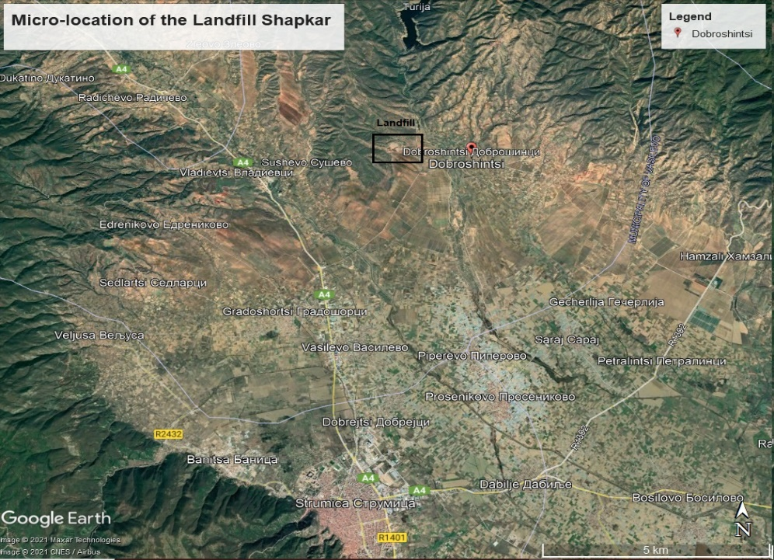
Figure 6: Micro location of the regional landfill and the existing landfill
There is a 4.5 km long local asphalt road connecting the landfill with A4 national road (Radovish-Strumica-Novo Selo), while a smaller part of the road (500 m) leading to the landfill is a macadam road. This local road will be used for transport of waste to the Dobrosinci landfill. The river Turija flows about 1 km west of the landfill. The landfill is located on the lower western slopes of the Ograzden mountain, at the edge of the Strumica plain, at an altitude of about 300 m asl. The existing landfill is shown in Figure 7.
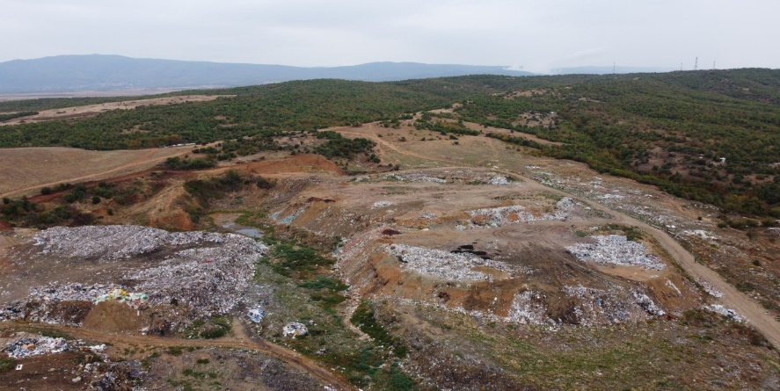
Figure 7: Existing non-compliant municipal landfill
Transfer stations. The definite locations of TSs are not known.

History of Project Development and Planning
Information on key milestones, preceding the Bank’s involvement in the Project, is given in Table 3.
Table 3: Project milestones – VSE region
Year | Activity | Description
2004 | Adoption of the Spatial Plan of N. Macedonia | In the Spatial Plan (2002-2020), the village of Dobrosinci was assessed as favourable for the location of a regional landfill in hydrogeological terms.
2010-2012 | Initiative to establish a regional landfill | An initiative was undertaken by the Regional Centre to establish a regional landfill at the Dobrosinci location, in cooperation with an Austrian company. The initiative was unsuccessful.
2016-2017 | Development of RWMP and SEA for Vardar | In 2016, an RWMP (Regional Waste Management Plan) and SEA for the Vardar region were developed, and approved by the MoEPP in 2017.
2017 | Development of RWMP and SEA for SE | In 2017, an RWMP and SEA for the SE region were developed, and approved by the MoEPP in the same year.
2017 | Development of Draft EIA Study for Vardar | The EIA Study for the Vardar region was finalised in November 2017. Two public consultations were organised in the Municipalities of Rosoman and Veles. However, the EIA study and subsequently obtained permits/decisions refer to the previously planned regional landfill Rosoman, which is no longer considered.
2017 | Development of the Final FS for Vardar | In November 2017, the Feasibility Study for the Vardar region was completed. The FS provides information about the proposed waste storage and waste collection system to improve the current situation in the region.

Summary of Environmental and Social Baseline
In the absence of a national EIA, this section provides a summary of the E&S baseline of the planned landfill location, derived through the independent E&S due diligence process conducted on behalf of EBRD from September 2021 to February 2022. The summary also identifies the need to conduct additional collection of information/data and required mitigation measures and actions that need to be implemented as part of the ESAP. This will be done through conducting an ESIA.
Biodiversity. Eight habitat types (EUNIS classification) were identified within the landfill site and the 500 m-wide buffer zone. Approx. 24.34 ha will be under direct impact, most of which belongs to habitat type I1.5 Bare tilled, fallow or recently abandoned arable land – 14.10 ha, followed by J6.2 Household waste and landfill sites – 10.18. A considerably smaller area of 0.06 ha is covered by G1.714 Eu-Mediterranean white oak woods. An additional approx. 184.96 ha will be indirectly impacted. G1.714 Eu-Mediterranean white oak woods are included in 91AA Eastern white oak woods (Annex I of the Habitats Directive). No endangered, endemic species or species listed in relevant annexes to EU directives (Habitats, Birds Directives) were found during the rapid biodiversity assessment. Three invasive plant species were observed: Erigeron canadensis (Canadian fleebane) – in all the ruderal sites, Populus canadensis (Canadian poplar) – in the hedges, widespread, and Ailanthus glandulosa (Chinese sumach) – few specimens were recorded on agricultural land. There are no IBA, IPA, KBA or any other designated areas around the landfill site. Collection of supplementary baseline information on habitats, flora and fauna in spring/early summer season is included in the ESAP.
Water. The landfill site is an abandoned clay mine depression, based on uniform clay layer with low permeability. The site and its immediate surroundings are mainly low permeability Pliocene sediments, and no ground water movement is noted. The Turija River flows at 1 km west of site. A few km above the site is the largest water reservoir in the area (Turija Lake). There are no data about surface and ground water quantity and quality for the immediate vicinity of the proposed landfill site. The “Lukar” spring is the main spring in the VSE region, used for water supply of towns Kavadarci, Negotino and Rosoman. Rural water supply systems are mainly supplied from springs and groundwater, but lately they often use surface water. The site is not part of any protected areas or included in any sanitary water supply zone.
Air quality. Ambient air quality in the Strumica urban zone is characterised by extreme wintertime pollution episodes and relatively clean air during the hot season. The main pollutant of concern is ambient particulate matter (PM_{2.5} and PM₁₀). All other main pollutants (NOx, CO, SO₂ and O₃) are mostly within the prescribed limits.
Land. The landfill site is described as a small depression with a minor catchment area, based on uniform clay layers with thickness above 4 m and very low permeability. Deeper layers are mix of sands and clay with thickness above 15 m. The subsoil is natural and can be considered resistant to subsidence. The landfill site is located on the lower western slopes of the Ograzden mountain, at the edge of the Strumica plain, with average altitude of about 300 m asl.
Climate. The Strumica area has a hot summer climate while winters are very cold and partly cloudy. Over the course of the year, temperature typically varies from -1 °C to 32 °C and is rarely below -7 °C or above 36 °C. The wetter season lasts 7.1 months, while the drier season lasts 4.9 months. The windiest month of the year in Strumica is February, with an average hourly wind speed of 2.7 meters per second.
Landscape. The area is slightly hilly. To the east and south it turns into a plain filled with agricultural plots and plantations, while to the west and north it is a hilly area with low-stemmed trees and shrubs.
Noise and vibration. The surrounding area of the proposed landfill site is a rural area, with low traffic or other noise intense activities.
Waste and materials management. Based on the current population data and waste generation rates, the estimated amounts of generated waste for the municipalities of the Polog region in 2021 is 98,725 t/year. In terms of waste composition, garden and other biodegradable waste has the highest share. Waste management services are provided by municipal PUEs. A variety of waste containers are used but typically they include 120 l and 240 l plastic wheeled bins, both plastic and metal, 1.1 m³ wheeled waste containers, and 5 m³ skips. The largest number of vehicles used for collection are rear end loaded waste compaction trucks. There are numerous small and large dumpsites where various types of waste (municipal waste, construction and demolition waste, agricultural waste) are disposed.
Population and nearest settlements. The nearest inhabited settlement to the planned landfill is the Dobroshinci village at a distance of about 1.5 km east with a population of approx. 900 people. There about 10 agricultural land plots (all owned by residents of the Dobroshinci village) around the landfill and along the access road.
Land requirements. The new landfill is planned to be constructed on an area adjacent to the existing landfill. This proposed site is public land, currently officially registered as pastureland. The land is not used by anyone for any purposes. The process of land conversion from agricultural to construction land has been initiated with the Ministry for Transport and Communication.
Cultural heritage. There is no cultural heritage in the wider project area or in the vicinity of the planned landfill.
Waste pickers. About 10 Roma families from Strumica regularly collect waste on the existing landfill. They come from the Dobroshinci village. Around 15-20 people collect waste during the summer, and around 7-8 during the winter. They have been collecting waste as their only source of income at this landfill for 10-20 years.
Access road to the landfill. There is a 4.5 km long local asphalt road which connects the planned landfill area and the existing landfill with the A4 national road (this local road will be used to transport waste to the new landfill).

Summary of Identified Environmental and Social Impacts and Measures
Impacts and measures for planned activities in the VSE region will be defined in the future ESIA.

ADDITIONAL ACTIVITIES TO BE UNDERTAKEN FOR THE PROJECT

In order to meet the requirements of the EBRD, the MoEPP will implement the following activities, which are described in detail in the ESAP. The MoEPP will be responsible for ensuring that contractors working on project sites and regional landfill operators to be established follow the requirements of the ESAP.
STRENGTHEN INSTITUTIONAL CAPACITY FOR E&S MANAGEMENT:
- Establish a Project Implementation Unit (PIU) and staff it with competent personnel
- Nominate a responsible person for preparing and submitting annual E&S reports to EBRD
- Develop and implement a Project specific Environmental and Social Management System, with an appropriate E&S Policy
APPROVE THE LOCATIONS OF ALL ASSOCIATED INFRASTRUCTURE:
- Formally approve all sites for TS and composting plants
- Use E&S criteria for selection of sites
CONDUCT ADDITIONAL ANALYSES:
- Carry out Supplementary E&S Analysis for the landfills to address identified gaps in the national EIA for Polog region and ESIA for PSW region, and carry out “Smaller Scale E&S Assessment Studies” (called elaborates in national legislation) on TS and composting plants
- Conduct an ESIA study for the VSE region and carry out public consultations for the landfill and TS
- Conduct public consultations for both the existing EIA and ESIA as well as Supplementary E&S Analysis and Smaller Scale E&S Assessments Studies
- Conduct detailed hydrogeological investigations in all regions to establish the baseline and to avoid negative impact of construction on groundwater, local geology and stability of the terrain

OBTAIN ALL PROJECT PERMITS:
- Obtain necessary permits prior to construction and operational activities
CARRY OUT STAKEHOLDER ENGAGEMENT:
- Implement the Stakeholder Engagement Plan (SEP) for the Project and update on a regular basis throughout the Project duration
- Implement grievance mechanism as defined in SEP to ensure stakeholders are able to raise their concerns about the Project and that these concerns are addressed promptly
- Ensure that contractor and regional operators implement the grievance management provisions defined in SEP

MITIGATE IMPACTS ON WASTE PICKERS AT THE THREE PLANNED LANDFILL SITES:
- Prepare and implement a Livelihood Restoration Plan to address Project impacts on waste pickers and other affected people identified in the Livelihood Restoration Framework

PLAN THE CLOSURE OF NON-COMPLIANT LANDFILLS AND DUMPSITES:
- Require from regional operators to prepare and implement Landfill and Dumpsite Remediation and Closure Plans
- Assess impacts on informal waste pickers at all non-compliant landfills and dumpsites to be closed throughout all three regions, and update the Livelihood Restoration Framework and Livelihood Restoration Plan accordingly

ENSURE APPROPRIATE CONSTRUCTION OF ALL FACILITIES:
- Require from the contractors to submit and implement a Construction E&S Management Plan (CESMP), Construction Waste Management Plan (CWMP) and Construction Landfill Erosion Plan, and to comply with all requirements specified in the Project design and tender documentation for all project components, as well as to implement construction mitigation measures and monitoring plan as per obtained permits
- Require from the contractors to develop and implement a Biodiversity Management Plan, forest clearing and reclamation plan and Land restoration plan (if needed).
- Obtain the consents of cultural heritage authorities prior to any works and require contractors to develop and implement a Chance Find Procedure.

ENSURE APPROPRIATE OPERATION OF ALL FACILITIES:
- As part of the licensing procedure and contractually require regional operators to prepare and implement an Operational E&S Management Plan (OESMP), Operational Landfill Erosion Control Plan and Operational Waste Management Plan (OWMP), as well as to implement mitigation measures and monitoring plan prescribed in the obtained permits
- As part of the licensing procedure and contractually require regional operators to develop a robust, effective and pragmatic system for segregated collection of waste at the source and system for recording and tracking of waste, as well as to introduce a two-bin waste collection system (recyclable waste bin and residual waste bin)
- Assist regional enterprises and PUEs to deploying the system of separate collection of waste in the region
- Ensure that all facilities for collection and treatment of leachate, embankments and drainage canals for atmospheric water and biogas are constructed as designed and in compliance with the EU landfill Directive
- Ensure that additional facilities for materials recovery are constructed as planned in the RWMPs
- Require regional operators to prevent flooding by prioritising clearance of dumpsites in the vicinity of the surface flows, carry out climate risk assessment for landfill operations in line with EBRD methodology, undertake monitoring of landfill gas and leachate as well as all other monitoring as required by Annex III of the EU Landfill Directive 1999/31
- Require regional operators to enhance biodiversity/landscape through planting and restoration schemes and implementation of biodiversity related plans.

DISCLOSURE AND COMMUNICATIONS
The MoEPP intends to provide all relevant Project information to the public in local language and English (where appropriate). A detailed Stakeholder Engagement Plan has been developed for this Project, outlining the stakeholder engagement and communication programme, including access to the Project’s Grievance Mechanism.
Contact information for enquiries and grievances:
Attention: Mr. Saso Sekulovski
Ministry of Environment and Physical Planning
Address: Plostad Presveta Bogorodica No. 3, Skopje
Tel: + 389 076 456 716
E-mail: info@moepp.gov.mk

MoEPP will undertake the following disclosure activities for the Project:
- Make the following disclosure package for the Project publicly available on its website, and ensure it is disclosed on the websites of all municipalities in all three regions:
- This Non-technical Summary
- Project Information Leaflet
- Stakeholder Engagement Plan (SEP), Project Grievance Form and Public Grievance Leaflet
- Livelihood Restoration Framework (LRF), future Livelihood Restoration Plan (LRP) and Resettlement Information Leaflet
- National EIA studies for Polog and PSW regions along with future Supplementary E&S Assessments
- Future ESIA for VSE region

The Project Information Leaflet, Project Grievance Form, Project Grievance Leaflet and Resettlement Information Leaflet will be made available in Macedonian, Albanian and Turkish. Additionally, translation of the entire disclosure package into minority languages (Turkish and Serbian) will be ensured as needed.
- Ensure that hard copies of the disclosure package are made available at the following 10 locations:
MoEPP | address: Plostad Presveta Bogorodica No. 3, Skopje
Municipality of Gostivar | address: Bul. Braka Ginoski 61, 1230, Gostivar
Municipality of Novaci | address: S. Novaci, Novaci
Municipality of Bitola | address: Bul. 1-vi Maj, No. 61, Bitola
Municipality of Vasilevo | address: S. Vasilevo bb, 2411
Municipality of Ohrid | address: Dimitar Vlahov 57, 6000 Ohrid
Municipality of Kichevo | address: Boris Kidric No. 1, 6254 Kichevo
Municipality of Kavadarci | address: Plostad Marsal Tito bb, Kavadarci
Municipality of Debar | address: 8 September bb, Debar
EBRD Resident Office in Skopje | address: Soravia Centre Skopje, 7th floor, Filip II Makedonski no. 3, 1000 Skopje

- Send electronic versions of the disclosure package to interested NGOs asking them to publicise the package on their websites, with the purpose of wider dissemination of information;
- Regularly update its webpage to inform the public about Project activities, including the announcements for public meetings to be organised for the Project.
Following disclosure of the above listed documents, MoEPP will:
- Distribute the Project Information Leaflet through Local Community Offices to local residents in the vicinity of Project sites in all three regions;
- Not earlier than 2 weeks after disclosure (to allow sufficient time for public review of documents), organise public consultation meetings: (i) near the locations of the planned three sanitary landfills, and (ii) in the municipalities where transfer stations/composting plants are planned
- Together with the municipalities of Gostivar, Novaci, Vasilevo, Ohrid, Kichevo, Kavadarci and Debar, inform all stakeholders about the exact date, time and venue where the meetings will be held, at least 1 week in advance (but preferably 2 weeks), through:
- disclosure through the websites of MoEPP and the municipalities
- local media (newspapers, online news portals);
- posting of the announcement of public meetings in the neighbourhoods of Rusino, Novaci and Dobrosinci, in order to specifically target the local population living in these communities;
- Directly contact by email to inform interested NGOs of the planned public meetings;
- As necessary, hold separate individual meetings to ensure that more targeted stakeholder engagement or gender responsive engagement;
- Document all meetings in the form of minutes of meetings; consider and address all comments and proposals; publish summary reports on its website of all relevant issues raised, including explanations for inclusion or exclusion of proposals;
- Prior to the start of any construction works start, publicise information about the extent, timing and duration of planned construction works, and any expected disruptions and inconveniences via (i) its website, (ii) websites of the municipalities of Gostivar, Novaci and Vasilevo where the sanitary landfills will be located, (iii) websites of the municipalities where transfer stations will be built, and (iv) on bulletin boards of Local Community Offices in the settlements where the landfills and transfer stations are located.

Before the two regions were joined, two separate national EIAs were prepared in 2017. After the Government decided to merge these two regions, the two EIAs were also merged into a "consolidated ESIA" in 2021. Since financing negotiations with EBRD had started, it was developed to be aligned with EBRD requirements and include social aspects along with environmental aspects; hence the document was renamed into ESIA.
Visually sensitive receptors are people who would reside within, work within, play within, or travel through, the zone of visual influence.

