Information related to status of small hydro power plants in Shar Mountains
January 2021 The process for receiving a concession for operating a SHPP needs several steps:
- approval by the Ministry of Economy (Government decision)
- approval by MoEPP based on environmental impact assessment
- The concessioners receive contracts to build SHPPs and receive subsidies from the Government

The small hydro power plants (SHPP) projects can therefore be divided in 4 categories (depending on the progress of the projects):
- SHPPs for which there is a Decision from the Government of RNM and are critical
- SHPPs for which a Concession Agreement has been issued and are critical
- SHPPs that are in operation: these are accepted as existing infrastructure in the NP
- Planned (proposed) SHPPs: these will not be accepted in the NP

At this stage the new proposed zonation of NP Shar Mountains is going to provide advisory support to the Minister for Environment how to proceed with the SHPPs. All projects in sustainable zone have legal right to continue building unless the Minister declared a moratorium for building SHPPs on Shar Mountain. Projects for building SHPPs in the active management and strict protected zone should be stopped.
This document does not replace an environmental impact assessment.

The advice stated below has taken into account: natural values, previous expert opinion, consultation with Municipalities and local people, reactions from NGO sector (a letter that has been publicly sent to the Prime Minister) a consultation with AD ESM and Ms. Melita Goshevska from the Water sector within MoEPP.
The expert recommendation is provided in line with the IUCN criteria for category II NP. Out of all the four categories the expert’s advice is to proceed with the SHPPs located only in the sustainable development zone for which concessioner contracts are granted. All other concessioners with granted projects for construction in the active or strict protected zone should be immediately stopped from any further construction, withdraw and be reimbursed for the caused financial losses.
Statement to the public: If the Law for proclamation and the new proposed zonation is supported by the public the Shar National Park initiative will stop: 21 SHPPs (6 approved by Government + 15 planned) and it will prevent building of 5 SHPPs (3 in Ljuboten area and 2 in the heart of Shar Mountain Leshnica

Valley) for which there are already contracts. In total, 26 SHPPs will be stopped and only 4 located in the sustainable zone will have the legal rights to continue completing their contracts.

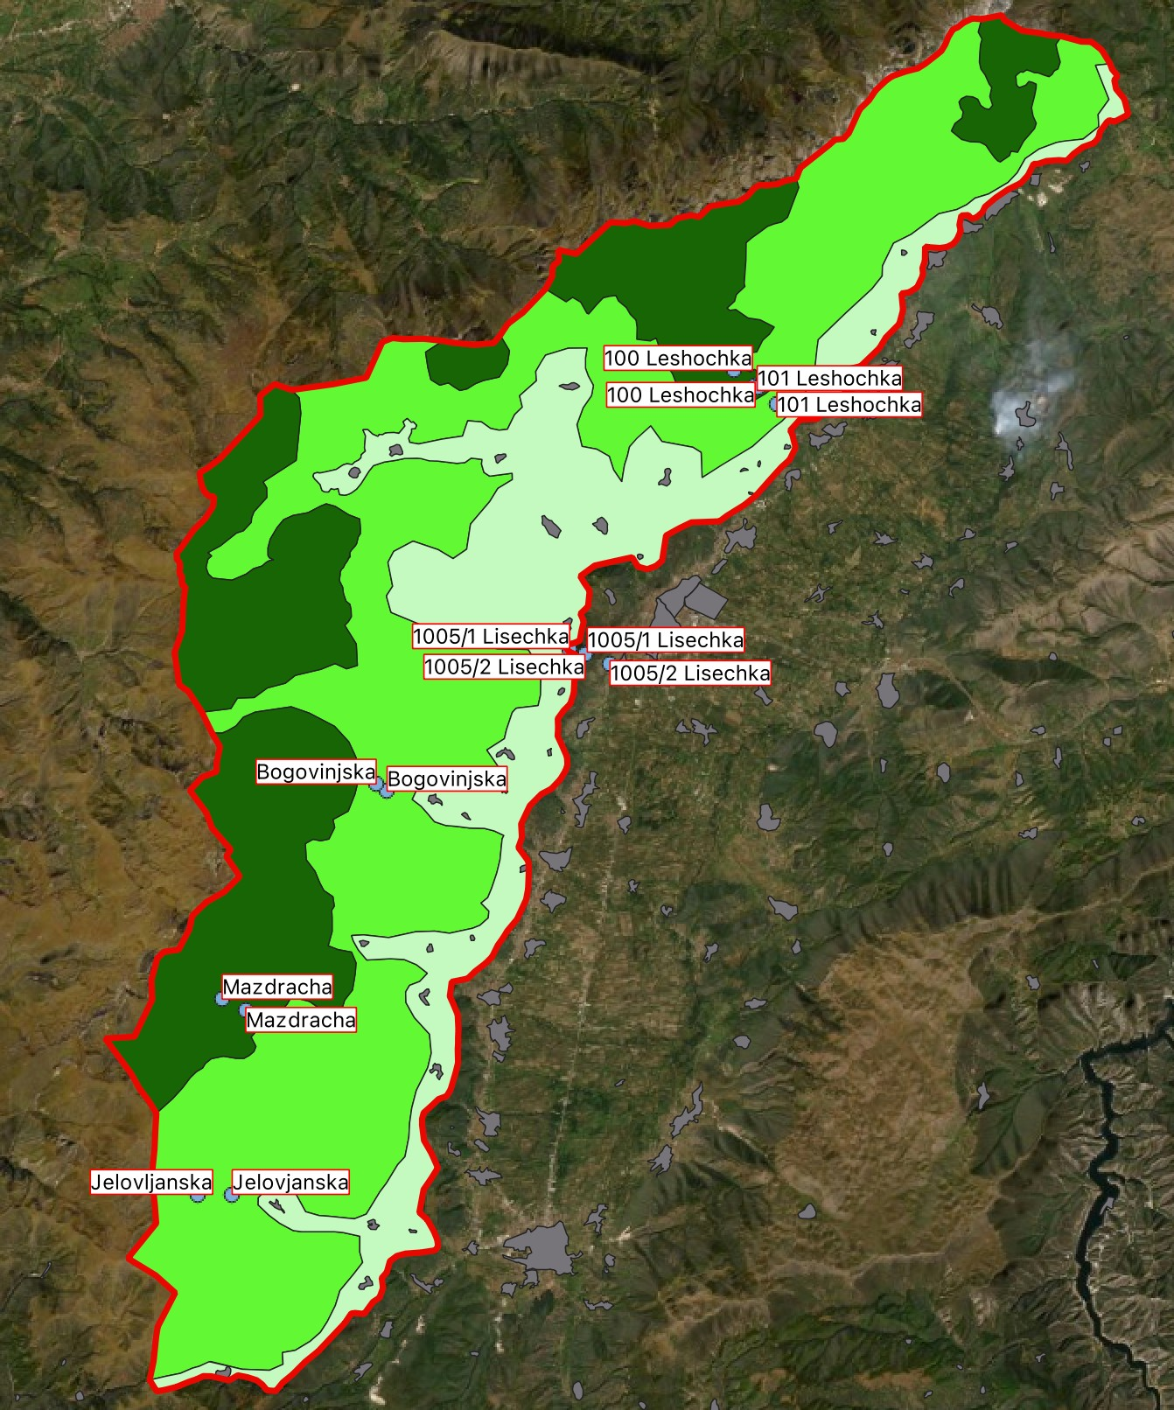
SHPPs for which there is a Decision from the Government of RNM
This group contains SHPPs for which the Government gave positive decision.
However, none of them have signed concessioner’s contract and next step is to receive a positive opinion from the sector for environment by following the impact assessment procedure.

Since all of them are in active and strict protected zone this opinion cannot be positive meaning they will be automatically stopped.

Once the Law for proclamation is passed it will be a base on which the Minister can explain to the Government that those SHPPs should be stopped.

This group of SHPPs would not have high financial implications because there has not been any concession / contract. Maybe some costs will have to be reimbursed to the applicants to cover their costs for preparation of the documentation.

SHPP number 1005 Lisecka (Recica 1 and Recica 2) has a contract and they have already started building but it is out of the territory of the proposed National Park.

Expert opinion: None of the SHPPs with status “Decision from Government” are advised to continue building.

Table: SHPPs for which there is a Decision from the Government of RSM

No. | ID | Name | Object description | Previous Protection zone | Comment | New Protection zonation
1. | 441 | 100  Leshochka | 100 Intake of the river Leshochka | Active management zone | No buffer zone will be installed, it is proposed not to give a Concession Agreement | Strict protection zone
 |  |  | 100 Machine building on the  river Leshochka | Active management zone |  | Strict protection zone
2. | 442 | 101  Leshochka | 101 Intake of the river Leshochka | Active management zone | No buffer zone will be installed, it is proposed not to give a Concession Agreement | Strict protection zone
 |  |  | 101 Machine building on the  river Leshochka | Active management zone |  | Active management zone
3. | 662 | Bogovinjska | Bogovinje construction | Active management zone | No buffer zone will be installed, it is proposed not to give a Concession Agreement | Active management zone
 |  |  | Bogovinje machine  building | Active management zone |  | Active management zone
4. | 651 | Jelovjanska | Jelovjanska machine building | Active management zone | No buffer zone will be installed, it is proposed not to give a Concession Agreement | Active management zone
 |  |  | Jelovjanska zafat | Active management zone |  | Active management zone
5. | 665 | Mazdracha | Mazdracha construction | Strict protection zone | No buffer zone will be installed, it is proposed not to give a Concession Agreement | Strict protection zone
 |  |  | Mazdracha  machine building | Strict protection zone |  | Strict protection zone
6. |  | 1005  Lisecka | Recica 1  Recica 2 | outside NP | In building | outside NP

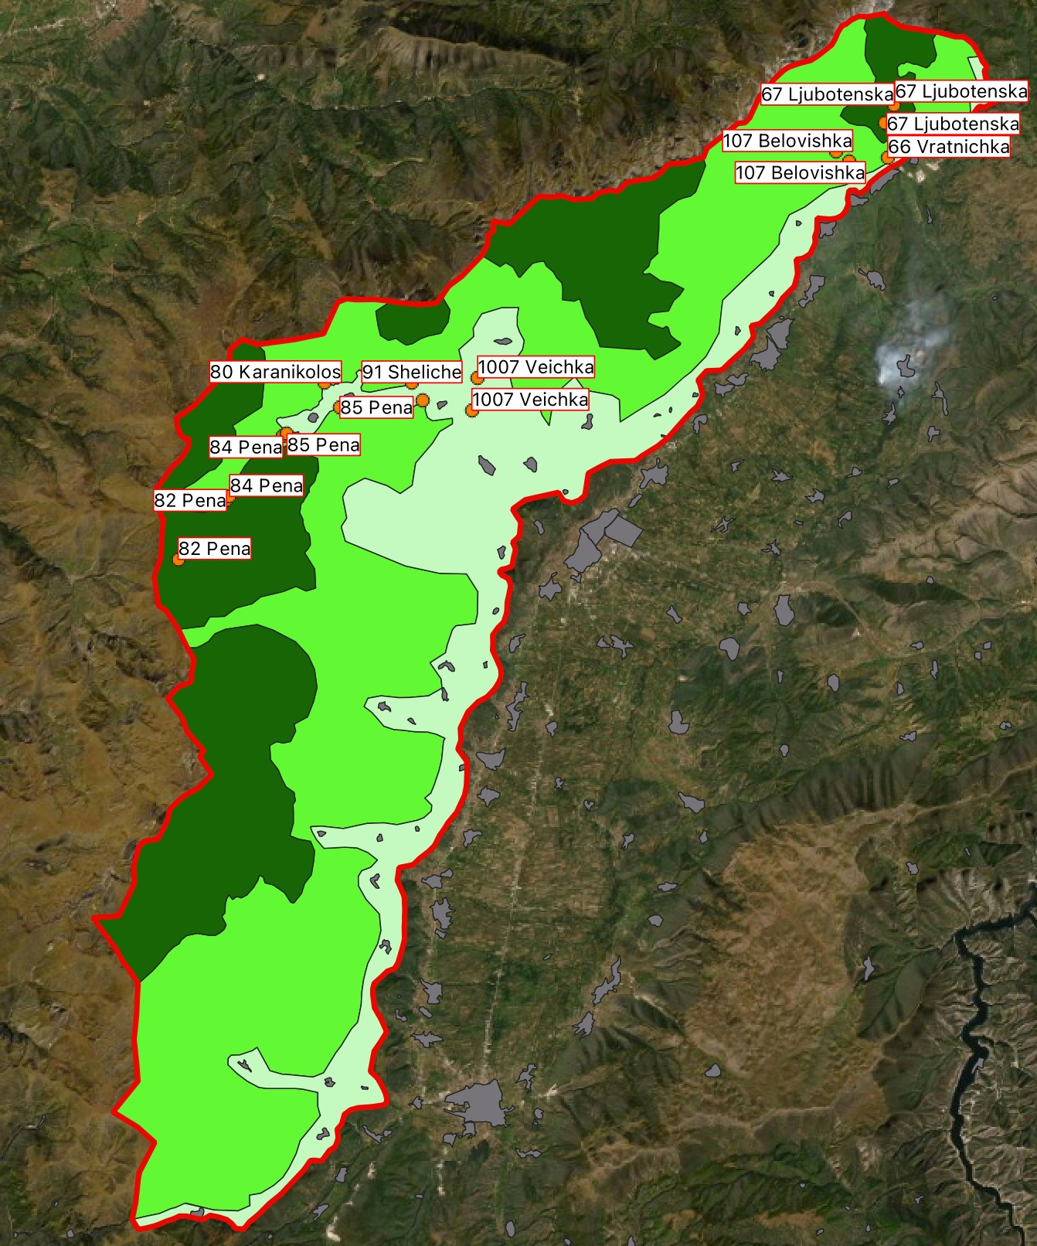
SHPPs for which a Concession Agreement has been issued This is the most critical group of SHPPs, where 9 projects are given permits from the Government, approval by MoEPP and they have
concession contracts. Out of the 9, one is in negotiation to be stopped
and one is blocked by local people. This has been taken into account by the IUCN experts.
Based on the zonation within the Law for proclamation the Government can decide to cancel the concessioner’s contracts.
Based on the proposed zonation the following SHPPs with concessioner contract, located in the sustainable development zone, can continue processing their contracts: 1007 Veicka River; 80 Karanikolicka; 85 Pena; 91 Shelice.

The following SHPPs with concessioner’s contract, located in strict or active management zone, is advised to not continue construction:
- 107 Belovishka SHPP will not proceed anyway since local people are blocking the process for many years already;
- 66 Vratnicka is located in a very important strict protected area and the concessioner will have to be paid out;
- 67 Ljubotenska is located in a very important strict protected area and the concessioner will have to be paid out;
- 82 Pena is located in a very important strict protected area and the concessioner is already in negotiation to withdraw;
- 84 Pena is located in a very important strict protected area and the concessioner will have to be paid out. This is the location for which construction has already started. Taking into account the pressure from the public it is advised to immediately stop the construction and negotiate with the investor to rehabilitate the location;

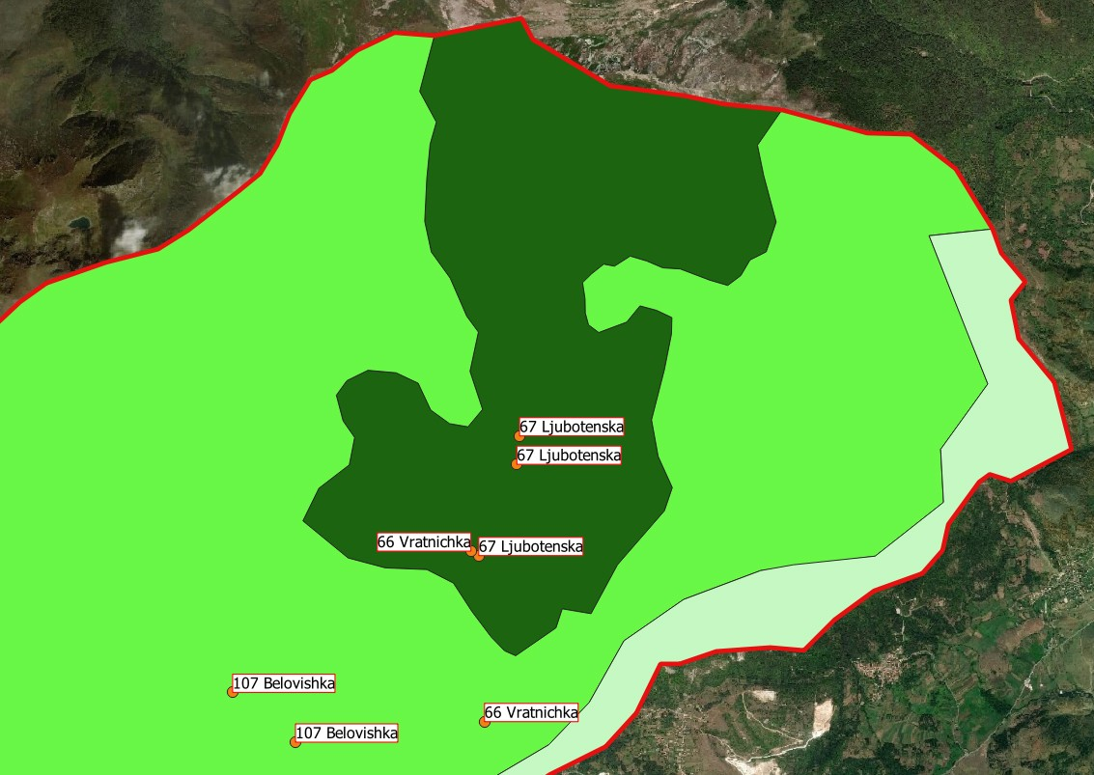

Photo: Overview of SHPPs, in the Ljuboten area, with concessioner’s contracts that should not continue construction

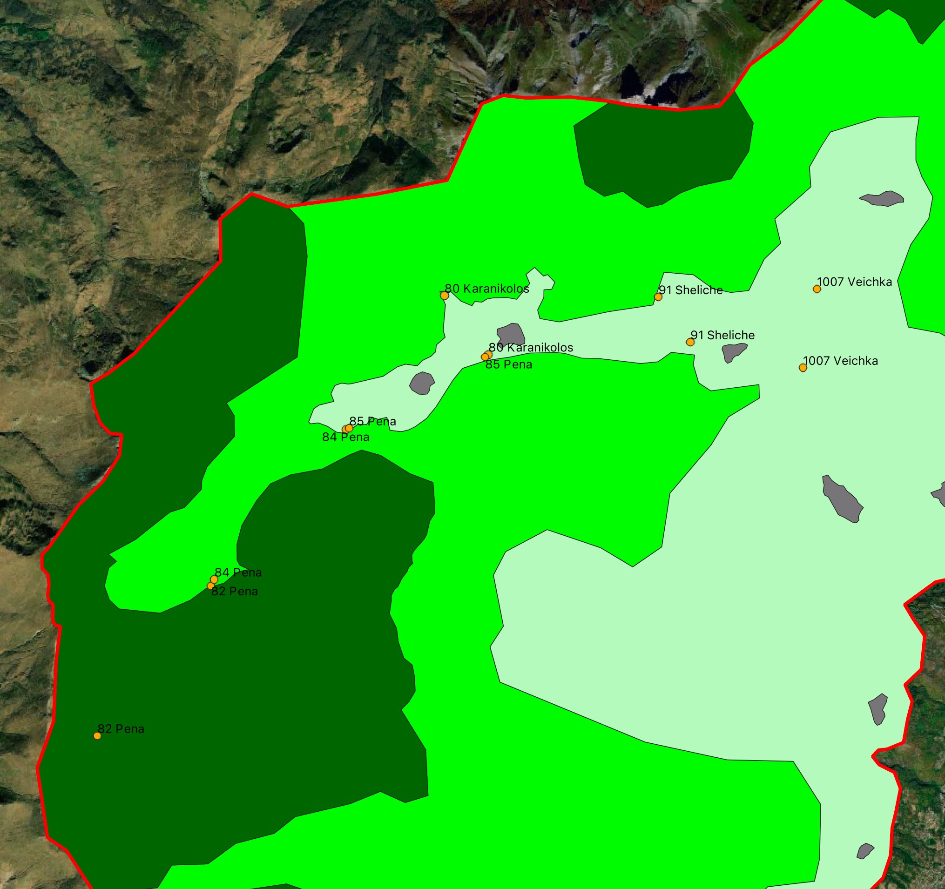

Photo: Overview of SHPPs in the Leshnica area

Table: SHPPs for which a Concession Agreement has been issued

No. | ID | Name | Object description | Previous Protection zone | Comment | New Protection zone
1. | 219 | 1007 Veicka river | 1007 Veicka construction | Zone for sustainable use | The procedure for obtaining a Building Permit is continued | Zone for sustainable use
 |  |  | Veicka Machine  Building | Zone for sustainable use |  | Zone for sustainable use
2. | 387 | 107 Belovishka | 107 Belovishka construction | Active management zone | No protection belt will be set, it is proposed to cancel the Concession Agreement  Initiative from local people and NGO to be removed. Concession from Ministry of Economy. The local population is blocking the process. The Minister of finances asked to make an assessment for  reimbursement. | Active management zone
 |  |  | Belovishka machine building | Active management zone |  | Active management zone
3. | 485 | 66 Vratnicka (it is managed as Ljubotenska river above Vratnica) | 66 Vratnicka construction | Zone for sustainable use | No protection belt will be set, it is proposed to cancel the Concession Agreement | Strict protection zone
 |  |  | Vratnicka machine building | Active management zone |  | Active management zone
4. | 367 | 67 Ljubotenska (on Vratnicka river) | 67 Ljubotenska  construction 1 | Active management zone | No protection belt will be set, it is proposed to cancel the Concession Agreement | Strict protection zone
 |  |  | 67 Ljubotenska  construction 2 | Active management zone |  | Strict protection zone
 |  |  | Ljuboten Machine Building | Zone for sustainable use |  | Strict protection zone

No. | ID | Name | Object description | Previous Protection zone | Comment | New Protection zone
5. | 407 | 80  Karanikolicka | 80 Karanikolicka construction | Zone for sustainable use | The procedure for obtaining a Building Permit is continued | Zone for sustainable use
 |  |  | 80 Karanikolicka  Machine Building | Zone for sustainable use |  | Zone for sustainable use
6. | 350 | 82 Pena | 82 Pena construction | Strict protection zone | No protection belt will be set, it is proposed to cancel the Concession Agreement  Negotiated to be out | Strict protection zone
 |  |  | 82 Pena machine building | Strict protection zone |  | Active management zone
7. | 409 | 84 Pena | 84 Pena construction | Active management zone | No protection belt will be set, it is proposed to cancel the Concession Agreement  Negotiated to be out | Active management zone
 |  |  | 84 Pena machine building | Sustainable use zone |  | Sustainable use zone
8. | 410 | 85 Pena | 85 Pena construction | Sustainable use zone | The procedure for obtaining a Building Permit is continued | Sustainable use zone
 |  |  | 85 Pena machine building | Sustainable use zone |  | Sustainable use zone
9. | 440 | 91 Shelice | 91 Shelice  construction | Zone for sustainable use | The procedure for obtaining a Building Permit is continued | Sustainable use zone
 |  |  | 91 Shelice machine building | Zone for sustainable use |  | Sustainable use zone

