

Land Degradation Neutrality   
Target Setting Programme

Land Degradation Neutrality Target Setting –

A Technical Guide

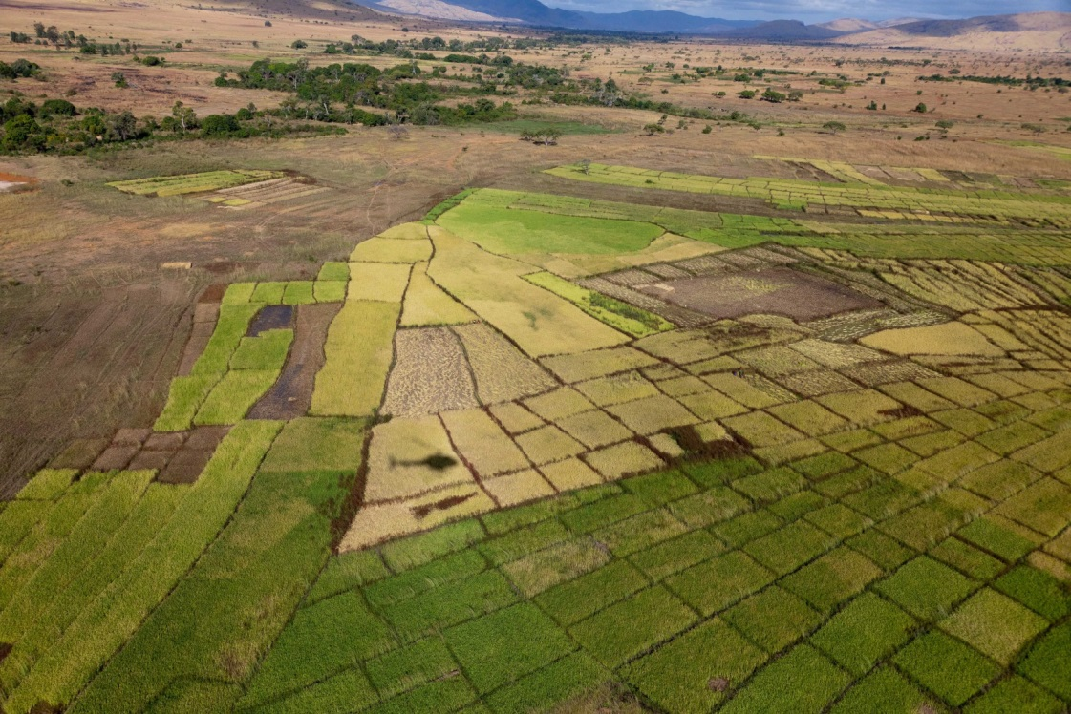

Draft for consultation during the

Land Degradation Neutrality Target Setting Programme inception phase

May 2016

# I. Executive summary

In September 2015, the United Nations General Assembly adopted “The 2030 Agenda for Sustainable Development”, including 17 Sustainable Development Goals (SDG) and 169 targets. SDG 15 urges countries to protect, restore and promote sustainable use of terrestrial ecosystems, sustainably manage forests, combat desertification, and halt and reverse land degradation and halt biodiversity loss. Target 15.3 aims to “combat desertification, restore degraded land and soil, including land affected by desertification, drought and floods, and strive to achieve a land degradation-neutral world” by 2030. The indicator adopted to measure the achievement of SDG target 15.3 is “Proportion of land that is degraded over total land area”.

The twelfth session of the Conference of Parties (COP) of the United Nations Convention to Combat Desertification (UNCCD), held in Ankara, Turkey in October 2015, endorsed SDG target 15.3 and the concept of land degradation neutrality (LDN) as a strong vehicle for driving the implementation of the Convention. It invited all UNCCD country Parties to formulate voluntary targets to achieve LDN and requested UNCCD bodies to provide “guidance for formulating national LDN targets and initiatives” and to facilitate “the use of the UNCCD indicator framework as a contribution to the monitoring, evaluation and communication of progress towards the national LDN targets”.

In response to the decisions taken by the UNCCD COP.12, the Global Mechanism (GM) of the UNCCD established a LDN Target Setting Programme (TSP), which aims to support countries to define national LDN targets and associated measures. The present document “Land Degradation Neutrality Target Setting – A Technical Guide” has been prepared by the GM and the Secretariat of the UNCCD to provide operational guidance on how to define national baselines, identify voluntary targets and associate measures to achieve LDN by 2030, and monitor progress towards LDN targets.

This technical guide proposes ten steps for the LDN target setting process, which are outlined in table 1. Implementation of these steps can be contextualised and adjusted to the (sub)national context.

**Table 1.** Ten steps towards voluntary land degradation neutrality targets

|  |  |
| --- | --- |
| **Steps** | **Main activities** |
| **Coordination** | |
| Step 1: Government leadership and stakeholder engagement | * Government leadership and coordination across line ministries to tap leverage potential of LDN target setting process * Identify the main stakeholders to be involved in the land degradation neutrality (LDN) target setting process * Ensure stakeholder engagement and coordination, including the establishment of national LDN working groups |
| **Assessment** | |
| Step 2: Setting LDN baselines | * Define the LDN baseline * Calculate the baseline using LDN indicators, including: i) land cover; ii) land productivity; and iii) carbon stocks above and below ground (soil organic carbon (SOC)) * Supplement the above indicators, as appropriate, with (sub)national indicators * Use global data sources in the absence of, or to complement and enhance national data |
| Step 3: Assessing land degradation trends | * Carry out an assessment of historic land degradation trends to understand the current situation, reveal anomalies and identify degraded areas * Identify significant trends in land degradation, i.e. when:   + negative land cover changes occur; and/or   + land productivity shows a significant decrease; and/or   + SOC shows a significant decrease; and/or   + a negative change occurs in another nationally relevant indicator. * Interpret trends in the context of local conditions |
| Step 4: Identifying drivers of land degradation | * Identify types of land degradation for specific land cover categories * Identify direct and indirect causes of land degradation * Analyse the legal and institutional framework related to LDN * Identify strengths, weaknesses, opportunities and threats of the LDN legal and institutional framework, including National Action Programmes of the UNCCD |
| **Planning** | |
| Step 5: Defining national voluntary LDN targets | * Define measurable targets on what the country wants to achieve in terms of LDN * Define the degree of comprehensiveness and ambition related to LDN * Define the time reference (e.g. 2030) to achieve LDN targets |
| Step 6: Mainstreaming LDN in land use planning | * Integrate LDN into national land-use planning models to predict “gains” and “losses” |
| Step 7: Identifying measures to achieve LDN targets | * Identify measures addressing the drivers of land degradation * Promote implementation of the LDN response hierarchy: Avoid, minimise, reverse land degradation * Plan to balance unavoidable land degradation with restoration efforts |
| **Action** | |
| Step 8: Facilitation of action towards LDN | * Communicate the multiple benefits of LDN * Mainstream LDN in national policies and plans * Increase investments to achieve LDN * Establish/strengthen LDN-related partnerships |
| **Monitoring & Reporting** | |
| Step 9: Monitoring progress towards LDN | * Monitor changes in the values of LDN indicators to quantify “gains” and “losses” * Assess the achievement of LDN targets |
| Step 10: Reporting on LDN | * Communicate progress towards LDN at all levels |

LDN target setting is not a stand-alone process but should be embedded in overarching national development policy processes. Strong county ownership and the active involvement of all stakeholders groups and sectors impacting the land based natural capital are required to allow the LDN target setting-process to contribute to Land Degradation Neutrality by 2030 and the achievement of the Sustainable Development Goals.

# II. Table of Contents

I. Executive summary 2

II. Table of Contents 5

III. Acronyms 6

IV. List of tables 8

V. List of boxes 8

VI. List of figures 8

1. Introduction 9

2. Setting national land degradation neutrality targets and associated measures – a step-wise approach 14

Step 1: Government leadership and stakeholder engagement 16

Step 2: Setting the land degradation neutrality baseline 20

Step 3: Assessing land degradation trends 27

Step 4: Identifying drivers of land degradation 32

Step 5: Defining national voluntary land degradation neutrality targets 38

Step 6: Mainstreaming LDN in land use planning 40

Step 7 Identifying measures to achieve land degradation neutrality targets 43

Step 8: Facilitating action towards land degradation neutrality 45

Step 9: Monitoring progress towards land degradation neutrality 48

Step 10: Reporting on land degradation neutrality 52

3. Conclusions 54

4. References 55

5. Annex 58

5.1 Relevant paragraphs of decisions related to land degradation neutrality taken by the Conference of the Parties at its twelfth session 58

5.2 Draft balance sheet for land degradation neutrality tracking 65

# III. Acronyms

|  |  |
| --- | --- |
| AFR100 | African Forest Landscape Restoration Initiative |
| BRICS | Brazil, Russia, India, China and South Africa |
| CBA | Cost-Benefit Analysis |
| CBD | Convention on Biological Diversity |
| CCI-LC | Climate Change Initiative Land Cover |
| CEE | Central and East Europe |
| CGIAR | Consultative Group on International Agricultural Research |
| COP  CRGE | Conference of Parties  Climate-Resilient Green Economy |
| CRIC  CSO | Committee for the Review of the Implementation of the Convention  Civil society organizations |
| DLDD | Desertification, land degradation and drought |
| ES | Ecosystem services |
| ESA | European Space Agency’s dataset |
| EU | European Union |
| FAO | Food and Agriculture Organization of the United Nations |
| FLR | Forest and Landscape Restoration |
| GCF | Green Climate Fund |
| GEF  GGWSSI | Global Environment Facility  Great Green Wall for the Sahara and Sahel Initiative |
| GHG | Greenhouse gas |
| GIS | Geographic information system |
| GIZ | Deutsche Gesellschaft für Internationale Zusammenarbeit |
| GM | Global Mechanism of the UNCCD |
| ha | Hectares |
| IIF | Integrated Investment Framework |
| ILM | Integrated Landscape Management |
| INDC | Intended Nationally Determined Contributions |
| IPCC | Intergovernmental Panel on Climate Change |
| ISRIC | World Soil Information |
| IWG-FSF | Intergovernmental Working Group on the future strategic framework of the Convention |
| JRC  LADA | Joint Research Centre of the European Commission  Land Degradation Assessment in Drylands |
| LCML | Land Cover Meta Language |
| LDN | Land Degradation Neutrality |
| LPD | Land Productivity Dynamics |
| MDG | Millennium Development Goals |
| NAP | National Action Programme of the UNCCD |
| NBSAP | National Biodiversity Strategies and Action Plans |
| NDC | Nationally Determined Contribution |
| NDVI | Normalized Difference Vegetation Index |
| NPP | Net primary productivity |
| RAPTA | Resilience, Adaptation Pathways and Transformation Assessment |
| REDD+ | Reducing Emissions from Deforestation and Forest Degradation |
| SDG(s) | Sustainable Development Goal(s) |
| SEEA | System of Environmental-Economic Accounting |
| SEIA | Social and environmental impact assessment |
| SLM | Sustainable land management |
| SOC | Soil organic carbon |
| SPI | Science-Policy Interface of the UNCCD |
| STAP | Scientific and Technical Advisory Panel |
| SWOT | Strengths, Weaknesses Opportunities, Threats |
| TEEB | The Economics of Ecosystems and Biodiversity |
| ToR | Terms of reference |
| TSP | Target Setting Programme |
| UNCCD | United Nations Convention to Combat Desertification |
| UNDAF | United Nations Development Assistance Framework |
| UNEP | United Nations Environment Programme |
| UNFCCC | United Nations Framework Convention on Climate Change |
| USA | United States of America |
| USD | Dollar of the United States |
| WOCAT | World Overview of Conservation Approaches and Technologies |

# IV. List of tables

# V. List of boxes

# VI. List of figures

# 1. Introduction

***The UNCCD and land degradation***

Land degradation is characterised by the reduction and loss of the biological and economic productive capacity of land. It is a global phenomenon, with often immediate detrimental impacts at the local level. Land degradation is often caused by human activities, and exacerbated by natural processes such as climate change. Some 25% of the global arable land surface is considered to be degraded; every year, approximately 12 million hectares are added to the total area of degraded land. The economic costs of land degradation are estimated at USD 490 billion per year, corresponding to three to six per cent of the agriculture gross domestic product worldwide.

Recognising that desertification, land degradation and drought (DLDD) are major environmental and developmental concerns worldwide, the United Nations Convention to Combat Desertification (UNCCD) was established in 1994. It has been ratified by 195 member states of the United Nations and one regional economic integration organisation (the European Union). The main mission of the Convention, as indicated by the 10-year strategic plan and framework to enhance the implementation of the Convention for 2008-18 (the 10-year Strategy), is “to provide a global framework to support the development and implementation of national and regional policies, programmes and measures to prevent, control and reverse desertification/land degradation and mitigate the effects of drought through scientific and technological excellence, raising public awareness, standard setting, advocacy and resource mobilisation, thereby contributing to poverty reduction”.

Twenty years after the establishment of the Rio Conventions (Convention on Biological Diversity (CBD), UNCCD, United Nations Framework Convention on Climate Change (UNFCCC)) during the Earth Summit in 1992, the outcome document of the Rio+20 process, “The future we want” (United Nations, 2012), was adopted in June 2012, reconfirming the global commitment to i) strive for a land degradation-neutral world; ii) take coordinated action nationally, regionally and internationally in the context of the UNCCD; and iii) monitor, globally, land degradation and restore degraded lands in arid, semi-arid and dry sub-humid areas.

***Global context***

Following the adoption of the Millennium Development Goals (MDG) and the declaration of the United Nations Decade for Deserts and the Fight Against Desertification (2010-2020), in September 2015, the global community agreed on “The 2030 Agenda for Sustainable Development”, including 17 Sustainable Development Goals (SDGs) and 169 targets (United Nations, 2015). Goal 15 urges countries to protect, restore and promote sustainable use of terrestrial ecosystems, sustainably manage forests, combat desertification, and halt and reverse land degradation and halt biodiversity loss. Target 15.3 aims to “combat desertification, restore degraded land and soil, including land affected by desertification, drought and floods, and strive to achieve a land degradation-neutral world” by 2030. The indicator adopted to measure the achievement of SDG target 15.3 is the “Proportion of land that is degraded over total land area”. The monitoring of this indicator is based on the combined use of three sub-indicators, namely land cover, land productivity and carbon stocks above and below ground, enhanced and complemented with other nationally relevant indicators and contextualised with information at the national and sub-national level.

Target 15.3 is linked to a variety of global and regional initiatives dedicated to promoting sustainable land management (SLM) and the restoration/rehabilitation of degraded land, such as the Aichi Biodiversity Targets of the CBD, the Bonn Challenge on Forest and Landscape Restoration (FLR), the New York Declaration on Forests and the 4 per 1000 Initiative, along with related regional initiatives such as the 20x20 Initiative for Latin America and the Caribbean, and the African Forest Landscape Restoration Initiative (AFR100).

***The twelfth session of the Conference of the Parties to the UNCCD***

At the twelfth session of the Conference of Parties (COP.12) to the UNCCD, held in Ankara, Turkey in October 2015, the Parties endorsed SDG target 15.3, which includes the concept of land degradation neutrality (LDN), as a strong vehicle for driving the implementation of the Convention. Furthermore, the COP.12:

* invited all country Parties to “formulate national voluntary targets to achieve LDN” and to incorporate them in their UNCCD national action programmes (NAPs);
* requested UNCCD bodies i) to provide “guidance for formulating national LDN targets and initiatives”; and ii) to facilitate “the use of UNCCD indicator frameworks as a contribution to the monitoring, evaluation and communication of progress towards the national LDN targets”;
* decided “that affected country Parties should provide timely feedback where possible on the default data and the proposed methodology to formulate national voluntary LDN targets using the monitoring and assessment indicators framework, and complete the reporting and target setting exercise for review by the Committee for the Review of the Implementation of the Convention (CRIC) at its intersessional session that will take place after January 2018” … ”provided that countries have sufficient national official data/information to report or validate national estimates derived from global data sources and that reporting should be provided primarily from official national data”;
* invited affected country Parties to include voluntary national LDN targets in their national reports, as appropriate; and
* decided, “as a means to understanding the status of land degradation and the potential for land restoration, that reporting is required for the following three UNCCD progress indicators”, which correspond to the SDG sub-indicators for target 15.3: ‘trends in land cover’ (metric: vegetative land cover), ‘trends in land productivity or functioning of the land’ (metric: land productivity dynamics); and ‘trends in carbon stocks above and below ground’ (metric: soil organic carbon (SOC) stock).[1]

In these guidelines, the term “indicator” is used for the three UNCCD progress indicators mentioned above. If the guidelines refer to other indicators, these will be specified.

COP.12 also endorsed the definition of LDN as “a state whereby the amount and quality of land resources necessary to support ecosystem functions and services and enhance food security remain stable or increase within specified temporal and spatial scales”. It furthermore requested the Science–Policy Interface (SPI) of the UNCCD to propose a conceptual framework to scientifically underpin the implementation of LDN.[2]

Key elements of the scientific conceptual framework for LDN are:

* *LDN vision* – to sustain the natural capital of the land and associated land-based ecosystem services;
* *LDN frame of reference* – to set a baseline based on agreed indicators, which becomes the (minimum) target with the intention to maintain (or improve) this state;
* *LDN balancing mechanism* – to categorise and account for land-use decisions with respect to neutrality and establish principles to limit unintended outcomes;
* *LDN implementation pathways* – to provide guidance on the pathways towards achieving neutrality;
* *LDN monitoring & evaluation* – to provide guidance on assessing progress towards neutrality.

The present guidelines address the above elements and provide further guidance for their operationalisation throughout the LDN target setting process.

***Why land degradation neutrality?***

As an aspirational target, LDN aims to sustain the productivity of land resources, support ecosystem functions and services, and thus meet the needs of current and future generations. In terms of neutrality, the LDN concept aims to achieve a balance between anticipated new land degradation and future efforts to improve degrade land (e.g. through land restoration, and SLM). In other words, it aims at balancing (anticipated) losses with gains in terms of ecosystem services and functions provided by land resources, i.e. soil, water and biodiversity. These services and functions also serve to maintain or improve productivity and increase the resilience of the land and the populations dependent on the land.

LDN aims to maintain the land based natural capital and associated ecosystem functions and services such as:

* *provisioning services* (e.g. food availability, water quality, raw materials, medical services);
* *regulating services* (e.g. climate regulation, climate change mitigation, disaster risk reduction, habitat regulation of pests and diseases, pollination, water regulation);
* *supporting services* (e.g. water cycling, soil fertility); and
* *cultural services* (e.g. cultural heritage, recreation and tourism).

SLM and integrated landscape management (ILM), including integrated water management, as well as the rehabilitation and restoration of degraded land are key concepts promoted by the UNCCD and other institutions and initiatives in order to achieve LDN.

SLM can be defined as “the use of land resources, including soils, water, animals and plants, for the production of goods to meet changing human needs, while simultaneously ensuring the long-term productive potential of these resources and the maintenance of their environmental functions” (UNCCD). According to TerrAfrica, it is based on four common principles:

* land-user-driven and participatory approaches;
* integrated use of natural resources at ecosystem and farming system levels;
* multi-level and multi-stakeholder involvement; and
* targeted policy and institutional support, including development of incentive mechanisms for SLM adoption and income generation at the local level.

ILM refers to “long-term collaboration among different groups of land managers and stakeholders to achieve their multiple objectives and expectations within the landscape for local livelihoods, health, and well-being” in a sustainable manner (EcoAgriculture Partners, undated).

While both SLM and ILM aim to maintain functioning ecosystems, land rehabilitation/restoration targets the recovery of lost or degraded ecosystem and landscape functions:

* land(scape) *rehabilitation* can be defined as the process of returning the land in a given area to some degree of its former state, after some process (over exploitation, natural disasters etc.) has resulted in its damage (UNCCD, undated).
* land(scape) *restoration* is considered as “the process of assisting the recovery of an ecosystem that has been degraded, damaged, or destroyed” (Society for Ecological Restoration International, 2014), including the re-establishment of the structure, productivity and species diversity of the landscape/ecosystem that were originally present (Lamb & Gilmour, 2003).

Once land(scapes) or ecosystems have been degraded, the costs of restoration may be significantly higher than that of conservation and prevention, including the promotion of SLM/ILM.

***The multiple benefits of land degradation neutrality***

Taking action to achieve LDN by i) avoiding land degradation; ii) upscaling SLM/ILM practices; and iii) adopting restoration and rehabilitation measures is environmentally sound, socially responsible and economically viable to secure the healthy and productive land needed for equitable and sustainable development.

LDN provides multiple environmental and societal benefits, which help to address issues such as food security, income equality, poverty, and resource availability. Applying SLM can increase crop production and generate up to USD 1.4 trillion of economic benefits (ELD, 2015a).

Furthermore, LDN provides significant benefits for the mitigation of and adaptation to climate change. Halting and reversing land degradation can transform land from being a source of greenhouse gas emissions to a sink by increasing carbon stocks in soils and vegetation. Soils alone can sequester around 1–3 billion tonnes of CO2 per year while the whole land sector has mitigation potential of around 7–11 billion tonnes of CO2 per year, which equals around one third of all fossil fuel CO2 emissions (UNCCD, 2015). Simultaneously, LDN plays a key role in strengthening the resilience of rural communities against climate shocks by securing and improving the provision of vital ecosystem services.

These links between land and climate are well reflected in the Intended Nationally Determined Contributions (INDCs) that countries developed to implement the new Paris agreement to fight climate change. More than 100 of the INDCs submitted land-based activities for mitigation as well as adaptation. In this sense, LDN targets and measures contribute directly to the implementation of national climate plans and vice versa. Such synergies should be taken into due account when developing national plans for LDN and climate action.

LDN is also closely related to many other SDGs. There are direct linkages between LDN and SDGs in the area of poverty, food security, environmental protection and sustainable use of natural resources (see figure 1). To meet the SDGs, it will be vital to manage these linkages and harness the synergies between them. Implementing LDN creates multiple benefits and will, therefore, make a direct contribution to achieving these and other SDGs (UNCCD, 2016).

**Figure 1.** The relationship between SDG 5 and other SDGs

Source: Akhtar Schuster et al. (in prep)

The LDN target setting process will pave the way to achieving LDN, taking into account relevant safeguards, including:

* broad stakeholder participation in design, implementation and monitoring;
* sound use of LDN indicators available at (sub)national and global levels;
* strategic identification and prioritisation of measures to achieve LDN; and
* effective mainstreaming of LDN in national and international policy processes, development agendas and investment frameworks.

# 2. Setting national land degradation neutrality targets and associated measures – a step-wise approach

In response to LDN- related COP.12 decisions (see annex 5.1), the GM of the UNCCD has established, in cooperation with the UNCCD secretariat and other partners, the LDN Target Setting Programme (TSP).[3] The programme aims to enable interested country Parties to define national baselines and to identify voluntary targets and associated measures to achieve LDN by 2030. The following steps provide operational guidance on how to define national baselines and identify voluntary targets and associated measures:

* Step 1: Government leadership stakeholder engagement
* Step 2: Setting the LDN baseline
* Step 3: Assessing land degradation trends
* Step 4: Identifying drivers of land degradation
* Step 5: Defining national voluntary LDN targets
* Step 6: Mainstreaming LDN in land use planning
* Step 7: Identifying measures to achieve LDN
* Step 8: Facilitating action towards LDN
* Step 9: Monitoring progress towards LDN
* Step 10: Reporting on LDN

While these steps provide overall guidance on the LDN target setting process, the implementation of the guidelines can always be adjusted to the (sub)national context.

## Step 1: Government leadership and stakeholder engagement

***LDN target setting process as opportunity for leverage and coordination across line ministries***

The LDN target setting process is consistent with international policies (SDGs, UNCCD) and should be integrated into national policy processes. It should build on and leverage national initiatives and be integrated into national policy processes, including:

* *National land use planning* – What are the entry points for mainstreaming LDN into existing national land use policies, programmes and administration systems?
* *The National SDG process* – What is the status? Who is in the lead? Which partners are involved? How are LDN and land-related issues addressed?
* *Other relevant national policy processes at national and sub-national levels* – Which major ongoing national policy processes could LDN be integrated into? Which ministries are involved, including the UNCCD, UNFCCC, CBD and GEF national focal points?
* *NAP/UNCCD implementation and national UNCCD alignment process* – Has the NAP/UNCCD been aligned to the UNCCD 10-year Strategy? Does the country have access to an updated NAP/UNCCD and an associated Integrated Investment Framework (IIF)?
* *Other relevant land-based initiatives in which LDN could be integrated* – Is the country a member of global or regional initiatives such as TerrAfrica or AFR100 in Africa, Initiative 20x20 in Latin America, or Global/Regional Soil Partnership(s)?
* *United Nations Development Assistance Framework (UNDAF)* – How can LDN be integrated into the national UNDAF process? Are multilateral and bilateral development partners interested in supporting the LDN target setting process? Is a development partner serving as coordinating lead agency (*chef de file*) for land-related issues?

Highest-level political commitment is a key success factor for LDN target setting and implementation and requires strong cross-sectoral collaboration.

***Who should engage in land degradation neutrality?***

Land has multiple functions. The way land is used varies at sub-national levels and may change over time. It can be used i) for storing minerals and raw materials for human use, ii) for agricultural and industrial use (e.g. food, fibre, fuel), iii) as a space for settlements, social and technical infrastructure and recreation; iv) as a buffer or filter for chemical pollutants and a source and sink for greenhouse gases; v) as a space for surface and ground water; vi) as a habitat for plants, animals and micro-organisms; vii) as a basis for livelihoods, a homeland and a place of ancestry; and viii) as an object of investment and speculation (GIZ, 2011).

Taking into account the variety of functions fulfilled by land, it is not surprising that a wide range of stakeholders and sectors are involved in land management. The Food and Agriculture Organization of the United Nations (FAO)/the United Nations Environment Programme (UNEP) (1999) distinguish between three main types of stakeholders:

1. Direct stakeholders, i.e. stakeholders using the land for agricultural or other purposes;
2. Indirect stakeholders, who are affected by the actions of the land users; and
3. Interest groups, who are concerned with the management, conservation or scientific use of land.

These stakeholders or interest groups often have different resources and degrees of commercial orientation, and would normally favour different land-use options.

Promoting the sustainable use of land resources requires the active involvement of a multitude of sectors and stakeholders, who must be involved in the LDN target setting process:

* *Land users* are the direct stakeholders who ultimately make management decisions regarding the land. This group of stakeholders is diverse, including small and large scale farmers/pastoralists, harvesters of forest products and private national and international companies. These stakeholders may or may not have guaranteed land titles. Land users are often organised into associations in order to defend common interests. Specific consideration should be given to ensuring equitable gender representation. Many land users are active outside the agricultural sector (e.g. mining, urbanisation, energy, roads and infrastructure).
* *Private service providers* support the efforts of land users in many ways. These stakeholders, who are indirectly involved in land management, are also a diverse group and may include banks (e.g. microfinance), agricultural input providers (e.g. providers of seeds, fertilisers and machinery), energy and communication service providers, traders and manufacturers (e.g. processing or raw materials), and chambers of commerce.
* *Governmental agencies* at national and sub-national level are in charge of developing and implementing (sub)national policies and plans on land-related issues. In some cases, they can also be considered as land users. Key line ministries involved in land management are, for example, in charge of agriculture, environment/forestry, water, mining, energy, trade, economic development and statistics. Institutions in charge of overall national economic and land use planning could serve as an ideal entry point for pursuing the LDN agenda. The Ministry of Finance plays an important role in the allocation of budgets for land-related issues. Each government has appointed national focal points related to various national processes, including the Rio Conventions (CBD, UNCCD, UNFCCC) and the Global Environment Facility (GEF).
* *National and international research institutes* offer scientific advice to all stakeholders on good land use practices and related policy options. Key players include national agriculture research institutes, universities and institutes of the Consultative Group on International Agricultural Research (CGIAR).
* *Civil society organisations (CSO) are another important stakeholder group, both at (sub)national* and international level, and often constitute an important interface between the above stakeholders in support of national land users. CSOs engage on land-related issues at all levels, cooperating with local land users, land user associations, governmental extension services, governmental agencies at local, district and central levels. International CSO often operate like a development partner (see below).
* *Development partners* such as multilateral and bilateral organisations provide financial and technical support to stakeholders involved in land management. This support can be provided on a grant and/or loan basis following the procedures and priorities of the various development partners.

It is important to engage each main stakeholder group in the LDN target setting process as much as possible, taking into account their respective influence (power) and (possibly competing) interests as outlined in figure 3.

**Figure 3.** Influence and interest of stakeholders

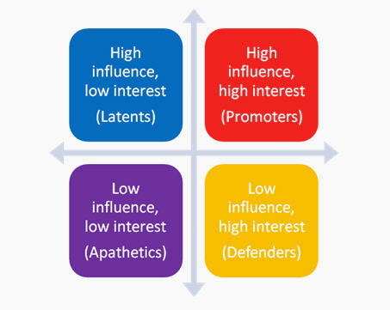

Source: University of Kansas, 2015

***How to coordinate stakeholder involvement?***

It is imperative for LDN target setting to identify and involve representatives from key stakeholders (see above) in the process. In this regard, existing national-level coordination mechanisms can be screened in order to identify suitable mechanisms able to serve as LDN working groups, i.e. as a platform, where interested stakeholders can exchange information and views on the LDN target setting process.

UNCCD or SLM coordination mechanisms exist in many countries and could serve as a basis for the LDN working groups. Generic terms of reference (ToR) for national LDN working groups are proposed in Box 1, which can be adapted as appropriate to the national context.

**Box 1.** Possible Terms of Reference of a national Land Degradation Neutrality Working Group

|  |
| --- |
| **Objective:** Steer the LDN target setting process and promote LDN mainstreaming into national policies and plans  **Tasks:**   1. Provision of information to the stakeholders 2. Representation of stakeholders at national level 3. Provision of a platform for negotiation among stakeholders 4. Review and endorsement of a national LDN target setting road map 5. Identification of key stakeholders and resource persons relevant for the LDN target setting process 6. Review and validation of national reports related to LDN target setting, including national LDN baselines, land degradation trends and drivers assessments, LDN targets and associated measures 7. Support for the organisation of national stakeholder consultations related to LDN target setting 8. Support for national outreach and communication activities related to LDN target setting 9. Support for mainstreaming of LDN target setting in national policy processes, including Sustainable Development Goals 10. Awareness creation among stakeholders on LDN 11. Monitoring and evaluation of the LDN target setting process   **Composition:** +/- 30 members representing:   * Governmental organisations (e.g. national land use planning, agriculture, environment/forestry, trade, statistics, finance) * The private sector (e.g. farmer organisations, trade unions, chambers of commerce, land-based companies, including mining, energy, urbanization) * Academia and research organisations * CSOs * Development partners   **Secretariat:** Institution coordinating the national LDN target setting process (e.g. UNCCD Focal Point Institution) |

Stakeholders should ideally be integrated into all stages of the LDN target setting process as indicated in table 2.

**Table 2**. Stakeholder participation in the national land degradation neutrality target setting process

|  |  |
| --- | --- |
| **Steps** | **Stakeholder engagement** |
| Step 1 | * Identification of stakeholders * Assessment of interest of identified stakeholders in land degradation neutrality (LDN) * Establishment of a national LDN working group * Participation of representatives of key stakeholders in an LDN working group * Organisation of a national LDN target setting inception workshop |
| Step 2-5 | * Identification and mobilisation of stakeholders involved in LDN baseline setting and data provision/processing * Agreement on methodological approaches among stakeholders (LDN working group) * Involvement of stakeholders in the analysis of (sub)national trends and drivers of land degradation and existing land management practices * Organisation of a validation workshop on the results of the LDN assessment and proposed LDN baseline |
| Step 5-7 | * Identification of LDN targets and associated measures * Organisation of a validation workshop on LDN targets and measures |
| Step 8 | * Mobilisation of stakeholders to commit on action to achieve LDN * Facilitation of the political commitment to achieving national voluntary LDN targets * Establishment of LDN-related partnerships |
| Step 9-10 | * Involvement of stakeholders in LDN monitoring, including the analysis and interpretation of related results * Endorsement of an LDN TSP report by an LDN national working group |

## Step 2: Setting the land degradation neutrality baseline

***What is a land degradation neutrality baseline?***

For the purpose of a voluntary target setting exercise, LDN can be understood as a no-net-loss approach. It implies a commitment to maintaining or enhancing the land-based natural capital relative to a reference state. Thus, the reference state, or baseline, is the (minimum) target.

The baseline is expressed as the initial (t0) estimated value of each of the indicators used as proxies of land-based natural capital and the ecosystem services that flow from that land base.

***What is the baseline period?***

The assumption is that, for most countries, **the baseline depends on the current situation and conditions.**

The condition of land is highly variable both spatially and temporally, due to climate variability and the variety of human activities on the land. Therefore, the baseline should be calculated, for each indicator, as an average across 10-15 years.

In line with the adoption of the SDGs in 2015, it is therefore recommended that the default baseline period (t0) be a 10-15 year epoch ending in 2015. However, the exact identification of the baseline will ultimately depend upon available data series at the national level. Countries should therefore clearly state the identified baseline period.

***Which indicators to use to calculate the baseline?***

The baseline should be calculated by estimating, for each of the following indicators, the average value across the 10-15 year baseline period (t0):

1. **land cover;**
2. **land productivity (metric: net primary productivity); and**
3. **carbon stocks above and below ground (metric: SOC).**

The use of this small set of comparable indicators is recommended for baseline setting, detecting changes over time and reporting progress towards LDN targets.

These globally-relevant indicators can be **enhanced and complemented by national (or subnational) level indicators**.

***Why are land cover, land productivity, and carbon stocks used to calculate the baseline?***

The three indicators recommended for calculating the baseline and tracking progress towards LDN targets are part of a set of six progress indicators adopted by the UNCCD to track progress in the implementation of the Convention through national reporting.[4] They have also been recommended as sub-indicators to compute the SDG indicator, “Proportion of land that is degraded over total land area”, adopted to measure progress toward the SDG target 15.3 (see Figure 4).[5] The monitoring approach recommended for LDN therefore builds on the work conducted in recent years to develop a conceptual framework for monitoring the progress of the UNCCD in addressing DLDD. The alignment with the UNCCD and SDG indicator frameworks aims to reduce the reporting burden on countries.

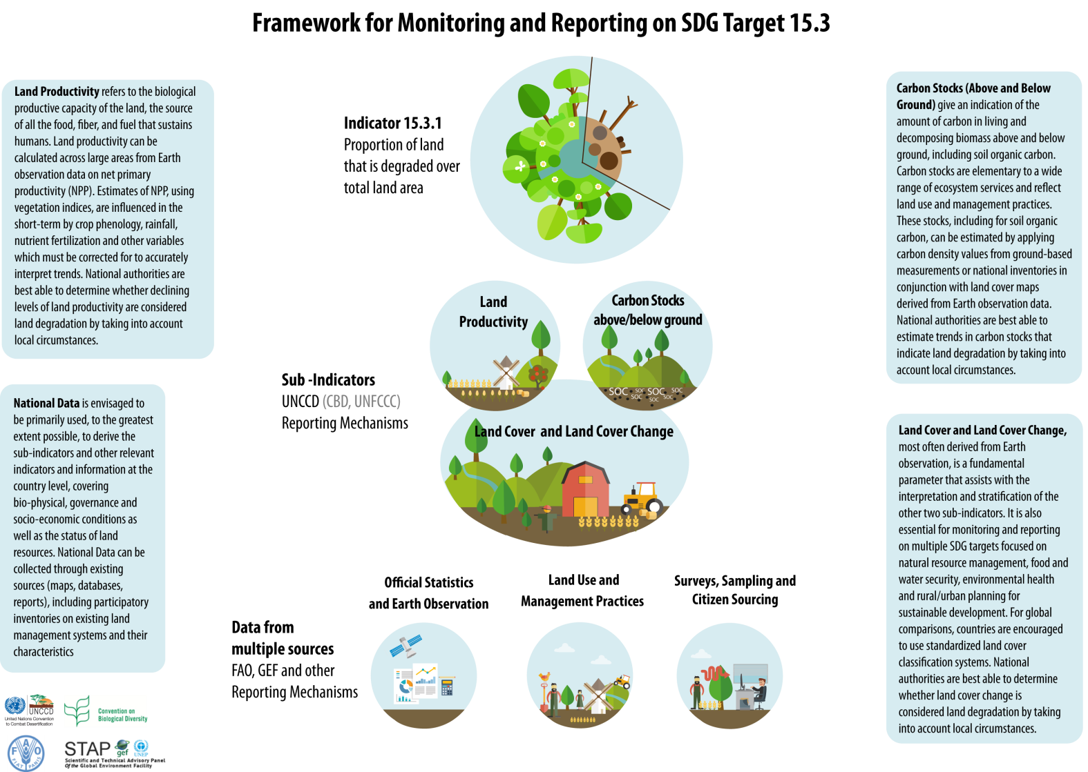

**Figure 4.** Indicator framework for monitoring and reporting on Sustainable Development Goal target 15.3

Source: UNCCD et al., 2016 (adapted)

For the purposes of LDN, it is important to note that the three indicators provide good coverage of the land-based ecosystem services underpinning LDN and together can be used to monitor the quantity and quality of land-based natural capital and the ecosystem services that flow from that land base. In addition, the indicators address change in the system in different yet highly relevant ways. Land cover provides a first indication of a reduction or increase in vegetation, habitat fragmentation and land conversion, land productivity captures relatively fast changes while SOC reflects slower changes that suggest trajectory and proximity to thresholds. As mentioned above, these indicators can, however, be complemented and enhanced by national (or subnational) level indicators to provide full coverage of the ecosystem services associated with the land.

***How to compute the indicators? Which data sources to use?***

The indicators should be computed **primarily**, and to the largest extent possible, using comparable and standardised **national official data sources.**

**Global data sources should be used in the absence of, or to complement and enhance, national data sources.** While in the long term, all countries should be empowered to independently perform relevant data collection and analysis and report on land degradation, global data sources can bridge data gaps and ultimately decrease the reporting burden on countries.

A **tiered approach** is therefore recommended for the computation of the indicators. A tiered approach generally provides advice on estimation methods at three levels of detail, from tier 1 (the default method) to tier 3 (the most detailed method). In the context of the LDN TSP, the following approach is used:

* Tier 1: Global/regional Earth observation, geospatial information and modelling;
* Tier 2: National statistics based on data acquired for administrative or natural reference units (e.g. watersheds) and national earth observation;
* Tier 3: Field surveys, assessments and ground measurements.

Such an approach **allows national authorities to use methods consistent with their capacities, resources and data availability** and facilitates comparability at global level.

A description of the indicators and some broad guidelines for tier 1 computation methods are contained in the following **indicator factsheets**.[6]

As part of the LDN TSP, participating **countries will be provided with default tier 1 data derived from global data sources for their use and validation in the absence of national data**.[7] While a number of suitable global data sources are available for the computation of the indicators, the selected sources of default tier 1 data were identified based on considerations of immediate availability and readiness for use, as along with temporal and spatial coverage and resolution.

***How to evaluate default tier 1 data?***

In the absence of, or as a complement to, national data, countries may decide to use the default tier 1 data provided by the programme or to retrieve and process data from existing open platforms.

**Data derived from global or regional data sources should be contextualised with information at the national and sub-national level**. The most common approach involves the **use of site-based data** to assess the accuracy of the indicators derived from Earth observation and geo-spatial information. Another approach uses site-based data to calibrate and validate Earth observation indices and measures where the remote sensing variable is used to predict the same biophysical variable on the ground.

In the absence of site-based data, one cost-effective solution is to **use high-resolution Google Earth images** as validation data for tracking land cover patterns and their changes over time. User-friendly tools are being developed to facilitate this task (e.g. Collect Earth[8]).

**Qualitative information and stakeholder perspectives** also play an essential role. A range of methods exist to gather these perspectives, including surveys, workshops, in-depth interviews, consultations and the establishment of expert panels. These methods are often based on the principles of expert elicitation (i.e. the synthesis of opinions of technical and scientific experts). Ultimately, it is likely to be the task of the lead organisation and its partners, who coordinate monitoring and reporting at national level in order to interpret what this combination of quantitative and qualitative data reveals about land degradation and restoration trends.

|  |  |
| --- | --- |
| **Land cover** | |
| Definition | Land cover refers to the observed physical cover of the Earth’s surface (Intergovernmental Panel on Climate Change (IPCC, 2003). |
| Meas. unit | Hectares (ha) |
| Relevance | Land cover is a fundamental land surface parameter that assists with the interpretation and stratification of the other two indicators.  Changes in land cover are also important indicators in their own right as they provides a first indication of a reduction or increase in vegetation, habitat fragmentation and land conversion. |
| Method of computation | Most often derived from Earth observation, the indicator requires geospatial mapping of land cover classes using comparable methodologies at regular time intervals. A common ontology (i.e. the formal naming and definition of the types, properties, and interrelationships) should be used to enable global comparisons. The use of the Food and Agriculture Organization’s (FAO) Land Cover Meta Language (LCML) is recommended (FAO, 2016).  The following hierarchical classification is proposed as a reference. Level 1 is based on IPCC land categories (IPPC, 2006). Level 2 is based on land cover classes provisionally used by the System of Environmental-Economic Accounting (SEEA) which uses the FAO LCML (United Nations, 2014). Countries should use this hierarchical classification as a reference and at the level consistent with the amount of information available to describe each land cover class. If a country's national land-use classification system does not match classes in level 1 or 2, the land-use classifications should be combined or disaggregated in order to represent the classes presented here.   |  |  | | --- | --- | | **Level 1** | **Level 2** | | Forest Land | Forest tree cover | | Grassland | Pasture and natural grassland  Shrubland, bushland, heathland  Sparsely vegetated areas  Natural vegetation associations and mosaics | | Cropland | Medium to large fields of rain-fed herbaceous cropland  Medium to large fields of irrigated herbaceous cropland  Permanent crops, agriculture plantations  Agriculture associations and mosaics | | Wetlands | Open wetlands | | Settlements | Urban and associated developed areas | | Other Land | Barren land  Permanent snow and glaciers | | Water bodies (inland water bodies, coastal water bodies, sea) | | |
| Default tier 1 data source | The European Space Agency’s Climate Change Initiative Land Cover dataset (CCI-LC).[9] The dataset has global coverage and spatial resolution of 300m. Three epochs are available centred around 2000, 2005 and 2010; the 2015 epoch is expected to become available shortly. The dataset uses a hierarchical classification system based on the FAO LCML: the 37 CCI-LC classes were aggregated into the level 2 classes listed above. |
| Interpreting trends | Changes in land cover may be characterised as positive or negative when contextualised with national or local information. Some critical transitions are generally considered as negative, for instance those from natural or semi-natural land cover classes to cropland or settlements, from forest land to other land cover classes (i.e. deforestation), as well as those from natural or semi-natural land cover classes and cropland to settlements (i.e. urbanisation). However, the interpretation of changes in land cover is ultimately the responsibility of national and local authorities who should provide explanations as to why changes are evaluated to be positive (gains) or negative (losses) in the given context. |
| **Land productivity** | |
| Definition | Land productivity refers to the total above-ground net primary productivity (NPP) defined as the energy fixed by plants minus their respiration (Millennium Ecosystem Assessment, 2005). |
| Meas. unit | Tonnes of dry matter per hectare per year (tDM/ha/year) |
| Relevance | Land productivity refers to the biological productive capacity of the land, the source of all the food, fibre, and fuel that sustains humans (i.e. provisioning ecosystem services). Maintaining and enhancing the productivity of agro-ecosystems in a sustainable manner reduces the pressure for expansion and thus minimises the loss and degradation of natural ecosystems. |
| Method of computation | The indicator can be calculated across large areas from Earth observation data on net primary productivity (NPP). In terms of maturity and “operational readiness”, vegetation indexes as proxies for NPP are most realistic to use routinely at this time (Yengoh et al. 2015). The Normalized Difference Vegetation Index (NDVI) is by far the most commonly used vegetation index. The following sources of NDVI time series are accessible at low cost or no cost, inter alia:   * AVHRR: 1982-present, 8 km resolution; 1989-present, 1km resolution * MODIS: 2000-present, 250m resolution * SPOT Vegetation: 1999-present, 1 km   Proxies to measure NPP, such as NDVI and other vegetation indices, are influenced in the short-term by crop phenology, rainfall, nutrient fertilisation and other variables which must be corrected to accurately interpret trends.  Land productivity data should be disaggregated by land cover. |
| Default tier 1 data source | The Joint Research Centre’s Land Productivity Dynamics dataset (LPD).[10] The dataset has been derived from a 15-year time series (1999 to 2013) of SPOT Vegetation NDVI observations composited in 10-day intervals at a spatial resolution of 1 km. |
| Interpreting trends | Areas with increasing NPP should be interpreted as improving, unless assessed otherwise at country level. For example, bush and tree encroachment (i.e. land cover change from grassland to shrub-dominated) in the drylands often leads to a loss of natural capital with less forage for grazing animals and wildlife. It is therefore considered to be land degradation, even though the NPP and soil organic carbon (SOC) may both be increasing. In cases where a “false positive” has been identified, countries should report the anomalies backed by evidence as a means of providing a more accurate assessment of LDN. |

|  |  |
| --- | --- |
| **Carbon stocks above and below ground (metric: soil organic carbon)** | |
| Definition | Carbon stock is the quantity of carbon in a pool (i.e. a system which has the capacity to accumulate or release carbon). Terrestrial carbon pools are biomass (above-ground biomass and below-ground biomass); dead organic matter (dead wood and litter); and soil (soil organic matter) (IPCC, 2003).  SOC should be used as metric to assess carbon stocks, to be replaced by the total terrestrial system carbon stock (above and below ground carbon) once operational. |
| Meas. unit | Tonnes of carbon per hectare (t/ha C) |
| Relevance | SOC is an indicator of overall soil quality associated with nutrient cycling, water holding and its aggregate stability and structure. SOC stocks are therefore of local importance, but also of global importance because of their role in the global carbon cycle: the SOC pool can be both a source and sink of carbon and is thus fundamental to the estimation of carbon fluxes. SOC stocks are largely influenced by anthropogenic activities such as land use change and management practices, which affect the productive potential of the soil. |
| Method of computation | Coarse estimates of SOC stock changes can be produced with the help of modelling techniques. As part of its methods for greenhouse gas (GHG) inventories in the land sector, the IPCC offers a relatively simple approach to model stock changes in SOC (IPCC, 2006). For estimations at tier 1 level, the IPCC provides default reference values for SOC stocks under different climate/soil combinations for a reference depth of 30cm (see table 2.3 in IPCC 2006) as well as carbon stock change factors for different land use (6 IPCC land use/cover classes) and land management regimes. In the absence of national data, this allows for broad estimates on SOC changes in areas where land cover has changed. To a more limited extent, this approach also allows for estimates on SOC changes in areas where the land cover class did not change but where substantial management changes (e.g. restoration, irrigation, fertilisation) have occurred. This requires clear information on the spatial extent of the management practice. |
| Default tier 1 data source | The International Soil Reference and Information Centre’s SoilGrids250m (2016, in prep.)[11] SOC stocks are computed from SOC content, gravel content, soil depth and bulk density data estimated for each depth layer and aggregated to SOC content for topsoil (0-30 cm depth) and subsoil (below 30 cm).  The accuracy of prediction can be improved by incorporating more shared soil profile data. To improve predictions for country, consider contributing soil profile data via the ISRIC (World Soil Information) data portal can be considered.[12] |
| Interpreting trends | Areas with increasing SOC should be interpreted as improving, unless assessed otherwise at country level. For example, bush and tree encroachment (i.e. land cover change from grassland to shrub-dominated) in the drylands often leads to a loss of natural capital with less forage for grazing animals and wildlife. It is therefore considered to be land degradation, even though the SOC and net primary productivity may both be increasing. In cases where a “false positive” has been identified, countries should report the anomalies backed by evidence as a means of providing a more accurate assessment of LDN. |

## Step 3: Assessing land degradation trends

***Why assessing land degradation trends?***

Setting the LDN baseline, as described in step 2, is a stock-taking exercise where a snapshot of the current land-based natural capital is taken; it does not provide any information on the current status of land degradation.

A retrospective assessment of land degradation trends, coupled with an analysis of the driving forces behind these trends (step 4), is an essential step in terms of **understanding current conditions of land degradation, revealing anomalies and identifying degraded areas.** Such an assessment will provide an **informed evidence base for setting sound LDN targets, making decisions about potential interventions and prioritising efforts in areas where degradation is taking place.**

Ideally, in order to determine viable intervention options for any specific site, the assessment of land degradation trends should be complemented by reliable assessments of: i) the potential or capability of the land to support a range of sustainable land uses and management practices; and ii) of its resilience to cope with shocks. Land capability is the ability to accept a type and intensity of land use permanently, or for a specified period under management that does not result in long-term degradation (Houghton and Charman 1986). Guidelines for land capability evaluations were established by FAO (1976 and 2007). Resilience assessment considers the current condition of the land, and its likely trajectory under anticipated stressors and shocks, particularly the likely impacts of climate change. Tools including the Resilience Adaptation Pathways and Transformation Assessment (RAPTA)[13] and Self-evaluation and Holistic Assessment of climate Resilience of farmers and Pastoralists (SHARP)[14] are available to guide resilience assessment.

Many countries have already conducted assessments of the status and trends of land degradation using a variety of different approaches (e.g. Land Degradation Assessment in Drylands (LADA), carried out by the FAO) and implemented some form of land evaluation for the assessment of the land potential. In order to leverage the efforts made, countries are encouraged to use the results from those assessments to underpin the LDN target-setting process.

In the absence of such assessments, or to complement existing information, step 3 provides countries with a possible approach to assessing land degradation trends, while step 4 provides guidance on the analysis of drivers of land degradation. As causes (drivers) and effects (trends) are directly linked, the two steps may be carried out in parallel, rather than one after the other.

***What is land degradation and how do we assess it?***

According to the UNCCD (1994),

**Land degradation** is defined as “reduction or loss, in arid, semi-arid and dry sub-humid areas, of the biological or economic productivity and complexity of rainfed cropland, irrigated cropland, or range, pasture, forest and woodlands resulting from land uses or from a process or combination of processes, including those arising from human activities and habitation patterns, such as: (i) soil erosion caused by wind and/or water; (ii) deterioration of the physical, chemical and biological or economic properties of soil; and(iii) long-term loss of natural vegetation”.

**Desertification** is defined as “land degradation in arid, semi-arid and dry sub-humid areas resulting from various factors, including climatic variations and human activities”.

**Land degradation**, which does not occur in linear or easily mapped patterns, **can be more readily detected as a change in the values of a specific set of consistently measured indicators** than by assessing land degradation status. The precision (repeatability) in such measurements of change may be fairly high, while the accuracy (the proximity of the measured value is to the actual value) of the major global efforts to assess land degradation has been relatively low.[15]

***How do we assess land degradation trends?***

**The three indicators used for setting the baseline** (i.e. land cover, land productivity and carbon stocks above and below ground (metric: SOC)), complemented as needed by nationally relevant indicators, **can also be used to assess trends**.

When setting the baseline it is necessary to estimate, for each indicator, the average value across the five-year baseline period (t0), however **a retrospective trend analysis requires an observation of the changes in the value of the indicators over a 10-15 year assessment period prior to the current condition (i.e. 2000-2015)**.

As these indicators are complementary rather than additive and components of land condition, they should be analysed separately. However, land cover, while being an important indicator in its own right, should also be used to stratify the other two indicators.

**Degradation is generally considered to occur when:**

* land productivity shows a significant negative trend; or
* SOC shows a significant negative trend; or
* negative land cover change occurs; or
* a negative change occurs in another nationally relevant indicator.

However, trends in the indicators need to be interpreted in the context of local conditions.

***How do we interpret trends in the indicators?***

Interpreting changes in the indicators is likely to be the task of the national and local authorities and institutions that coordinate monitoring for national-level reporting. Relevant stakeholders should be involved in the interpretation of data.

**Changes in land cover may be characterised as positive or negative when contextualised with national or local information**. Some critical transitions are generally considered as negative, for instance those:

* from natural or semi-natural land cover classes to cropland or settlements;
* from forest land to other land cover classes (i.e. deforestation), as well as those
* from natural or semi-natural land cover classes and cropland to settlements (i.e. urbanisation).

However, the identification of critical processes and the interpretation of changes in land cover should include explanations as to why changes are evaluated to be positive or negative in a given context (see also figure 6).

Areas with increasing land productivity and SOC stocks can generally be interpreted as improving, while areas with decreasing land productivity or SOC stocks can be interpreted as deteriorating (i.e. degradation).

However, under exceptional circumstances, these indicators can lead to “false positives”. For example, bush and tree encroachment (i.e. land cover change from grassland to shrub-dominated) in the drylands often leads to a loss of natural capital with less forage for grazing animals and wildlife. It is therefore considered to be land degradation, though the NPP and SOC may both be increasing. In cases where a “false positive” has been identified, countries should report the anomalies backed by evidence as a means of providing a more accurate assessment of LDN.

Generally, the areas in question are well-known by national ministries of agriculture and research centres, and can be easily identified on publically available high-resolution satellite imagery servers such as Google Earth or equivalent data sources.

***Which data sources do we use to assess trends?***

The identification of land degradation trends requires reliable data series on the indicators.

At tier 1, **the same data sources used to calculate the baseline can also be used to assess trends** (see step 2 and the indicator factsheets for more information). Participating countries will be provided with default tier 1 data in a standard format that facilitates their computation in order to identify and quantify trends.

At tier 2 and 3, these time series of data can be substituted or complemented by national official data series on the same indicators. Additional indicators relevant to land degradation can be used at the discretion of participating countries.

**Box 2**. Possible support of the Land Degradation Neutrality Target Setting Programme in the assessment of land degradation trends

|  |
| --- |
| The Land Degradation Neutrality Target Setting Programme will provide countries with:  Land cover data for the epochs 2000 and 2010 as well as land cover changes for the period 2000-2010 at a spatial resolution of 300 meters, derived from the European Space Agency’s Climate Change Initiative Land Cover dataset. Land cover and land cover change 2000-2015 may become available.  Land productivity trends derived from a 15-year time series (1998 to 2012) of global Normalized Difference Vegetation Index observations composited in 10-day intervals at a spatial resolution of 1 km. The European Commission Joint Research Centre’s Land Productivity Dynamics dataset (LPD) provides five LPD classes as follows: 1) declining, 2) early signs of decline, 3) stable but stressed, 4) stable not stressed, and 5) increasing. The five qualitative classes of productivity trends do not correspond directly to a quantitative measure of lost or gained annual ecosystem biomass productivity. The five classes are rather a qualitative combined measure of the intensity and persistence of negative or positive changes of photo-synthetically active vegetation over the observed period. For the identification of degraded areas, it is recommended to pay particular attention to the areas classified as LPD classes 1) declining, 2) early signs of decline, and 3) stable but stressed. Land productivity data can be aggregated by land cover classes to calculate the rate of forest, grassland or cropland productivity decline.  Data on soil organic carbon (SOC) for the year 2010, derived from the International Soil Reference and Information Centre’s SoilGrids250m. In the absence of data from a previous period, SOC trends cannot be assessed. However, the analysis of trends in land cover and land productivity, eventually coupled with the analysis of trends in other nationally relevant indicators, can be considered sufficient to obtain an overview of on-going land degradation processes, necessary for practical LDN target setting. Coarse estimates of SOC stock changes can be produced with the help of modelling techniques. As part of its methods for greenhouse gas inventories in the land sector (Intergovernmental Panel on Climate Change (IPCC), 2006), the IPCC offers a relatively simple approach to modelling stock changes in SOC based on land cover change. During the LDN project, Italy already successfully used this approach to derive broad estimates for trends in SOC stock change based on land cover change and using national SOC data (i.e. Tier 2) (Ministerio dell’Ambiente & UNCCD, 2015). |

**Figure 6.** Identification of critical processes

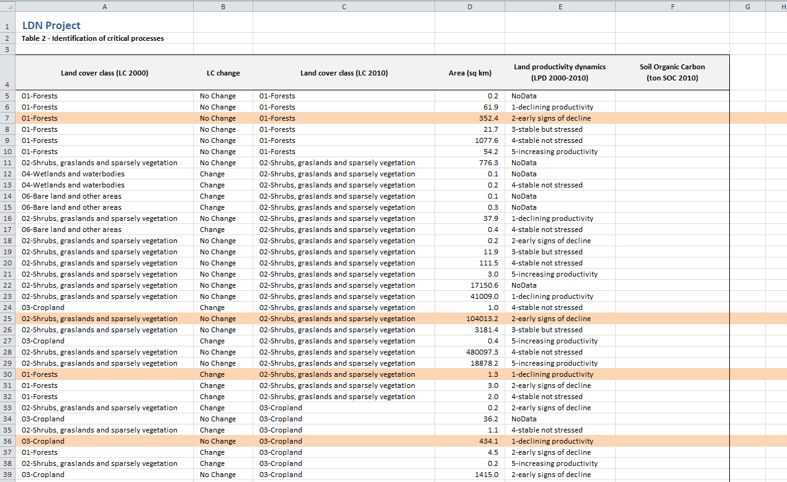

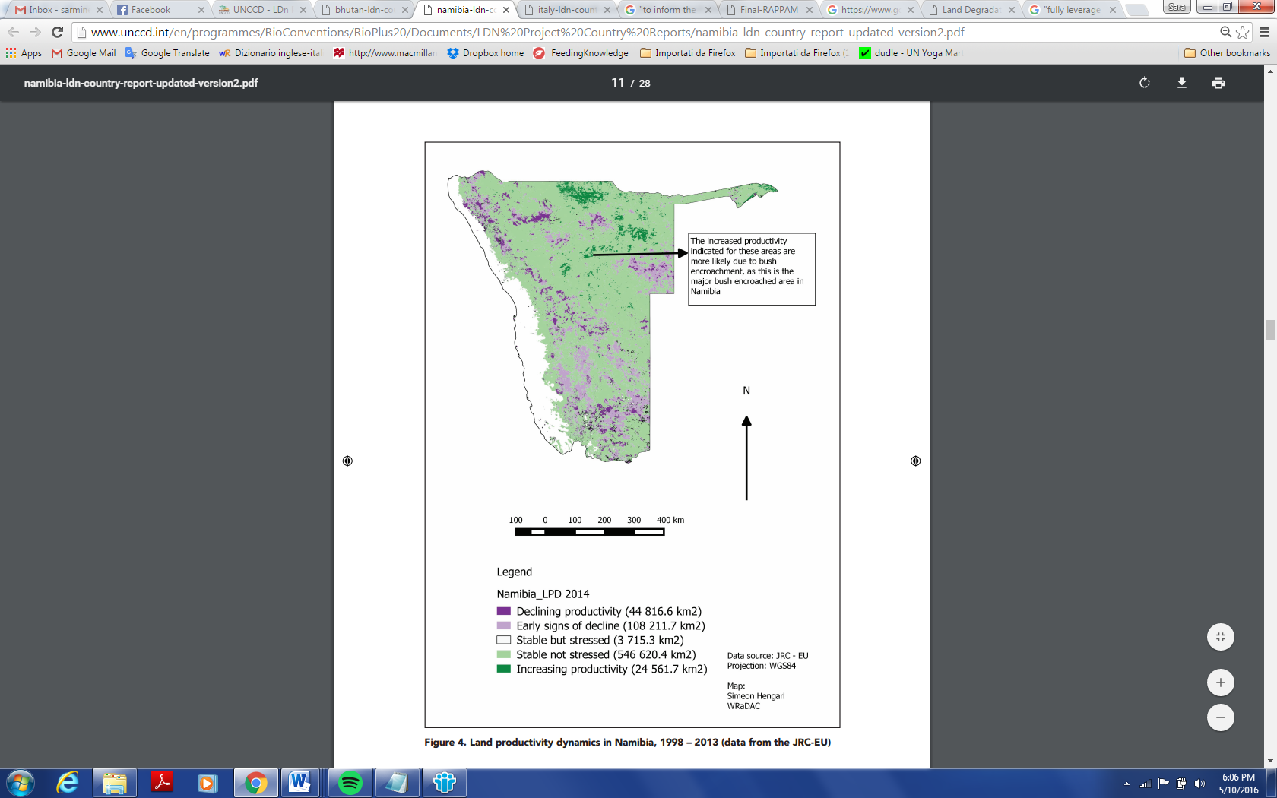N.B. In figure 1, some rows are highlighted to demonstrate how to read the data. In row 7, 352.4 sq. km of ‘forest’ (which remained ‘forest’ in 2010) show early signs of decline. Similarly, in row 25, 104013.2 sq. km of ‘shrubs, grasslands and sparsely vegetated areas’ show early signs of decline, and in row 36, 434.1 sq. km of ‘cropland’ show declining productivity. In row 30, 1.3 sq. km of ‘forest’ in 2000 changed into ‘shrubs, grasslands and sparsely vegetated areas’ in 2010 over an area with declining productivity.

**Figure 7.** Land productivity dynamics in Namibia, 1998 – 2013 (data from the JRC-EU) (Source: Republic of Namibia & UNCCD, 2015)

***How do we identify possible hot spots of land degradation?***

As a result of the assessment of land degradation trends, areas exposed to land degradation (step 3) and indirect causes of land degradation can be identified (see step 4). Therefore, further assessments in selected areas may be required to fully understand the land degradation dynamics using additional indicators and data sources, including possible field visits. These areas may cover different ecological zones and may be exposed to different direct drivers of land degradation.

This in-depth assessment will help to verify whether these areas are indeed land degradation hotspots and if they should become a priority for action to achieve LDN.

## Step 4: Identifying drivers of land degradation

Once the trends of land degradation have been identified, quantified and localised, and prior to defining measures to address the problem, two important steps should be carried out to better understand land degradation dynamics at (sub)national level:

1. analysis of the drivers of the degradation processes in the different parts of the country; and
2. assessment of the land management legal and institutional framework impacting LDN.

Land degradation is contextual and cannot be judged independently of its spatial, temporal, economic and cultural context (Warren, 2014). Various types of human activities and natural causes may lead to land degradation which is usually the result of the often complex interaction of different types of drivers. Two types of drivers can be distinguished:

* **proximate (direct) drivers** are directly linked to the local land use system;
* **underlying (indirect) drivers** can be local, national or global and include demographic, economic and socio-political circumstances.

In order to assess land degradation drivers behind the land degradation trends identified previously, it is recommended to analyse the causal chains as follows:

* First, identify the type(s) of land degradation for each area affected;
* Second, identify the direct drivers causing the identified types of land degradation;
* Third, identify the indirect drivers of land degradation.

***Diversity of types of land degradation***

While undertaking the assessment of land degradation drivers, it is important to first identify the land use categories affected by land degradation and to specify for each of them the type(s) of land degradation. There are five basic land-use categories, which can be matched up with the land cover classes described before and which are subject to land degradation: cropland, grazing land (used for animal production), forest, mixed land use (mainly agroforestry, agro-pastoralism, silvo-pastoralism), and non-vegetated artificial land use (mining, human settlements, communication, energy and water infrastructure).

These different land uses are subject to specific forms of land degradation. The World Overview of Conservation Approaches and Technologies (WOCAT: https://www.wocat.net) identifies six main types of degradation:

1. **Soil erosion by water,** including loss of topsoil and tillage erosion, generally preceded by compaction, gully erosion, landslides and riverbank and coastal erosion. Soil erosion by water causes off-site degradation effects such as the deposition of sediments downstream, flooding, siltation of reservoirs and waterways and pollution of water bodies with eroded sediments. The main proximate causes of soil erosion by water are insufficient land vegetation cover along with improper management of the soil and crops, often amplified by natural causes such as topography, heavy/extreme rainfall?
2. **Soil erosion by wind,** including loss of topsoil – a very frequent form of degradation in arid zones – caused by the excessive reduction of the land vegetative cover, silt and clay deflation hollows and off-site degradation, such as overblowing (deposition of sandy particles at a significant distance from its origin).
3. **Chemical soil deterioration**, including fertility decline and reduced organic matter content due to “soil mining” (nutrient outputs through harvesting, burning or leaching are not or insufficiently compensated by imports of nutrients and organic matter such as manure, compost, returned crop residues and flooding). This type of degradation is frequently combined with oxidation and volatilisation, i.e. emissions of the greenhouse gases N2O, CO2 and CH4. This is increasing, particularly under intensive commercial agricultural systems, namely mono-cropping. Another form of chemical soil deterioration is acidification (lowering of soil pH) due to the use of acidic fertilisers and, occasionally, atmospheric deposition (acid rain is common near major industrial cities). Soil pollution refers to the contamination of the soil with toxic materials from local or diffuse sources. It also includes salinisation and alkalinisation with the net increase in salt content in the topsoil leading to a productivity decline due to its toxicity for crops. This widespread type of degradation is typically found in large-scale irrigation perimeters, caused by a combination of excessive watering, insufficient drainage and improper crop management (insufficient soil vegetative cover).
4. **Physical soil deterioration**, including compaction, corresponding to a deterioration of soil structure due to trampling and the weight and/or frequent use of heavy machinery. It also encompasses sealing and crusting, i.e. the clogging of soil pores with fine soil materials, creating a thin, impervious layer at the soil surface and obstructing the infiltration of rainwater. This type of degradation is common in intensive commercial cereal production, especially under irrigation, but is also present in shifting cultivation when a slim water-repellent layer develops beneath surface ashes. Generalised soil sealing in urban areas and infrastructure produces significant off-site degradation effects such as downstream flooding. Human-induced water saturation through irrigation frequently causes waterlogging. Subsidence of organic soils and settling of soil are a major form of land degradation when draining peatlands or low-lying heavy soils to convert them into croplands and increase their productivity. Finally, some land use changes (mining, construction) erode the land’s bio-productive function.
5. **Water degradation**, including aridification (reduced average soil moisture content) due to declining rainfall (climate change) causes reduced time to wilting, affects phenology and leads to a lower yield. It also encompasses the decline in quantity of surface water (low flooding and drying up of rivers and lakes); the lowering of groundwater table (due to over-exploitation or reduced recharge of groundwater); an increased groundwater table (due to excessive irrigation resulting in waterlogging and/or salinisation); a decline in surface water quality (due to increased sediments and pollutants in fresh water bodies caused by direct effluents from intensive livestock production facilities, excessive use of agrochemicals – fertilisers and biocides, industry, sewage and waste water in river water bodies). The destruction of wetlands weakens the capacity to buffer floods and pollution.
6. **Biological degradation**, including reduced vegetation cover that results in increased bare soil and unprotected soil, loss of habitats (decreasing vegetation diversity in fallow land, mixed systems and field borders and hedges), quantitative biomass decline (caused by forest clearfelling or secondary vegetation with reduced productivity) and the detrimental effects of cold and hot fires on forests (slash and burn), bush, grazing and cropland. It also encompasses the loss of natural species, palatable perennial grasses and the spreading of invasive, salt-tolerant, unpalatable weeds, mainly due to the over-exploitation of natural species over time. Last but not least, biological degradation includes loss of soil life – composed of macro-organisms (earthworms and termites, acaridans) and micro-organisms (bacteria, fungi) – in both quantity and quality, mainly due to acidification and salinisation, and an increased number of pests due to predator loss following soil and water pollution.

***Main direct and indirect drivers of land degradation***

The main direct and indirect drivers of land degradation, as identified by WOCAT, are summarised in table 3.

**Table 3.** Main direct and indirect drivers of land degradation

|  |  |
| --- | --- |
| **Direct drivers of land degradation** | **Indirect drivers of land degradation** |
| * Improper management of the soil * Improper management of annual, perennial, scrub and tree crops * Deforestation and removal of natural vegetation * Over-exploitation of vegetation for domestic use * Overgrazing * Industrial activities, waste deposition and mining * Urbanisation and infrastructure development * Discharges * Release of airborne pollutants * Disturbance of the water cycle * Over-abstraction of water * Natural causes | * Population pressure * Land tenure * Poverty/wealth * Labour availability * Inputs (including access to credit/financing) and infrastructure * Education, access to knowledge and support services * War and conflict * Governance, institutional settings and policies (including taxes, subsidies, incentives) |

Source: World Overview of Conservation Approaches and Technologies, undated (adapted)

All forms of degradation and proximate or underlying drivers have internally recognised codes which can be used as attributes and included in descriptive Geographical Information Systems (GIS) tables. Such records can be part of the land degradation neutrality monitoring system. The codes are available at WOCAT (undated).

***How to identify drivers***

In the context of the LDN target setting process, the driver analysis can be carried out using the following approaches:

* Consultations within the national LDN working groups;
* Desk analysis and hot spot selection;
* Quick visits to hot spots to identify drivers and causal chains;
* Validation by experts.

This analysis should be complemented by an analysis of the main areas affected by negative trends using archive maps, satellite images, aerial photographs made available by governmental and non-governmental agencies, universities and specialised research centres, along with scientific papers analysing past negative land cover changes (e.g. 2000, 1990, 1970, prior).

The output of the retrospective geospatial trend analysis (step 3) and the assessment of drivers (step 4) should be:

* a national map locating degraded/degrading areas, identified and classified by type of land degradation process;
* a representative sample of degraded/degrading areas (e.g. at watershed level), taking into account the climate, soil nature, topography, accessibility and type(s) of land degradation processes concerned as well as the cultural and historical background of the landscape.

This sample may form the initial basis for future selection of possible LDN hot spots for action. Generally, three to ten sizeable areas (20,000 ha as a minimum) are sufficient to obtain a representative sample of the national territory conditions with regards to land degradation problems.

A quick visit to selected hot spots is proposed to verify the assumptions of the desk review on the ground, focusing on the nature, intensity and dynamics of the land degradation processes and associated drivers. The field visit is essential to acquire an in-depth understanding of the human dynamics having initiated and enabled the degradation process.

***Analysing the regulatory and institutional framework impacting land degradation neutrality***

The analysis of the legal and institutional framework governing land management is of paramount importance in terms of identifying gaps, inconsistencies, weaknesses and opportunities in order to create or enhance the national regulatory environment in view of achieving LDN. In this context, the UNCCD NAPs can provide a starting point for this assessment, as they (should) cover most of the technical, legal, policy and financing aspects related to land degradation.

***Analysing the legal and institutional framework in relation to identified drivers and trends***

Legal, institutional and public development policies are often underlying indirect drivers, which may contribute to either land degradation or the promotion of SLM/ILM practices. Without strong intervention from the public sector, in close coordination/cooperation with other stakeholders such as the private sector and civil society organisations, the achievement of LDN is unlikely to happen. Indeed, land degradation is deeply rooted at the interface between the availability of natural resources, evolving climate conditions, the interaction between different land users and the overall socio-economic and development context (opportunities and limitations) of a country.

SLM/ILM is often jeopardised by unclear land tenure and unsecured land rights, adverse international market conditions, competing economic sectors and actors (farmers and livestock producers, mines, industries, urbanisation) and inadequate access to appropriate education, knowledge, infrastructure and support services (including access to credit for investment, taxes, incentives and subsidies), which can undermine efforts to achieve LDN. These elements often fall under the authority of the Government and require an effective governance strategy that takes into account the (sometimes conflicting) interests of various stakeholder groups.

***How to assess the legal and institutional framework in light of achieving land degradation neutrality***

The LDN-related legal and institutional framework can be assessed by analysing its strengths, weaknesses, opportunities and threats (SWOT analysis), including by drawing on the UNCCD NAP as one of the references.

Key issues to be addressed during the SWOT analysis include:

* Strengths: legal basis and institutional framework conducive to achieving LDN;
* Weaknesses: legal and institutional bottlenecks that may hinder the achievement of LDN;
* Opportunities: positive trends/elements that should be further strengthened to achieve LDN;
* Threats: negative trends/elements that must be addressed to achieve LDN.

The strengths and weaknesses can be considered as internal factors to be defined or controlled by the Government as the responsible entity for coordinating LDN target setting and UNCCD NAP implementation. The opportunities and threats can be considered external factors, which are not under the direct control of the Government and require the mobilization of a broader range of stakeholders, including the private sector, civil society organizations and development partners.

***Brief description on how to organise the SWOT***

A SWOT analysis is best developed in a group setting, such as the National LDN working group, as all key actors are represented. Involving all members of the National LDN working group is important to have different perspectives on same problems, to raise awareness on indirect drivers, to promote interactions among stakeholders and to prepare for consensus and multi-stakeholder cooperation in the context of the LDN target setting process.

The SWOT meetings must allow participants to creatively brainstorm, identify obstacles and strategies potential solutions/ways forward regarding these limitations. They could include the following steps:

* Identification of relevant documentation;
* Review of the NAP and other documents creating the legal and institutional framework Compilation of a synthesis report, including the main elements appearing to be strengths, weaknesses, opportunities and threats;
* Discussion of the main findings of the report;
* Validation of SWOT by all stakeholders.

***How SWOT analysis feeds land degradation neutrality target setting***

The SWOT analysis is an essential step in the LDN target setting process, as it:

* Provides a better understanding of the legal and institutional framework and its (positive and negative) implications for LDN;
* Provides the opportunity to incorporate the results of the SWOT analysis into the UNCCD NAPs; and
* Identifies actions which may be included in the set of measures to achieve LDN.

## Step 5: Defining national voluntary land degradation neutrality targets

***What is a land degradation neutrality target?***

Defining LDN targets is about defining the level of ambition on LDN, i.e. **broad, yet clear and measurable** objectives on what a country wants to achieve in terms of halting and reversing land degradation and restoring degraded lands.

Overall, the LDN target should aim to achieve a balance between ongoing land degradation and future efforts to improve degraded land. In other words, it aims at **reaching, at least, a neutral status (no net loss of healthy and productive land) by balancing potential gains and losses** in terms of ecosystem services and functions that are provided by land resources.

In line with this overall aim, countries may wish to complement nation LDN targets with targets at sub-national scale:

* **LDN at the national scale:** the ambition is no net loss for the whole territory of a country and all its land cover classes. This means that any ongoing or anticipated land degradation (losses) will be counterbalanced with interventions to reverse land degradation occurring elsewhere (gains). Countries may set their LDN target above no net loss to raise the level of ambition and enjoy additional benefits.
* **LDN at the sub-national scale:** LDN targets can also be defined for specific regions. These geographically confined targets for achieving a neutral (no net loss) or improved (net gain) state allow countries to focus on areas that have been identified as degradation “hot spots” and considered to be a high-value priority in achieving LDN.

Additionally, the LDN approach also embraces more specific targets to avoid, minimize and reverse land degradation. While such targets are not defined in terms of neutrality they can play a critical role achieving a LDN state:

* **Specific targets to avoid, minimize and reverse land degradation:** These may be defined with reference to specific land cover classes. Degradation drivers and processes are usually linked to certain land cover classes and can be addressed by setting targets that are explicit in this regard. Targets in this category can take many different forms with varying degrees of comprehensiveness and ambition (see Box 3).

Countries may choose to set their voluntary LDN target(s) by following one or a combination of these approaches (see Box 3).

***What is the time reference for land degradation neutrality targets?***

LDN is an integral part of the 2030 Agenda for Sustainable Development (SDG target 15.3). As such, the time horizon for the **achievement of LDN targets (t1) is proposed to be the year 2030**.

In line with the adoption of the SDGs in 2015, the **proposed default baseline year (t0) is 2015** (10-15 year average) (see Step 2).

**Box 3.** Examples of different LDN targets

**LDN at the national scale**

* LDN is achieved by 2030 as compared to 2015 (no net loss)
* LDN is achieved by 2030 as compared to 2015 and an additional 10% of the national territory has improved (net gain)
* LDN is achieved by 2025 as compared to 2015 (earlier target year)

**LDN at the sub-national scale**

* LDN is achieved in the western province of country X by 2030 as compared to 2015 (no net loss)
* LDN is achieved in the southern province of country X by 2030 as compared to 2015 and an additional 25% of the province territory has improved (net gain)

**Specific targets to avoid, minimize and reverse land degradation**

* Improve productivity and SOC stocks in cropland and grasslands by 2030 as compared to 2015
* Rehabilitate X million hectares of degraded and abandoned land for crop production by 2030
* Halt the conversion of forests and wetlands to other land cover classes by 2020
* Increase forest cover by 20% by 2030 as compared to 2015
* Reduce the rate of soil sealing (conversion to artificial land cover) by 50% by 2030 as compared to 2015

***What kind of information should be taken into account when setting a LDN target?***

LDN target setting is first and foremost a political process to define aspirational goals on what the country wants to achieve in the future. Nonetheless, target setting should be based on best available knowledge to set ambitious, yet realistic targets. The data generated and analysis provided within the previous steps, particularly the assessment of land degradation (step 3) and its drivers (step 4), play a key role in informing LDN target setting. Decision-making also needs to take into account relevant policies, trends and goals in the field of land-use, agriculture, forests, environmental protection, economic development and their spatial implications. Furthermore, relevant stakeholder groups must be involved in the LDN target setting process in order to ensure ownership and evaluate trade-offs early on in the planning process.

***When is land degradation neutrality achieved?***

The aim of LDN is to **maintain (no net loss) or improve (net gain) the health and productivity of the land. In this sense, the state of LDN is achieved if the land-based natural capital (as measured and validated by the three indicators presented in Step 2) is maintained or enhanced** between the baseline period (t0) and a future date when progress is monitored (t1): **t1 ≥ t0**. In other words, LDN is achieved if **gains** in the land-based natural capital of the target area **equal or exceed losses** (see Step 9).

Countries aspiring to be more ambitious are invited to define targets focused on reversing land degradation. This could apply to countries with large areas of already degraded land that they wish to restore.

## Step 6: Mainstreaming LDN in land use planning

While the previous step dealt with the question of WHAT is to be achieved, this step focuses on HOW it can be achieved. It highlights the importance of land-use planning in achieving LDN and presents “LDN as a planning principle” whereas the subsequent step (step 7) focuses more specifically on the identification of measures conducive to achieving LDN targets.

***What is the role of land-use planning in implementing LDN?***

The ultimate objective of LDN (to maintain or increase the land resource base and its ecosystem services, including water resources) can only be realised if the right land-use decisions are taken. In order to influence decision-making, LDN must be mainstreamed into existing environmental, agricultural, infrastructure and overall development policies and plans, including UNCCD NAPs. Most importantly, **LDN must become an essential component integrated land-use planning**. Integrated land-use planning is based on the evaluation of the positive and negative impacts of different land-use options.

LDN itself can be considered a planning principle that guides the implementation of a “no net loss” policy. **LDN as a planning principle** involves making land-use decisions according to a **response hierarchy** that prioritises the avoidance of land degradation:

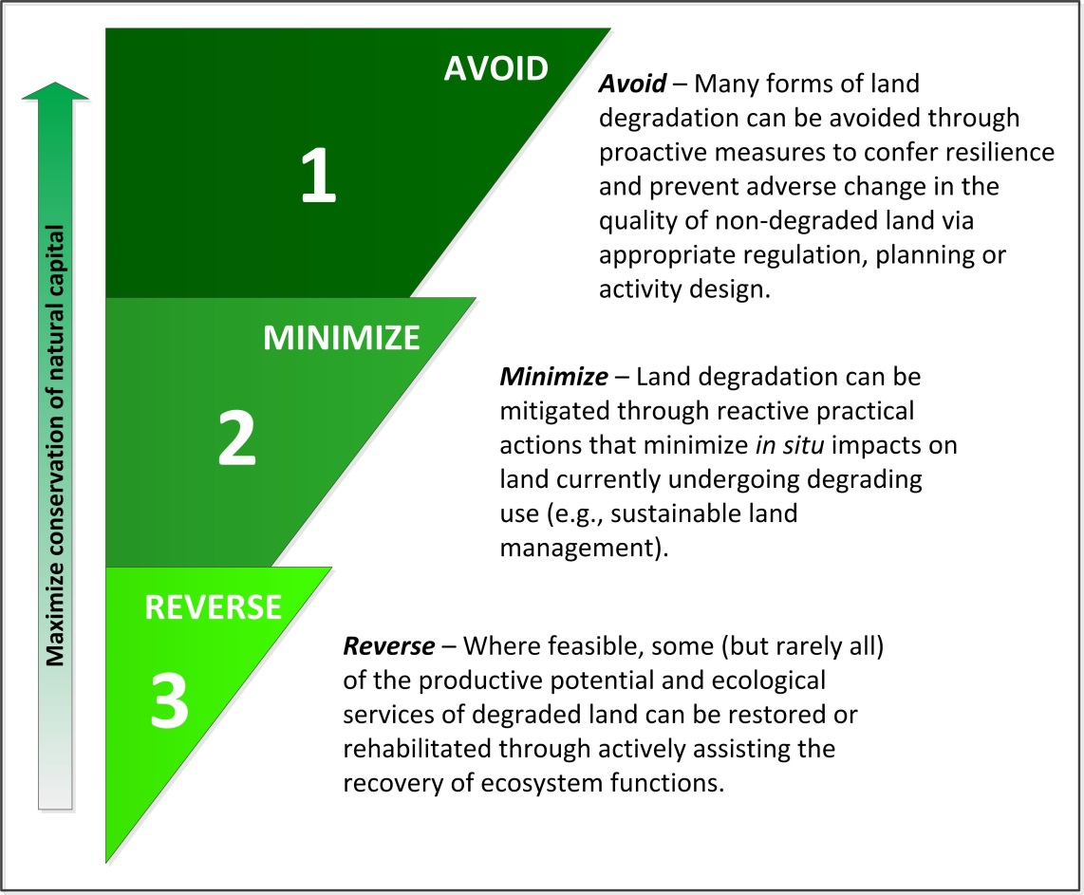

**Figure 8.** The land degradation neutrality (LDN) response hierarchy (Source: UNCCD SPI, 2016)

The rationale for this response hierarchy can be summarised as “prevention is better than the cure”. It is widely recognised that the **avoidance of land degradation is clearly beneficial** from both an ecological and economic point of view. Restoration efforts can succeed in bringing back important ecosystem functions, but often it is not feasible to fully restore all of the ecosystem services historically provided. Moreover, the restoration proves to be more costly than prevention measures. As a result, there is a strong case to make full use of the possibilities to avoid and minimise land degradation in the first place.

At the same time, many countries have large areas of land already degraded as a result of unsustainable land management practices. Preventive interventions are no longer an option, however, giving up on such areas should not be an option either. Instead, **degraded lands usually have significant potential for restoration or rehabilitation**. Depending on local circumstances, many degraded areas can be transformed into biologically and/or economically productive areas. The rehabilitation of degraded land for agricultural purposes or other uses generates not only benefits the land users but also prevents the further conversion of natural ecosystems into cultivated land.

***What does counterbalancing mean?***

Despite the fact that priority is given to avoiding and minimising land degradation, degradation cannot always be prevented due to population growth and the need to expand agricultural or settlement areas, for instance. In such cases of unavoidable degradation, land-use planners should consider counterbalancing the newly degraded area by restoring land that is already degraded. This is, in fact, what distinguishes LDN from existing strategies to fight land degradation. While highlighting the need to prevent land degradation, **LDN entails the possibility of counterbalancing unavoidable land degradation (“losses”) through restoration or rehabilitation efforts elsewhere (“gains”)**, thereby enabling a state of no net loss which amounts to “neutrality”.

However, counterbalancing land degradation is not a straightforward process. Given the ecological complexity of any given land and its socio-economic context, **counterbalancing involves risks** and, in most cases, will not succeed in replacing lost ecosystem functions and services in exactly the same way. Still, compared with the all too familiar situation in which land degradation goes on unabated, counterbalancing offers vast opportunities to mitigate harm.

***What are the key principles for counterbalancing?***

In order to manage risks and ensure positive outcomes, the following key principles should be carefully taken into account when counterbalancing actions are considered.[16].

* **“Like for like”**

In order to ensure that the restored land and its ecological services are similar to the ones lost, counterbalancing has to take place within the same land cover class and within the same ecosystem.

* **“Prioritise in situ restoration”**

Restoration should preferably be in situ or as close as possible to the degraded site in the same biogeographic territorial unit.

* **“No loss of natural land”**

Counterbalancing managed land for natural land should be avoided.

* **“Restore more than you degrade”**

Given that degradation can be a fast process while restoration is lengthy (up to several decades), there is a significant time lag until a new balance is reached. In order to offset this delay, more land should be restored than degraded. This principle may also function as a general “buffer” to mitigate other risks associated with counterbalancing.

* **“Manage counterbalancing at the same scale as land use planning”:**

Counterbalancing should be managed within (sub-)national boundaries at the scale of the biophysical or administrative domains at which land use decisions are made, to facilitate effective implementation.

* **“Counterbalance domestically”**

Counterbalancing between nations should be avoided

The concept of LDN does not foresee counterbalancing between countries.

***How to track “gains” and “losses”?***

To achieve LDN targets, tracking “gains” and “losses” is necessary. Typically, this is done at the monitoring stage when data from change observation becomes available (see Step 8). However, monitoring only provides information on changes that have already taken place. Given that it usually takes years (or decades) until the full positive effects of SLM or restoration materialise, ex-post monitoring alone is not enough to inform decision-making. Instead it is recommended to begin **anticipating “gains” and “losses” at the planning stage.** Such an ex-ante assessment may be facilitated by making use of (or establishing) a “land-use planning inventory” containing all major land-use decisions for the respective territory. The inventory can serve as a tool to keep track of “positive” land-use decisions expected to reduce or reverse land degradation and generate “gains” alongside “negative” ones foreseeing the land-use likely to be degrading and result in “losses”. Analysing the balance between expected losses and gains (in line with the above-mentioned key principles) will help countries and planning authorities to assess if they are on track to achieving their LDN targets or whether additional corrective measures are required.[17]

Annex 5.2 contains the example of a “balance sheet”, which may facilitate the analysis of expected losses and gains and their implications in terms of achieving LDN. However, as emphasised above, counterbalancing is a “last resort” option that should only be applied to compensate for ongoing land degradation after all options to avoid and minimise degradation have been fully explored.

## Step 7 Identifying measures to achieve land degradation neutrality targets

***How do we identify specific policy and technical measures?***

Mainstreaming LDN into land-use planning and decision-making provides the basis for implementing LDN in a systemic and sustainable manner. However, this must go hand in hand with the **identification and implementation of specific measures** that translate LDN targets into action.

Given that LDN is first and foremost a policy goal, there are no prescriptive sets of LDN measures. Instead, the potential options for measures are as diverse as the forms and drivers of degradation. Different types and degrees of land degradation require different types of interventions while specific forms of drivers call for specific measures. As a result, measures to achieve LDN cover **the whole range of possible interventions to avoid, minimise or reverse land degradation**.

The same diversity applies to the level and scale of activities. Measures may be implemented in the form of **policies or plans** at the (sub-)national level or as **programmes or projects** tailor-made to meet specific ecological and socio-economic circumstances at the local level. Irrespective of the form of intervention, what counts is that the measure addresses both the drivers and impacts of land degradation.

Box 4 provides an overview of the common **categories and examples of technical measures for SLM and restoration activities** that may be considered for different land-use classes, including cropland, grazing land and forestry.

**Agronomic measures:** measures that improve soil cover (e.g. green cover, mulch), measures that enhance organic matter/soil fertility (e.g. manuring), soil surface treatment (e.g. conservation tillage), subsurface treatment (e.g. deep ripping).

**Vegetative measures:** plantation/reseeding of tree and shrub species (e.g. live fences, tree crows), grasses and perennial herbaceous plants (e.g. grass strips).

**Structural measures:** terraces (bench, forward/backward sloping), bunds, banks (level, graded), dams, pans, ditches (level, graded), walls, barriers, palisades.

**Management measures:** change of land use type (e.g. area enclosure), change of management/intensity level (e.g. from grazing to cut-and-carry), major change in the timing of activities, control/change of species composition.

Box4: World Overview of Conservation Approaches and Technologies categories of sustainable land management measures (WOCAT, undated)[18]

In addition to measures directly impacting the land resource base, other **measures indirectly influencing the management of biodiversity, soil and water** may also be considered when identifying measures for achieving LDN. Such measures may include reforming land tenure systems or incentivising sustainable practices on the supply or demand side through subsidies or other support schemes. On the other hand, options to disincentivise and regulate unsustainable measures may also be considered, including the modification of subsidy or trading schemes that contribute to degrading practices. Other indirect measures may include capacity-building activities that increase awareness and knowledge of land degradation and SLM. These types of measures usually address the indirect drivers of land degradation which often underpin unsustainable practices.[19]

***How to evaluate options for specific land degradation neutrality measures?***

The evaluation of options for measures and activities under LDN must be based on the assessment of the land condition (see Step 3). The land assessment provides information on status and trends in land degradation which will guide the identification of measures.

In order to be effective and sustainable in halting and reversing land degradation, **measures must address the direct and indirect drivers of degradation processes**. Addressing only the symptoms of land degradation will fall short of making real progress towards LDN. It is thus a prerequisite to carefully identify the causes of land degradation and identify options on how they can be removed or mitigated. Depending on the scale of the measure, a detailed local analysis of land degradation drivers may be necessary (see Step 4).

One key to successful planning is the **involvement of local stakeholders in the evaluation of options** (see Step 1). Local land users know the land best and will be directly impacted by the measures taken. As such, they must be included in decision-making processes and feel that they are part of the solution. In fact, most measures will only be effective if land users are actively involved in their implementation and benefit from the results. SLM practices are of particular value in this regard as they are targeted at improving agricultural productivity, people’s livelihoods, and the resilience of ecosystems. In order to support the analysis of land-use patterns and their socio-economic context, it is recommended to combine approaches for **participatory planning** with scientific assessment tools that facilitate the understanding of complex human-ecological systems[20]

Another important part of the planning process for major interventions is a strategic, **social and environmental impact assessment (SEIA)**. Such an assessment aims to anticipate the likely consequences of an intervention and identify options to avoid and reduce adverse impacts. This also involves establishing certain environmental or social safeguards in order to minimise risks.[21]

***How to evaluate options in economic terms?***

Regarding the economic evaluation of land use options, The Economics of Land Degradation (ELD) Initiative is advocating for the assessment of the ‘Total Economic Value’ of land. The ELD approach primarily encourages to integrate the multiple ecosystem services provided by land into the decision-making processes. This includes not only those services for which markets exist, and hence a price of the service, but also those services for which there are no markets (e.g. water regulation flows, recreation, carbon storage, biological diversity). In this way, it is possible to evaluate and identify land management options with the highest socio-economic returns (ELD Initiative 2015).

## Step 8: Facilitating action towards land degradation neutrality

As stated in previous chapters, LDN is a policy concept embedded in the SDGs, which cannot be implemented in isolation. A wide range of activities are required to **develop an enabling environment for LDN and to upscale SLM and restoration activities**. The LDN target setting process can support these activities by identifying pathways to:

* **implementing the measures** identified (step 6) to achieve the LDN target(s) (step 5); and
* **utilizing the response hierarchy** (avoid/minimise/reverse land degradation), taking into account the direct and indirect drivers of land degradation (step 4).

As the implementation of the LDN response hierarchy requires Government leadership and shared ownership and active engagement of various stakeholders, the LDN working group plays a central role in coordinating and facilitating progress towards LDN, including the:

* communication of the multiple benefits from LDN;
* mainstreaming of LDN into national policies;
* increased investments in LDN-related activities;
* establishment/strengthening of LDN partnerships.

The LDN TSP will include a capacity-building needs assessment with the members of the LDN working group in order to identify gaps in the LDN target setting process.[22]

**Communicate the multiple benefits of land degradation neutrality**

The main expected outcome of the LDN target setting process is fostering action on the ground to achieve LDN. This requires the active mobilisation of all relevant stakeholders, including decision-makers at the highest possible political level. As such, LDN targets and measures must be effectively **communicated** at national level through all available media (e.g. press, TV, radio, social media) and to a wide variety of stakeholders (from local communities to policy makers). Political endorsement of national LDN targets would underline country leadership for the process and facilitate enhanced stakeholder engagement in LDN action.

**Mainstream land degradation neutrality in national policies**

Once LDN targets and measures are defined, they must be effectively **mainstreamed** in national development policy frameworks, including SDGs, national planning processes (including land-use planning), Poverty Reduction Strategies, Medium-Term Expenditure Frameworks and national action plans related to the Rio conventions (e.g. REDD+ (Reducing Emissions from Deforestation and Forest Degradation) strategies, INDC/nationally determined contributions (NDC) under the UNFCCC; National Biodiversity Strategies and Action Plans (NBSAPs) under the CBD). The UNCCD NAPs are the basic national planning documents with regard to UNCCD implementation, which often include an assessment of the enabling environment. The LDN target setting process can be used to update and/or complement this assessment and to propose targeted action to **improve policy and legislative, institutional and coordination frameworks**, which may underpin the achievement of LDN. A strategic mapping of mainstreaming opportunities is recommended in order to identify the relevant policy processes at (sub)national and sectoral levels (GM, 2007).

**Increase investments to achieve LDN**

LDN mainstreaming at policy level is also a prerequisite to increasing finance for LDN-related activities on the ground. An assessment by the GM (2009) on the interrelationship between policy and financing for SLM in Africa identified, inter alia, the following key areas for action:

* strengthen the information and evidence base on the scale and determinants of soil degradation and their costs, economic or otherwise[23];
* develop policies and institutions that ensure **security of land** **tenure** for the poorest and most marginalised farmers who are most vulnerable to land degradation;
* promote a more **programmatic approach to SLM** to ensure that the resources provided to address the problems are proportional to what the evidence suggests about the scale of the impact of land degradation on poverty and economic performance;
* carry out **public finance reforms** to improve the effectiveness of the planning and management of public resources and their allocation in line with agreed priorities.

The LDN TSP can help countries increase LDN finance by identifying **new investment opportunities** associated with key measures identified to achieve LDN. This can include the pre-identification (and subsequent formulation) of specific project proposals targeting multiple sources of finance, including the national budget, multilateral and bilateral donors, development banks or emerging funding mechanisms such as the Green Climate Fund (GCF) under the UNFCCC[24] and the LDN Fund spearheaded by the UNCCD[25]. Involving private sector representatives in the LDN target setting process at country level would also support the development of LDN bankable projects.

**Establish land degradation neutrality-related partnerships**

Strong partnerships among all stakeholders involved in land management and stewardship are crucial to facilitating action towards LDN. This will require, inter alia:

* the integration of LDN as guiding principle in all **land-related ministries** and at all levels (central, provincial, local), including local development plans;
* the establishment of **public-private partnerships** involving private companies investing in sound management practices, including the development of bankable transformative LDN projects and programmes; and
* the mobilisation of **blended** finance from a multitude of public and private sources, including the GCF, GEF, regional development banks and development partners; and
* active participation in **national, regional and global** **initiatives** promoting the upscaling of SLM and restoration activities in order to create the necessary synergies for LDN implementation on the ground.

The LDN target setting process is an opportunity to support the strengthening and/or establishment of **strategic partnerships at country level** as a means to facilitating action on the ground in order to achieve LDN. The LDN national working groups can play an important role in establishing and./or strengthening these partnerships.

## Step 9: Monitoring progress towards land degradation neutrality

***What are the purposes of monitoring?***

Monitoring can serve various purposes. It can:

* help to assess whether a policy or set of interventions has been effective in achieving its intended outcomes, and whether they have been achieved efficiently;
* help to track progress made towards intended outcomes based on agreed indicators;
* serve as an early warning system for potential problems and lead to the identification of potential remediation or adaptive management actions;
* support the learning of what works well (or not), in which circumstances and for what reasons;
* provide international and national accountability.

***What is the difference between monitoring and reporting?***

Monitoring is distinct from, yet closely linked to, reporting. **Monitoring refers to the continuous process of observing a state and its changes,** which may also include examining the local context, direct and indirect drivers, impacts and responses**. Reporting refers to how monitoring information is communicated**, often across scales (e.g. from the national to the global level), which could provide an overview of progress, for instance, at the global level (European Environment Agency, 2015).

While global reporting generally involves a few comparable indicators, national-level monitoring systems benefit from being flexible and pragmatic and using additional indicators, data and methods that are appropriate in the national or local context.

This section focuses on what must be monitored for the purpose of reporting, i.e. tracking and communicating progress towards LDN targets using a few comparable indicators. Broader monitoring strategies and frameworks could be developed by countries to suit their particular circumstances. Complementary indicators (including socio-economic indicators) monitoring issues relevant to specific national contexts are crucial to providing full coverage of the ecosystem services associated with the land.

***How to monitor progress towards land degradation neutrality targets?***

As explained in STEP 5, LDN targets can take different forms with various degrees of comprehensiveness and ambition; they can encompass the entire country, specific (sub-national) region(s), or specific land cover classes. The **spatial orientation of LDN targets will help determine the extent of the area to be monitored.**

**LDN, in the sense of a no-net-loss approach, is achieved when the land-based natural capital is maintained or enhanced** relative to the baseline period (t0). In other words, LDN is achieved if **gains** in the land-based natural capital **balance or exceed losses.**

To monitor progress towards LDN, it is therefore necessary to be able to detect changes from the baseline status.

As explained in STEP 2, the baseline is calculated using three of the UNCCD progress indicators, namely land cover, land productivity (metric: net primary productivity), and carbon stocks above and below ground (metric: SOC).

Both for the baseline (t0) and the time when progress is monitored (t1), the values of each of these three indicators should be calculated as an average across 10-15 years in order to minimise the effects of climate and data variability.

Changes in the indicators must be monitored separately. Gains in one indicator cannot compensate for losses in another indicator because all three are complementary, rather than additive, components of land condition. **Therefore, the values of all three indicators must remain stable or improve for LDN to be achieved.** In general, gains and losses can be defined as follows:

* A **gain** is an increase in the land-based natural capital, measured as a statistically significant increase in land productivity or SOC stocks, or a positive land cover change where there is no significant negative change in any other nationally relevant indicator.
* A **loss** is a decline in the land-based natural capital, measured as a statistically significant decline in land productivity or SOC stocks, or a negative land cover change.

However, changes in the indicators must be interpreted as positive or negative in the context of local conditions.

***How do we interpret changes in the indicators?***

Interpreting changes in the indicators is likely to be the task of the national and local authorities and institutions that coordinate monitoring for national-level reporting.

**Changes in land cover may be characterised as positive or negative when contextualised with national or local information.** Some critical transitions are generally considered as negative, such as those from natural or semi-natural land cover classes to cropland or settlements, from forest land to other land cover classes (i.e. deforestation), or those from natural or semi-natural land cover classes and cropland to settlements (i.e. urbanisation). However, the interpretation of changes in land cover is ultimately the responsibility of national and local authorities which should provide explanations as to why changes are deemed to be positive (gains) or negative (losses) in any given context.

**Areas with increasing land productivity and SOC stocks can generally be interpreted as improving** (i.e. gains), while areas with decreasing land productivity or SOC stocks can be interpreted as deteriorating (i.e. losses).

However, under certain circumstances, these indicators can lead to “false positives”. For example, bush and tree encroachment (i.e. land cover change from grassland to shrub-dominated) in the drylands often leads to a loss of natural capital with less forage for grazing animals and wildlife. It is therefore considered to be land degradation though the NPP and SOC may both be increasing. In cases where a “false positive” has been identified, countries should report the anomalies backed by evidence as a means of providing a more accurate assessment of LDN.

***How do we estimate the proportion of degraded land?***

Ultimately, the proportion of degraded land can be identified by adding up all areas subject to change that are considered negative by national authorities (i.e. land degradation) while avoiding double or triple counting.

***What is the frequency of monitoring?***

As mentioned above, monitoring is a continuous process of observing a state and its changes. As such, it is suggested that the monitoring of progress towards LDN targets begins as soon as possible and ideally be repeated **every four years until the end of 2030**.

Box 5. Example of monitoring land degradation neutrality for a hypothetical land type

Figure 9 illustrates an example of monitoring neutrality for a hypothetical land cover class. Changes in the values of the indicators between the baseline period (t0) and the monitoring period (t1) are recorded and interpreted in order to quantify gains and losses. While both gains and losses have been recorded for different land units at the time of the monitoring period (t1), an overall gain of 5,000 ha was achieved for the hypothetical land cover class under consideration, and therefore the neutrality target is considered achieved and exceeded.

Figure 9. Example of monitoring neutrality for a hypothetical land type (Source: UNCCD SPI, 2016)

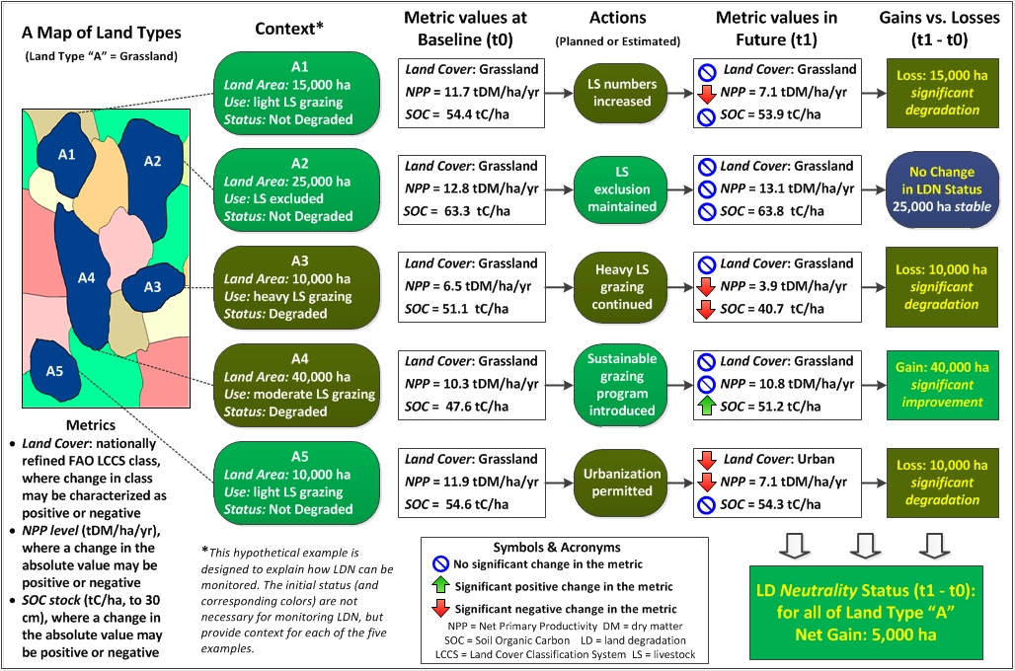

## Step 10: Reporting on land degradation neutrality

***What are the purposes of reporting?***

As mentioned in STEP 8, reporting refers to how monitoring information is communicated, often across scales (e.g. from the national to the global level). Reports therefore need to provide an overview of progress and communicate information in an effective, easily understood manner.

**First and foremost, reports are important tools for communicating** progress towards LDN targets **at the national and local levels** to a wide range of stakeholders, including decision makers.

Reports can also be important vehicles **for countries to share information at the international level** on progress made, lessons learned and ongoing challenges.

***How should a report on progress made towards LDN targets be prepared?***

Countries participating in the LDN TSP should prepare a national report summarizing the achievements and lessons-learned of the LDN target setting process. UNCCD national focal points are encouraged to work closely with the national LDN working groups in preparation of the report.

For use and dissemination at the national level it is advisable to prepare the report in the national language, however countries are encouraged to translate the report into English or one of the other official languages of the United Nations for use at the international level.

Information gathered through the LDN TSP can feed as appropriate into various international reporting and review mechanisms, including national reporting under the UNCCD and the SDG process.

***How does the UNCCD reporting and review mechanism work and evolve?***

Since the adoption of the 10-year strategic plan and framework to enhance the implementation of the Convention (2008–2018) (The Strategy) in 2007, Parties were requested to report every two years on progress made towards the operational objectives and every four years on progress made towards the strategic objectives. Three reporting cycles have been concluded so far (2010, 2012 and 2014); the 2010 and 2014 reporting and review exercises included reporting on operational objectives, while the 2012 reporting and review exercise included reporting on operational and strategic objectives.

In October 2015, Parties at COP 12 agreed to make the reporting exercise in 2016 optional (fourth reporting cycle),[26] considering: (i) the need to review the reporting process in light of the new resolutions and commitments taken at global level; and (ii) the fact that the current Strategy is soon to expire. Reports submitted in 2016 will be compiled and presented to Parties during the fifteenth session of CRIC in order to discuss findings, share experiences and make proposals on how to improve reporting under the Convention to the COP at its thirteenth session.

At its twelfth session, the COP also decided to establish an Intergovernmental Working Group on the future strategic framework of the Convention (IWG-FSF).[27] The IWG-FSF is requested to assess the current Strategy and propose whether it should be extended or revised, or whether a new strategy should be adopted.

Since the COP decided that striving to achieve SDG target 15.3 is a strong vehicle for driving implementation of the UNCCD and invited all country Parties to formulate national voluntary targets to achieve LDN,[28] it is expected that the future strategic framework of the Convention and associated reporting mechanism will include, at least on a voluntary basis, provisions related to LDN.

Data, information, results and lessons learned from the LDN TSP are therefore expected to contribute significantly to the future UNCCD reporting requirements.

***Sustainable Development Goals follow-up and review mechanism***

The UNCCD is well-positioned to contribute to the SDG follow-up and review mechanism by providing data needed for regional and global assessments of progress towards SDG target 15.3, including by:

* Receiving data from countries through well-established and further improved reporting mechanisms;
* Supporting increased adoption of and compliance with internationally agreed standards at the national level;
* Working for strengthening national statistical capacity and improving reporting mechanisms.

# 3. Conclusions

Following the adoption of the SDGs and the endorsement of SDG target 15.3 as a strong vehicle for driving the implementation of the UNCCD, the LDN target setting process aims enhance countries preparedness to achieve LDN by 2030. However, LDN target setting is not a stand-alone process but one that should be embedded in overarching national development policy processes. Strong Government leadership and the active involvement of all stakeholders groups and sectors impacting and benefitting from land based natural capital are required to support the LDN target setting-processes and contribute to preparing the ground for countries to achieve LDN by 2030.

A successful LDN target setting process will enhance UNCCD implementation at country level and contribute to the achievements of many SDGs. It will also contribute to

* enhanced stakeholder involvement in land use planning/policies and the implementation of more sustainable land management practices;
* strengthen cooperation among land use sectors;
* a better understanding of the drivers and trends of land degradation through improved monitoring based on agreed indicators;
* well-define LDN targets and associated measures that leverage policies, strategies, and investments across sectors and provide multiple societal benefits mainstreaming LDN at the highest level in development policy and national land use planning;
* more effective investment partnerships for land-based projects and programmes that will attract investors and help secure future social and economic benefits for the country; and
* improved reporting to interested constituencies at all levels.

# 4. References

Akhtar Schuster, M et al.: Operationalizing land degradation neutrality: unravelling the semantics to support action and synergies among the Rio Conventions. Environmental Management. (submitted manuscript)

De Groot, Rudolf; Brander, Luke; Van der Ploeg‚ Sander et al. 2012. Global estimates of the value of ecosystems and their services in monetary units. Ecosystem services‚ 1(1)‚ pp.50-61. <http://www.gwp.org/Global/ToolBox/References/Global%20estimates%20of%20the%20value%20of%20ecosystems%20and%20their%20services%20in%20monetary%20units%20(Groot,%202012).pdf>

EcoAgriculture Partners. Undated. <http://peoplefoodandnature.org/about-integrated-landscape-management/>

ELD Initiative. 2015. The value of land: Prosperous lands and positive rewards through sustainable land management. www.eld-initiative.org

European Environment Agency. 2015. National monitoring, reporting and evaluation of climate change adaptation in Europe. Technical report No 20/2015. <http://www.eea.europa.eu/publications/national-monitoring-reporting-and-evaluation>

FAO. 1976. A framework for land evaluation. FAO Soils bulletin 32. Soil resources development and conservation service land and water development division. Food and Agriculture Organization of the United Nations (FAO), Rome. ISBN 92-5-100111-1 Available online: http://www.fao.org/docrep/x5310e/x5310e00.htm

FAO. 2007. Land evaluation: Towards a revised framework. Land and Water Discussion Paper 6. TC/D/A1080E/1/04.07. Food and Agriculture Organization of the United Nations (FAO), Rome. ISSN 1729-0554. Available online: <http://www.fao.org/nr/lman/docs/lman_070601_en.pdf>

FAO. 2012. Voluntary guidelines on the responsible governance of tenure of land, fisheries and forests in the context of food security. http://www.fao.org/docrep/016/i2801e/i2801e.pdf.

FAO. 2016. Land Cover Classification System. Classification concepts. Software version 3. http://www.fao.org/3/a-i5232e.pdf

FAO/UNCCD. 2015. Sustainable financing for forest and landscape restoration. Rome, Italy. <http://www.fao.org/3/a-i5031e.pdf>

FAO/UNEP. 1999. The Future of our land: facing the challenge. Guidelines for integrated planning for sustainable management of land resources. http://www.fao.org/docrep/004/x3810e/x3810e00.htm#TopOfPage

Gibbs, H.K.; J.M. Salmon. 2015. Mapping the world’s degraded lands. Applied Geography 57: 12-21. <http://www.sciencedirect.com/science/article/pii/S0143622814002793>

GIZ. 2011. Land Use Planning Concept, Tools and Applications. Sector Project Land Policy and Land Management. <https://www.giz.de/fachexpertise/downloads/Fachexpertise/giz2012-en-land-use-planning-manual.pdf>

Global Mechanism. 2007. SLM Mainstreaming: Concept development and Practice. A user guide.

Global Mechanism. 2008. Integrated Financing Strategy for SLM. Rome, Italy. <file:///C:/Users/ristic/Downloads/2008_GM_International-Financing-Strategy.pdf>

Global Mechanism. 2009. Policy and financing for sustainable land management in Africa The challenge, lessons from experience and guidance for action. Rome, Italy. http://www.opml.co.uk/sites/default/files/UNCCD_Guidance_report_0.pdf

Houghton, P.D. and Charman, P.E.V. 1986. A glossary of terms used in soil conservation. Soil Conservation Service of New South Wales, Sydney.

IPCC. 2003. Good Practice Guidance (GPG) for Land use, Land Use Change and Forestry (LULUCF). http://www.ipcc-nggip.iges.or.jp/public/gpglulucf/gpglulucf_files/Glossary_Acronyms_BasicInfo/Glossary.pdf

IPPC. 2006. IPCC Guidelines for National Greenhouse Gas Inventories. http://www.ipcc-nggip.iges.or.jp/public/2006gl/pdf/4_Volume4/V4_03_Ch3_Representation.pdf

Lamb, David; Gilmour, Don. 2003. Rehabilitation and Restoration of Degraded Forests. IUCN, Gland, Switzerland and Cambridge, UK and WWF, Gland, Switzerland. x +110 pp. <http://cmsdata.iucn.org/downloads/rehabilitation_and_restoration_of_degraded_forests.pdf>

Ministerio dell’Ambiente & UNCCD. 2015. Towards achieving Land Degradation Neutrality: turning the concept into practice. Italy Summary Report. <http://www.unccd.int/en/programmes/RioConventions/RioPlus20/Documents/LDN%20Project%20Country%20Reports/italy-ldn-country-report-updated-version.pdf>

Mirova & GM. 2016. Reversing land degradation with environmental finance (under preparation).

Republic of Namibia & UNCCD. 2015. Namibia - Land Degradation Neutrality National Report. Republic of Namibia. Ministry of Environment and Tourism. <http://www.unccd.int/en/programmes/RioConventions/RioPlus20/Documents/LDN%20Project%20Country%20Reports/namibia-ldn-country-report-updated-version2.pdf>

Society for Ecological Restoration International Science & Policy Working Group. 2004. The SER International Primer on Ecological Restoration. www.ser.org & Tucson: Society for Ecological Restoration International. <http://www.ser.org/docs/default-document-library/ser_primer.pdf?sfvrsn=2>

TerrAfrica. Undated. Sustainable Land Management. <http://www.fao.org/nr/land/sustainable-land-management/en/>

UNCCD SPI. 2015. Pivotal Soil Carbon. Science-Policy Brief. <http://www.unccd.int/Lists/SiteDocumentLibrary/Publications/2015_PolicyBrief_SPI_ENG.pdf>

UNCCD SPI. 2016. LDN Conceptual Framework (under preparation)

UNCCD, CBD, FAO, STAP. 2016. Framework and Guiding Principles for a Land Degradation Indicator- (under preparation). Washington, DC. <http://www.unccd.int/Lists/SiteDocumentLibrary/Rio+20/LDN%202016/Framework%20and%20Guiding%20Principles%20for%20a%20Land%20Degradation%20Indicator.pdf>

UNCCD. 1994. United Nations Convention to Combat Desertification in Countries Experiencing Serious Drought and/or Desertification, Particularly in Africa. Article 1. <http://www.unccd.int/en/about-the-convention/Pages/Text-Part-I.aspx>

UNCCD. 2015. Land matters for Climate. Reducing the Gap and Approaching the Target. Bonn, Germany. <http://www.unccd.int/Lists/SiteDocumentLibrary/Publications/2015Nov_Land_matters_For_Climate_ENG.pdf>

UNCCD. 2016. A natural fix. Sustainable Development Goals, a joined-up approach to delivering the global goals for sustainable development. Bonn, Germany. <http://www.unccd.int/Lists/SiteDocumentLibrary/Publications/4_2016_Land_SDGs_ENG.pdf>

UNCCD. Undated. Glossary for UNCCD reporting. <http://www.unccd.int/en/programmes/Reporting-review-and-assessment/Documents/Glossary%20ENGLISH_Final.pdf>

UNDP. 2008. Guidelines for Developing Integrated Financing Strategies for Sustainable Land Management. An Introduction for Least Developed Countries and Small Islands Developing States. <http://www.gsu.co.za/>

United Nations. 2012. The future we want. <http://www.un.org/ga/search/view_doc.asp?symbol=A/RES/66/288&Lang=E>

United Nations. 2014. System of Environmental Economic Accounting 2012— Experimental Ecosystem Accounting. New York. http://unstats.un.org/unsd/envaccounting/seeaRev/eea_final_en.pdf

United Nations. 2015. Transforming our World: The 2030 Agenda for Sustainable Development. <https://sustainabledevelopment.un.org/?menu=1300>

University of Kansas. 2015. Section 8. Identifying and Analyzing Stakeholders and Their Interests. Community Tool Box and frameworks for guiding, supporting and evaluating the work of community and system change. <http://ctb.ku.edu/en/table-of-contents/participation/encouraging-involvement/identify-stakeholders/main>

Warren, A. 2014. Land degradation is contextual. Land Degrad. Dev., 13: 449–459. doi: 10.1002/ldr.532

WOCAT. 2012. DESIRE for Greener Land: Options for Sustainable Land Management in Drylands. Bern, Switzerland, and Wageningen, The Netherlands: University of Bern - CDE, Alterra - Wageningen UR,

WOCAT. Undated. WOCAT-Categorisation System. <https://www.wocat.net/fileadmin/user_upload/documents/QT_and_QA/CategorisationSystem.pdf>

Yengoh, G. T. et al. 2015. Use of the Normalized Difference Vegetation Index (NDVI) to Assess Land Degradation at Multiple Scales: Current Status, Future Trends, and Practical Considerations. <http://www.springer.com/gp/book/9783319241104#aboutBook>

# 5. Annex

## 5.1 Relevant paragraphs of decisions related to land degradation neutrality taken by the Conference of the Parties at its twelfth session

**Decision 1/COP.12: Multi-year workplans of the Convention institutions and subsidiary bodies**

Outcome indicator 2.1: The extent to which affected country Parties establish targets for addressing land degradation and rehabilitation

**Decision 2/COP.12: Formulation, revision and implementation of action programmes in view of the 2030 Agenda for Sustainable Development**

3. Invites affected country Parties, in accordance with decision 22/COP.11, to establish baselines and national-level voluntary land degradation neutrality (LDN) targets within their NAPs and to address ecosystem aspects at their discretion in their subregional and regional action programmes, making use of scientific and knowledge-based diagnostic tools at the national level;

4. Also invites Parties, other governments and other development partners to establish and increase partnership agreements for technical support to affected country Parties according to their bilateral priorities – giving special attention to the implementation of NAPs – and to assist them in monitoring progress towards achieving national targets;

5. Further invites affected country Parties to include voluntary national LDN targets in their national reports, as appropriate;

6. Requests the United Nations Convention to Combat Desertification and the Global Environment Facility (GEF) secretariats to continue consultations on the arrangements for the delivery of funding enabling activities for the sixth GEF Replenishment Phase (GEF-6) with a view to securing technical and financial support for the next reporting exercise, including in the area of progress reporting and national target setting towards achieving LDN;

7. Invites Parties and technical and financial institutions to provide support to affected country Parties in establishing, aligning and implementing NAPs, including, as appropriate, target 15.3 of the 2030 Agenda for sustainable development, and LDN national voluntary target setting;

8. Requests Parties at the thirteenth session of the Conference of the Parties to consider adding the first review of LDN voluntary targets and their implementation so far to the agenda of the intersessional meeting of the CRIC/CST prior to the fourteenth session of the Conference of the Parties;

9. Invites affected country Parties to develop and implement strategies through their NAPs to achieve the objectives of the Convention in the light of target 15.3 of the 2030 Agenda for sustainable development;

10. Requests the secretariat and the Global Mechanism to:

(a) Enhance their assistance to country Parties in terms of technical and financial support for the implementation of target 15.3 of the 2030 Agenda for sustainable development through the NAPs, including the LDN approach at national level;

(b) Engage with international organisations and funds, as well as other multilateral and bilateral donors, in order to mobilise additional resources for the implementation of target 15.3 of the 2030 Agenda for sustainable development through the NAPs, including the LDN approach at national level;

11. Also requests the secretariat to report to the next session of the CRIC on the implementation of this decision.

**Decision 3/COP.12: Integration of the Sustainable Development Goals and targets into the implementation of the United Nations Convention to Combat Desertification and the Intergovernmental Working Group report on land degradation neutrality**

1. Welcomes the report of the IWG contained in part two of document ICCD/COP(12)/4;

2. Endorses the IWG science-based definition of LDN as follows: “Land degradation neutrality is a state whereby the amount and quality of land resources necessary to support ecosystem functions and services and enhance food security remain stable or increase within specified temporal and spatial scales and ecosystems”;[29]

5. Invites Parties to:

(a) Formulate voluntary targets to achieve LDN in accordance with their specific national circumstances and development priorities, taking into account the list of options for operationalising LDN at the national level as outlined by the IWG;

(b) Use the monitoring and evaluation approach adopted in decision 22/COP.11, including the progress indicators as listed in the annex to this decision, where reliable data is available pursuant to paragraph 7 of that decision and taking into consideration national circumstances and, as needed, add additional indicators to monitor, evaluate and communicate progress towards achieving the LDN target;

(c) Explore options on how to integrate the voluntary LDN targets in their NAPs as part of their overall discussion on the implementation of the SDGs;

(d) Promote the use of LDN targets and projects and other SLM initiatives as an effective vehicle for mobilising additional sustainable financing and responsible and sustainable investments that address DLDD issues;

6. Encourages developed country Parties to actively support the efforts of developing country Parties in promoting SLM practices and in seeking to achieve LDN, by providing substantial financial resources, facilitated access to appropriate technology and other forms of support;

7. Also encourages developed country Parties and invites other countries in a position to do so, multilateral financial institutions, the private sector, civil society organisations, and technical and financial institutions to:

(a) Provide scientific, technical and financial assistance to help affected country Parties requesting assistance to set and achieve LDN targets as well as to implement SLM practices and LDN initiatives;

(b) Establish equitable partnerships that encourage responsible and sustainable investments and practices by the private sector, which contribute to achieving LDN that supports the health and productivity of the land and its people;

8. Further encourages Parties requesting assistance to include this request for support in their priorities in discussions with bilateral, multilateral and other donors, based on their national development plans or strategies;

9. Directs the secretariat of the UNCCD, as the lead organisation for DLDD, to take the initiative and invite other relevant agencies and stakeholders such as United Nations agencies, international organisations, financial institutions, civil society organisations and the private sector to seek cooperation to achieve SDG target 15.3;

10. Requests the secretariat and appropriate UNCCD bodies, within the scope of the Convention, to:

(a) Develop options for scaling up and scaling out successful LDN initiatives and other SLM practices;

(b) Explore how they could further develop partnerships with other organisations to provide scientific and technical support to the Parties by, inter alia, developing a ‘user guide’ for implementing LDN at the country level;

(c) Develop guidance for formulating national LDN targets and initiatives, including the identification, development and implementation of policy reforms, investment and incentive mechanisms, and capacity-building initiatives to address DLDD;

(d) Make options available to Parties for the integration of national LDN targets and initiatives in their NAPs;

(e) Further develop, keep under review and facilitate, including through pilot projects, the use of the UNCCD indicator framework as a contribution to the monitoring, evaluation and communication of progress towards the national LDN targets;

(f) Improve the effectiveness of collaboration with the other Rio conventions and other partners at national and, as appropriate, subnational levels to support the implementation and monitoring of LDN targets and initiatives;

11. Also requests the Managing Director of the Global Mechanism, in consultation with the Executive Secretary, to develop options for increasing incentives and financial support, including assisting in the possible creation of an independent LDN fund, to be made available for the full realisation of LDN initiatives;

12. Further requests the Executive Secretary to report to the Conference of the Parties at its thirteenth session on progress made in implementing this decision.

**Decision 8/COP.12: Addressing particular regional and national conditions**

1. Recognises that Parties may use the UNCCD to guide their policies relating to DLDD and voluntary targets when striving to achieve LDN at national and subnational levels;

2. Invites the secretariat, relevant Convention bodies, and bilateral and multilateral partners to provide assistance to Parties in that regard;

3. Requests the Executive Secretary to report to the thirteenth session of the Conference of the Parties on the implementation of the present decision.

**Decision 9/COP.12: Leveraging of synergies among the Rio conventions and promoting partnerships with other international agencies and bodies**

1. Proposes the use of the three land-based progress indicators as set out in decision 15/COP.12 for reporting under the Rio conventions, which are coherent with the progress indicators/metrics adopted in decision 22/COP.11, namely:

(i) Trends in land cover;

(ii) Trends in land productivity or functioning of the land;

(iii) Trends in carbon stock above and below ground;

2. Requests the secretariat:

(a) To promote further harmonisation of indicators and reporting procedures, including the land-based progress indicators across the Rio conventions;

(b) To continue working with the Interagency and Expert Group on Sustainable Development Goal Indicators (IAEG-SDGs) in order to define indicators for SDG target 15.3;

3. Also requests both the secretariat and the Global Mechanism to continue to fulfil their respective roles in the established partnerships and to seek new partnerships according to their respective mandates in order to further enhance the implementation of the Convention and, if appropriate, to bring them to the attention of the Conference of the Parties for any necessary action;

**Decision 12/COP.12: Collaboration with the Global Environment Facility**

1. Welcomes the continued support for the implementation of the Convention and the increase of resources for the land degradation focal area under GEF-6 as compared to GEF-5;

2. Invites the GEF to continue its support for the implementation of the Convention under GEF-6 in the light of the 2030 Agenda for Sustainable Development, in particular target 15.3;

3. Also invites the donors to the GEF to consider providing increased support to address country priorities relating to the implementation of the Convention, in the light of the 2030 Agenda for Sustainable Development, in particular target 15.3, during the planning process for GEF-7;

4. Encourages Parties to engage in South–South cooperation under GEF-6 and invites the GEF to continue its support to Parties in this regard;

5. Also invites the GEF to consider enhancing its support to the GEF Small Grants Programme under GEF-7;

6. Further invites donors to the GEF to give due consideration to the concerns expressed with regard to the allocation of resources across the different focal areas and encourages Parties, through the GEF and the Convention’s focal points and their constituencies, to advocate for a balanced allocation of funds among the Rio conventions;

7. Also invites the GEF to continue its GEF Country Support Programme, including GEF workshops aimed at strengthening the capacity of Parties to utilise GEF resources for the effective implementation of the Convention;

8. Invites the GEF, in the context of enabling activities under GEF-6, to consider technical and financial support for voluntary national land degradation neutrality target setting;

9. Invites the GEF to report on the implementation of this decision as part of its next report to the Conference of the Parties.

**Decision 15/COP.12: Improving the procedures for communication of information as well as the quality and formats of reports to be submitted to the Conference of the Parties**

*Refinement of the set of progress indicators relating to the strategic objectives 1, 2 and 3 and associated methodologies*

1. Decides, as a means to understanding the status of land degradation and the potential for land restoration, that reporting is required for the following three progress indicators: ‘trends in land cover’, ‘trends in land productivity or functioning of the land’ and ‘trends in carbon stocks above and below ground’, provided that countries have sufficient national official data/information to report or validate national estimates derived from global data sources and that reporting should be provided primarily from official national data;

2. Requests the secretariat, in cooperation with relevant specialised institutions, inter alia those included in the annex I to this decision, to:

(a) Compile and make available to affected country Parties national estimates of the metrics/proxies associated with these indicators from the global datasets, inter alia those indicators included in the annex I to this decision, as default data for validation in accordance with the procedure established in decision 22/COP.11;

(b) Prepare methodological guidelines and provide technical assistance to affected country Parties on the compilation and use of such default data, including for the preparation of national voluntary targets using the progress indicators;

(c) Undertake measures aimed at strengthening the capacities of affected Parties to validate, replace or reject the default data;

3. Decides, taking into consideration national circumstances and the availability of methodological guidelines, capacity building and financing, that affected country Parties should provide timely feedback where possible on the default data and the proposed methodology to formulate national voluntary LDN targets using the monitoring and assessment indicators framework, and complete the reporting and target setting exercise for review by the CRIC at its intersessional session that will take place after January 2018;

4. Invites relevant specialised institutions, inter alia those included in the annex I to this decision, to provide access to data and methodologies and assist the secretariat in the compilation and provision of global datasets, as mentioned in paragraphs 2 and 3 above;

5. Requests the secretariat to develop a user guide for practitioners and decision-makers in order to operationalize The Strategy progress indicators with respect to national monitoring and reporting, to be submitted for consideration to the Conference of the Parties at its thirteenth session;

**Decision 16/COP.12: Programme of work for the fifteenth session of the Committee for the Review of the Implementation of the Convention**

1. Decides that the fifteenth session of the CRIC (CRIC 15) should, in the form of a special intersessional session, review and discuss the following items:

(a) Inputs from regional meetings in preparation for CRIC 15;

(b) The land degradation neutrality target setting exercise and pilot projects;

(c) Initial findings from the Intergovernmental Working Group on the future strategic framework of the Convention with the aim of assisting its work;

(d) The report by the secretariat on the overall reporting procedures and modalities for reporting by Parties, including, as needed, proposals of guidelines and reporting tools for progress and performance indicators;

**Decision 21/COP.12: Work programme of the Science-Policy Interface**

*Follow-up on collaboration activities included in the Science-Policy Interface work programme for the biennium 2014–2015*

6. Encourages the SPI to:

(c) Consider, as part of its work programme 2016–2017, how the resilience-based assessment frameworks approach can be applied in its future work on developing guidance for the UNCCD on operationalising the voluntary land degradation neutrality target;

(d) Consider how the resilience-based assessment frameworks approach could contribute to the development of quantitative and narrative indicators at the national/subnational level to complement the UNCCD progress indicators;

**Decision 34/COP.12: Programme of work for the thirteenth session of the Conference of the Parties**

Decides to include the following items on the agenda of its thirteenth session and, if necessary, its fourteenth session:

(a) 2030 Agenda for Sustainable Development: implications for the United Nations Convention to Combat Desertification:

(i) Integration of the sustainable development goals and targets into the implementation of the United Nations Convention to Combat Desertification and the Land Degradation Neutrality;

(ii) The future strategic framework of the Convention;

## 5.2 Draft balance sheet for land degradation neutrality tracking

|  |  |
| --- | --- |
| **Land degradation neutrality tracking balance sheet (an example)** | |
|  | **Land area (ha)** |
| **A. Proposed future gains (on land classified as degraded at baseline only)** |  |
| ***On degraded land*** |  |
| Proposed restoration projects | 100,000 |
| Proposed rehabilitation projects | 200,000 |
| Proposed reclamation projects | 50,000 |
| *Subtotal of proposed gains on degraded land:* | 350,000 |
| ***On managed land under degrading use that could recover*** |  |
| Unsustainable agriculture to be put under sustainable land management | 500,000 |
| Managed land to be protected and excluded from use | 50,000 |
| Other mitigation initiatives | 100,000 |
| *Subtotal of proposed gains on managed land that could recover:* | 650,000 |
|  |  |
| **A. Total proposed gains** | **1,000,000** |
|  |  |
| **B. Anticipated future losses (on land classified as non-degraded at baseline only)** |  |
| ***On non-degraded land*** |  |
| Estimated conversion to agriculture | 200,000 |
| Estimated conversion due to urbanisation | 200,000 |
| Estimated expansion of mining | 50,000 |
| Other | 50,000 |
| *Subtotal of anticipated losses on non-degraded land:* | 500,000 |
| ***On managed land that could be degraded*** |  |
| Estimated new losses from unsustainable land management | 400,000 |
| Estimated losses from indirect anthropogenic factors (e.g. wildfire, climate variability) | 100,000 |
| *Subtotal of anticipated losses on managed land that could be degraded in future:* | 500,000 |
|  |  |
| **B. Total anticipated losses** | **1,000,000** |
|  |  |
| **C. Net loss or gain (A - B)** | **0** |

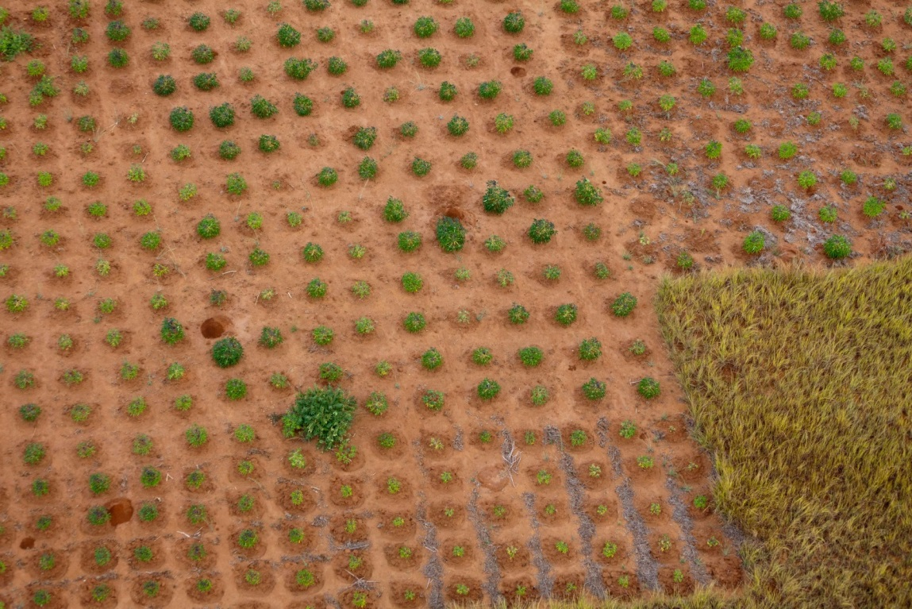

1. See annex 1 for a complete list of Land Degradation Neutrality-related decisions from the twelfth session of the Conference of the Parties.
2. These guidelines make reference to a draft version of the Land Degradation Neutrality Conceptual Framework prepared by the Science–Policy Interface (UNCCD SPI, 2016).
3. http://www.global-mechanism.org/resources/gm-publications
4. http://www.unccd.int/en/programmes/Science/Monitoring-Assessment/Documents/Decision22-COP11.pdf
5. http://unstats.un.org/sdgs/files/metadata-compilation/Metadata-Goal-15.pdf
6. A technical guidance document entitled “Framework and guiding principles on the use of a land degradation indicator” is under development as an input to the work on target 15.3 of the Inter-agency Expert Group on Sustainable Development Goal (SDG) Indicators and is expected to be released towards the end of 2016. This technical guidance document will contain ”Good Practice Guidance” on how to compute the land cover, land productivity, and carbon stocks indicators, as well as on how to jointly use them for deriving the SDG indicator “Proportion of land that is degraded over total land area”.
7. All country Parties will be provided with this default global data as part of the Global Support Programme funded by the Global Environment Facility “Increasing the quantity and improving the quality of information for the review of implementation of the UNCCD Implementation” in support of the UNCCD reporting process.
8. http://www.openforis.org/tools/collect-earth.html
9. http://www.esa-landcover-cci.org/
10. http://www.stapgef.org/stap/wp-content/uploads/2015/03/Michel-Cherlet-Remote-sensing-products-and-global-datasets.pdf
11. <http://www.isric.org/content/soilgrids>
12. <http://www.isric.org/data/wosis>
13. http://www.stapgef.org/the-resilience-adaptation-and-transformation-assessment-framework/
14. SHARP: http://www.fao.org/in-action/sharp/en/
15. A recent comparative study of the data sets of four major global assessments of the area of degraded land revealed large differences in the magnitude of the results (from less than 1 billion ha to over 6 billion ha), with an equally wide disagreement in their spatial distribution. See Gibbs &Salmon (2015)
16. See UNCCD SPI (2016) for a detailed description of these and other principles for counterbalancing.
17. UNCCD SPI (2016) provides further guidance on how to assess and balance gains and losses, including example balance sheets and suggestions for establishing a land-use planning inventory.
18. WOCAT also provides comprehensive databases of sustainable land management (SLM) technologies and approaches. The databases can be searched easily and in different languages by using several selection criteria:

    SLM technologies: <https://qt.wocat.net/qt_report.php>

    SLM approaches: <https://qa.wocat.net/SearchApproach.php?search_type=restricted#results>

    In addition, the WOCAT-UNCCD database provides access to SLM best practices reported by UNCCD member states and allows for new ones to be added: <https://qcat.wocat.net/>
19. For a full description of the process for identifying SLM options, see WOCAT (2012)
20. The Resilience, Adaptation Pathways and Transformation Assessment (RAPTA) Framework (2015), for instance, provides guidance on assessing complex human-ecological systems and identifying options to improve resilience and food security: <http://www.stapgef.org/stap/wp-content/uploads/2015/03/CSIRO-STAP-Resilience-Adaptation-Transformation-Assessment-Framework-Report.pdf>
21. In the event of interventions with implications for tenure rights and access to land, adherence to the Voluntary guidelines on the responsible governance of tenure of land, fisheries and forests in the context of food security may be established as a social safeguard (FAO, 2012)
22. The capacity building needs assessment is carried out in cooperation with the Soil Leadership Academy:http://www.unccd.int/en/Stakeholders/private_sector/Pages/Soil-Leadership-Academy.aspx
23. The Food and Agriculture Organization of the United Nations/UNCCD (2015) estimates that the global benefits of Forest and Landscape Restoration are more than twice the cost.
24. http://www.greenclimate.fund/home
25. http://www.global-mechanism.org/content/impact-investment-fund-land-degradation-neutrality
26. Decision 15/COP.12.
27. Decision 7/COP.12.
28. Decision 3/COP.12.
29. The IWG definition of LDN is included here as contained in document ICCD/COP(12)/4 as amended and with the deletion of the text in square brackets.